**OS_LAB_ASSIGNMENT_1**

**T KARTHIKEYAN**

**CED18I064**

ALL MY SCREENSHOTS AND FILES REGARDING THIS ASSIGNMENT CAN ALSO BE FOUND IN THE BELOW LINK

[PRESS ME](https://drive.google.com/drive/folders/1W1y1OlzD7YG24M6L2GGZmUVRYlKeA5F2?usp=sharing)

**1.Fifty Most Frequently used commands**

**1.1 TAR**

The Linux ‘tar’ stands for tape archive, and is used to create Archive and extract the Archive files. It provides archiving functionality in Linux. We can use tar command to create compressed or uncompressed Archive files and also maintain and modify them.

1. Zipping

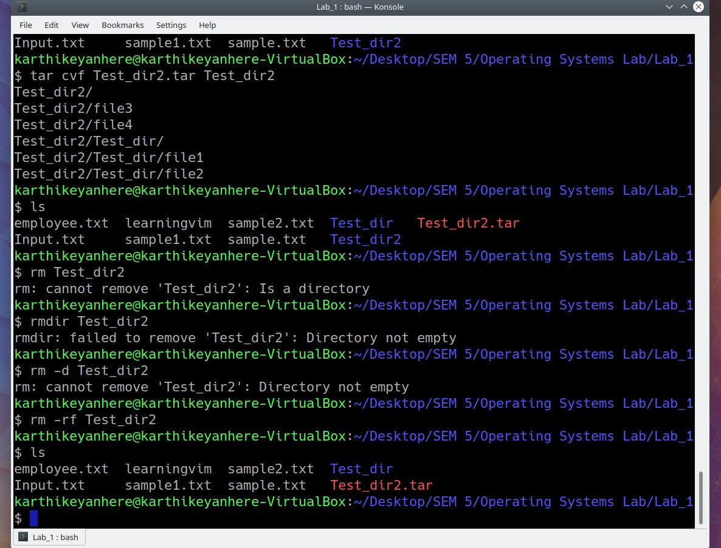

1. Unzipping
2. View existing tar

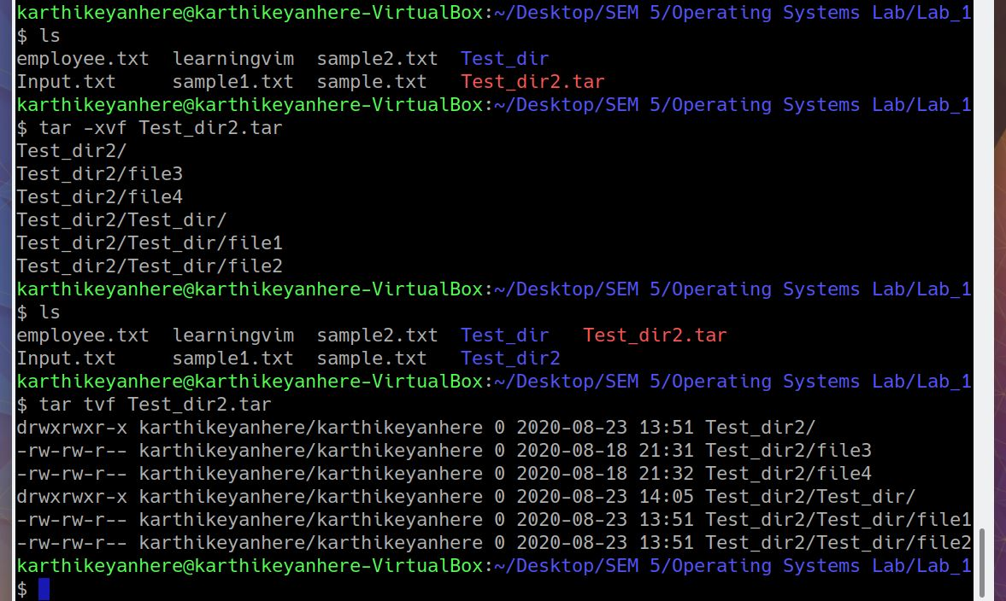

**1.2 GREP**

The grep filter searches a file for a particular pattern of characters, and displays all lines that contain that pattern. The pattern that is searched in the file is referred to as the regular expression (grep stands for globally search for regular expression and print out).

1. grep -i “UNix” file.txt : case insensitive search
2. grep -c “Unix” file.txt : number of lines that matches the given string
3. grep -l “Unix” * : display the files that contains the given string / pattern
4. grep -w “Unix” file.txt : match only the whole words

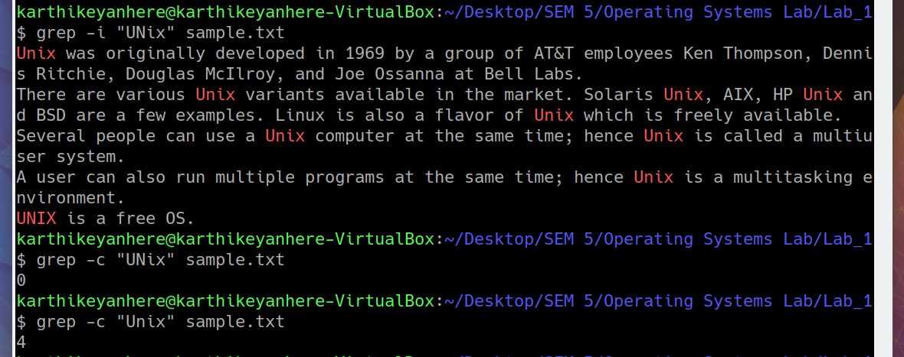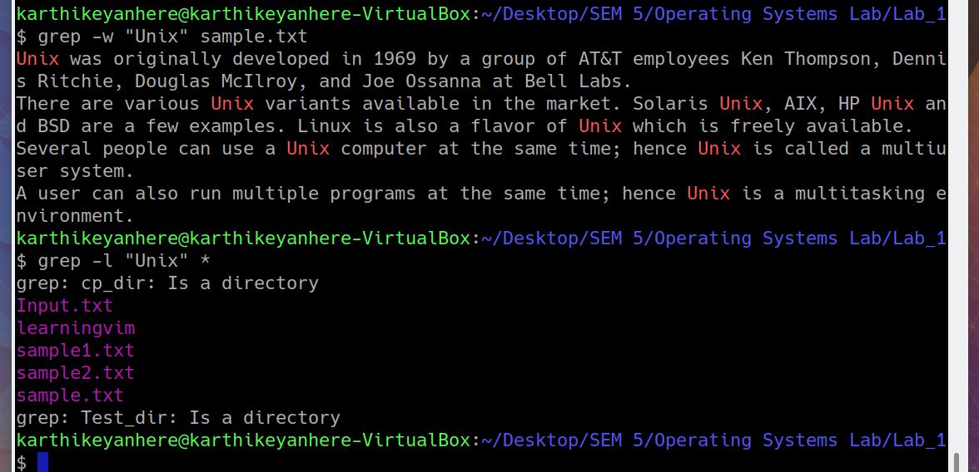

**1.3 FIND**

The find command is a command line utility for walking a file hierarchy. It can be used to find files and directories and perform subsequent operations on them. It supports searching by file, folder, name, creation date, modification date, owner and permissions.

1. find ./Test_dir/ *.txt : finds all the text files
2. find ./Test_dir/ -empty : finds all the empty files
3. find -perm 664 : finds all the files with permission 664

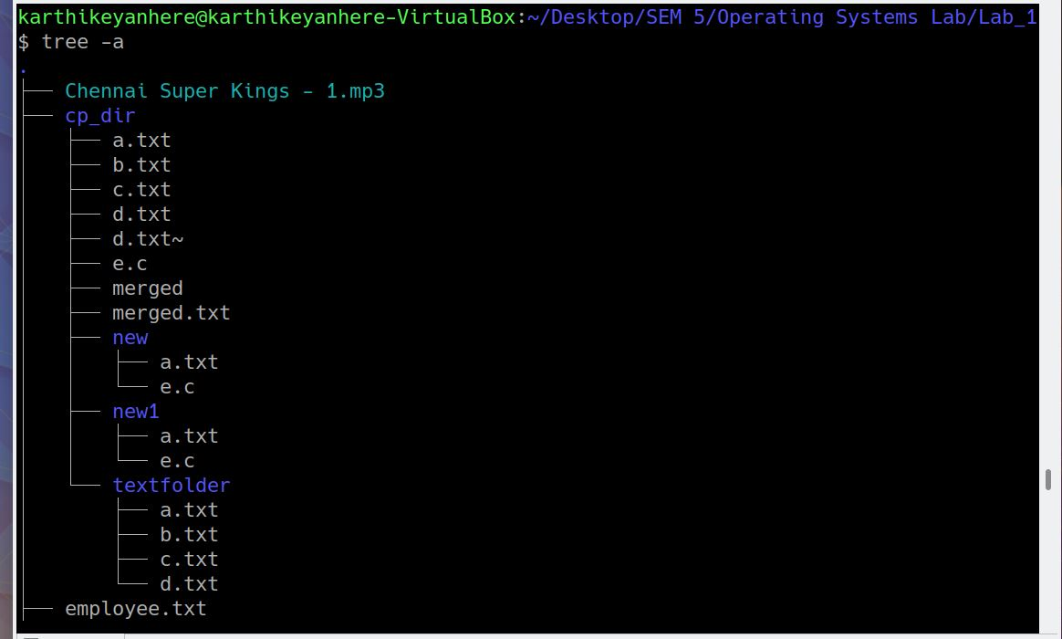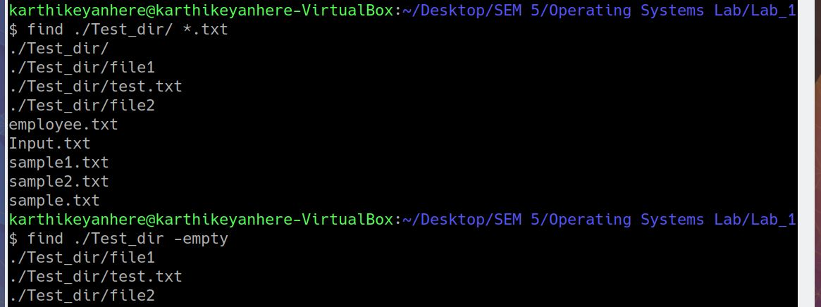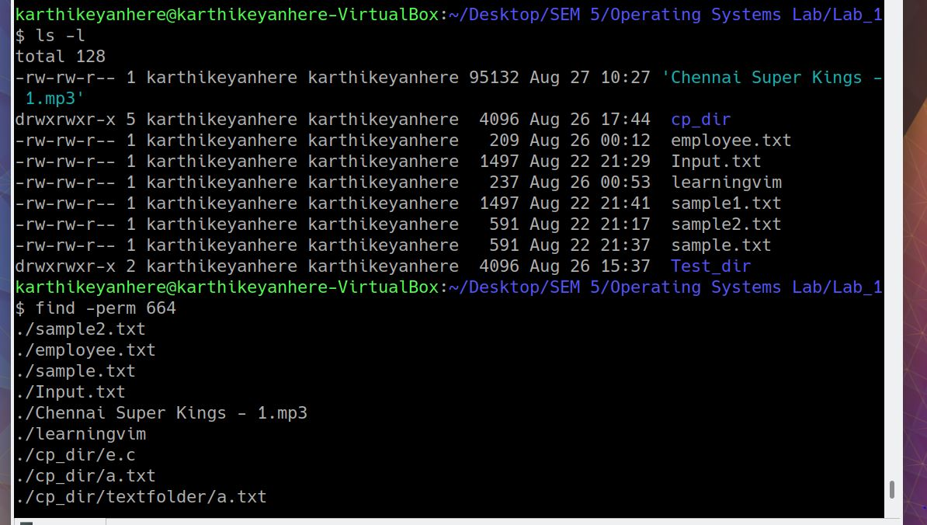

**1.4 SSH**

ssh stands for “Secure Shell”. It is a protocol used to securely connect to a remote server/system. ssh is secure in the sense that it transfers the data in encrypted form between the host and the client. It transfers inputs from the client to the host and relays back the output. ssh runs at TCP/IP port 22.

1. service ssh status
2. ssh karthikeyanhere@ip_address

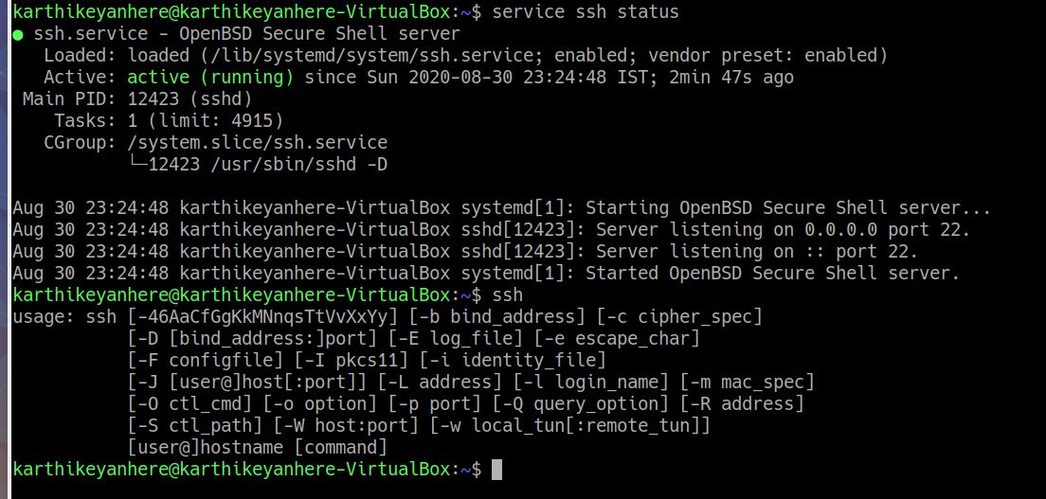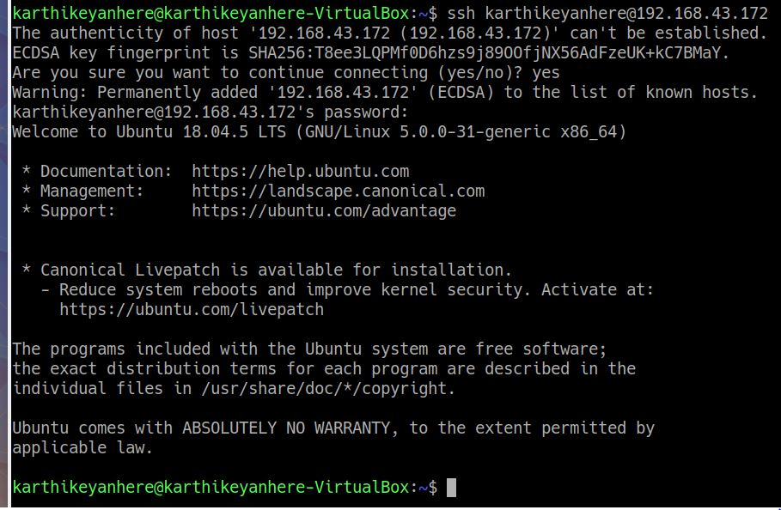

**1.5 SED**

sed in linux stands for stream editor, mainly used for find and replace

(i) Replacing or substituting string

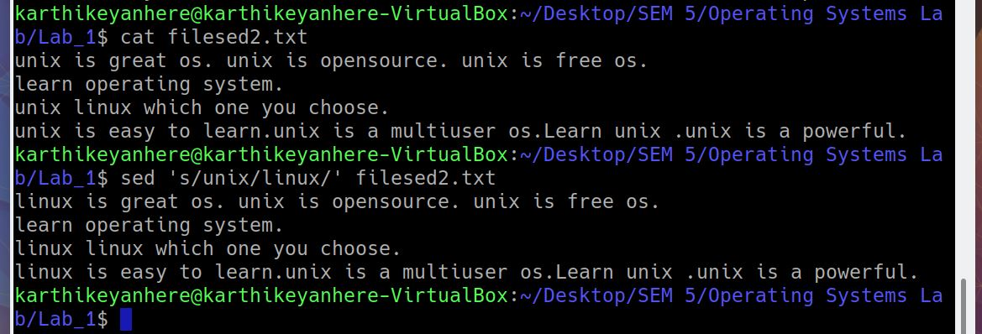

(ii) Replacing the nth occurrence of a pattern in a line

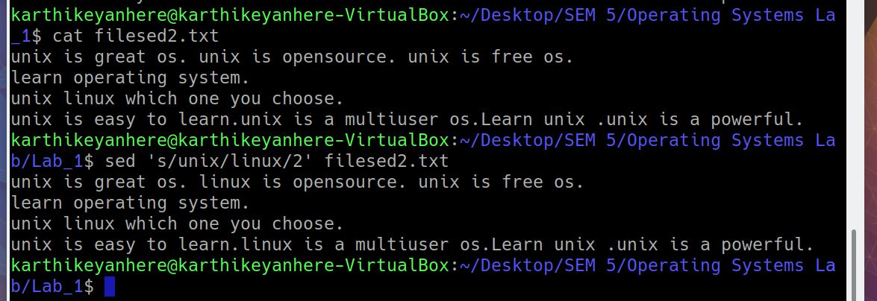

(iii) Replacing all the occurrences of the pattern in a line

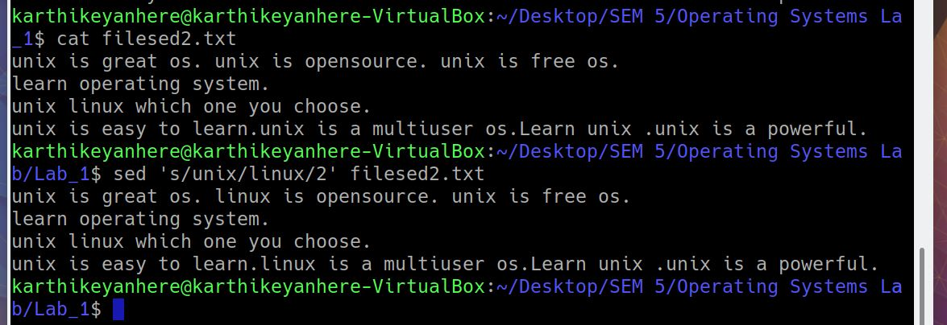

(iv) deleting lines from a particular file

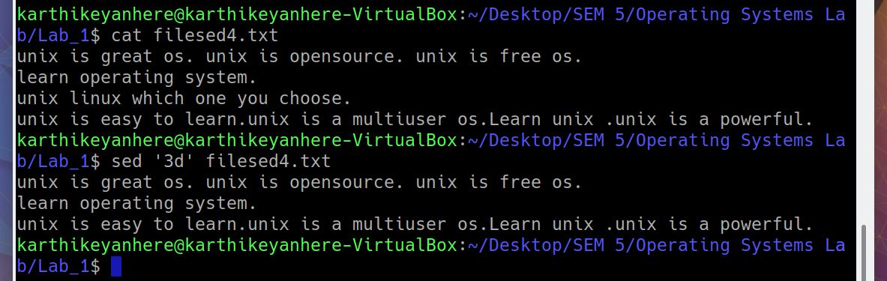

**1.6 AWK**

Awk is a scripting language used for manipulating data and generating reports.The awk command programming language requires no compiling, and allows the user to use variables, numeric functions, string functions, and logical operators.

1. To print the squares of first numbers from 1 to n say 6

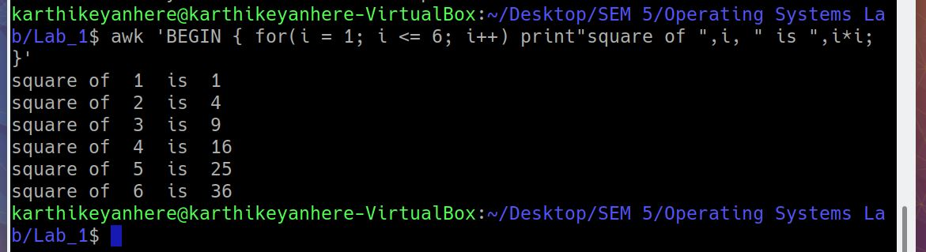

1. default behaviour of awk
2. Print the lines which matches with the given string
3. Splitting a line into fields

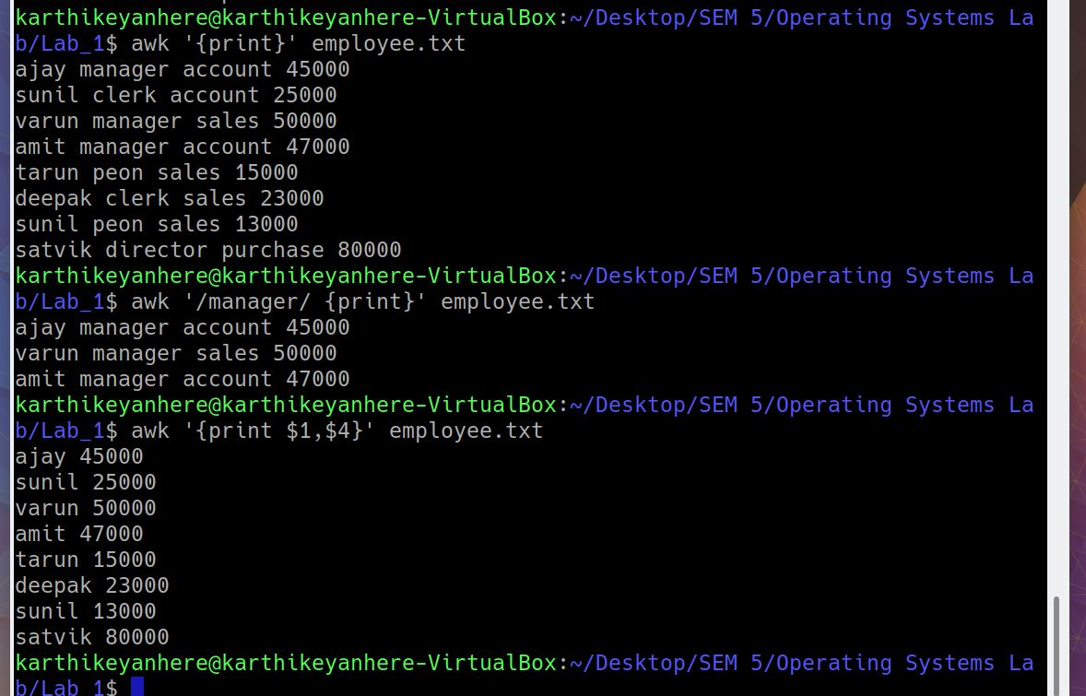

1. display line number

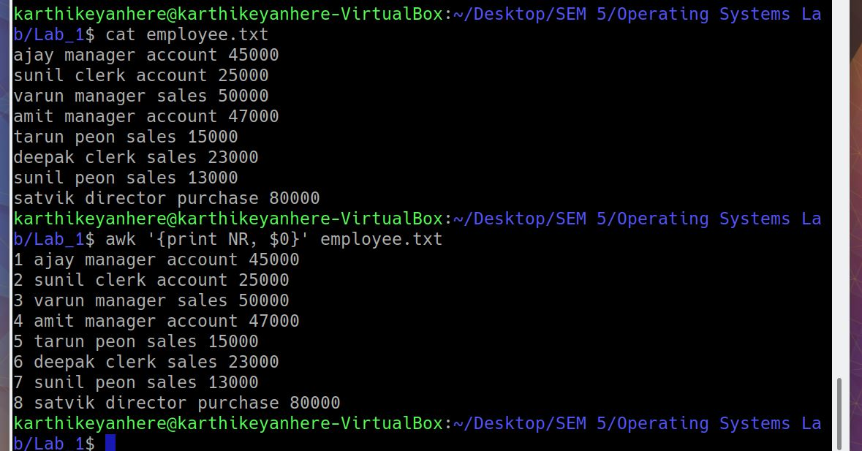

1. display last field

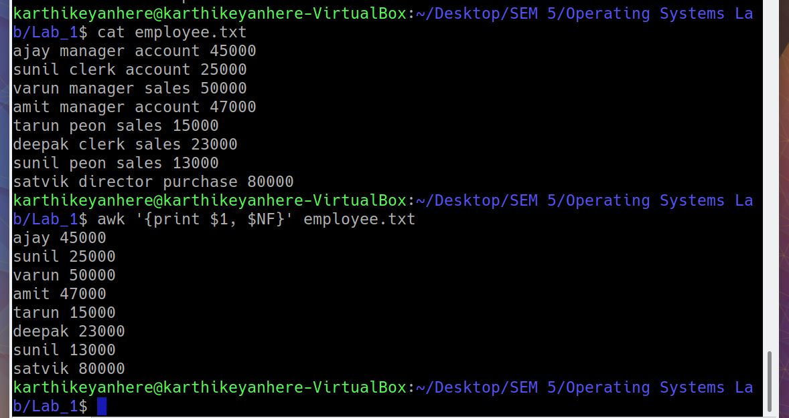

**1.7 VIM**

The default editor that comes with the UNIX operating system is called vim (visual editor). Using vim editor, we can edit an existing file or create a new file from scratch. we can also use this editor to just read a text file.

$ vim filename

Modes available for opening a file

* vi filename: Creates a new file if it already does not exist, otherwise opens existing file.
* vi -R filename : Opens an existing file in read only mode.
* view filename : Opens an existing file in read only mode.

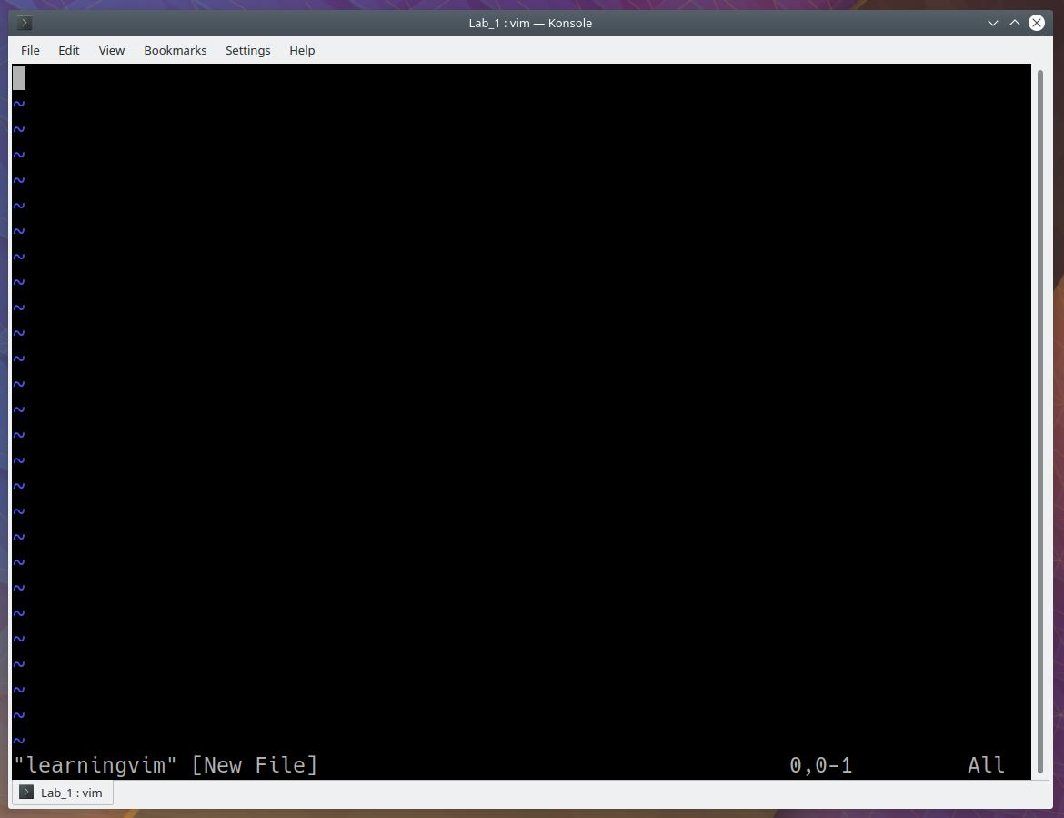

Initially you are in command mode, **to get into insert mode**

Press [ESC] + i

To return back to command mode

Press [ESC]

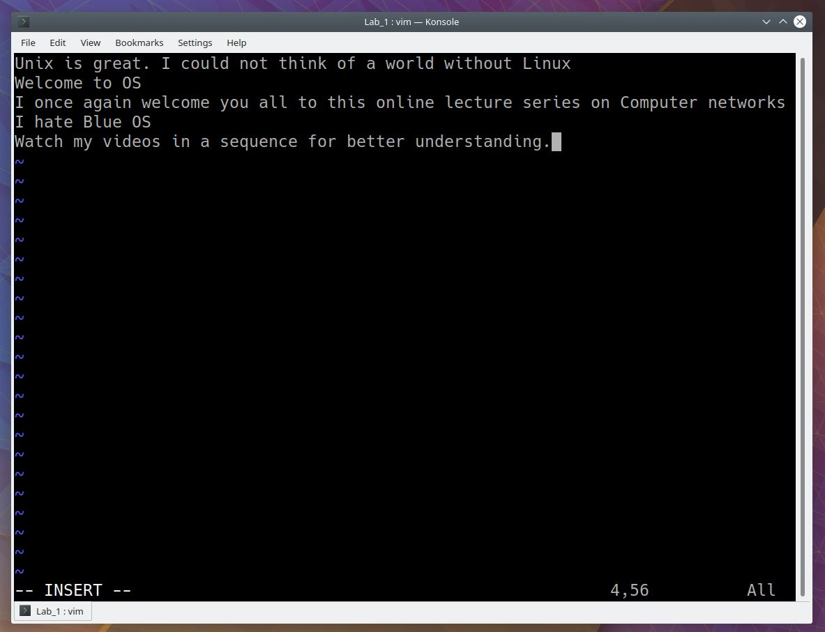

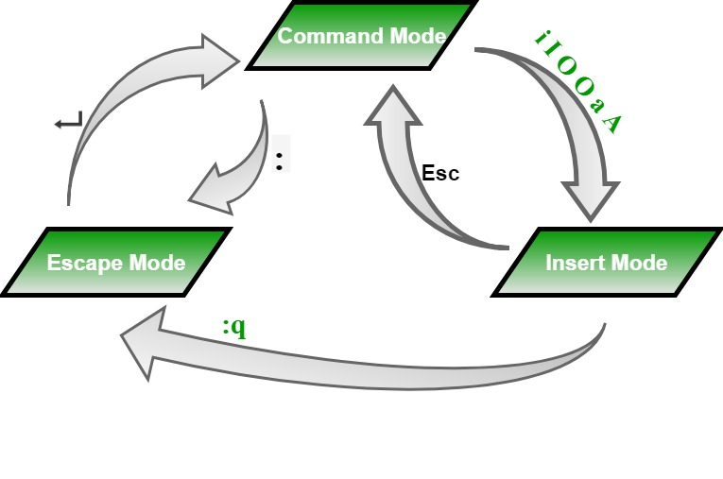

Save and exit options

From insert mode, press [ESC] + : + (any of the below options)

* q : Quit
* q! : Quit without saving changes i.e. discard changes.
* r fileName : Read data from file called fileName.
* wq : Write and quit (save and exit).
* w fileName : Write to file called fileName (save as).
* w! fileName : Overwrite to file called fileName (save as forcefully).
* !cmd : Runs shell commands and returns to Command mode.

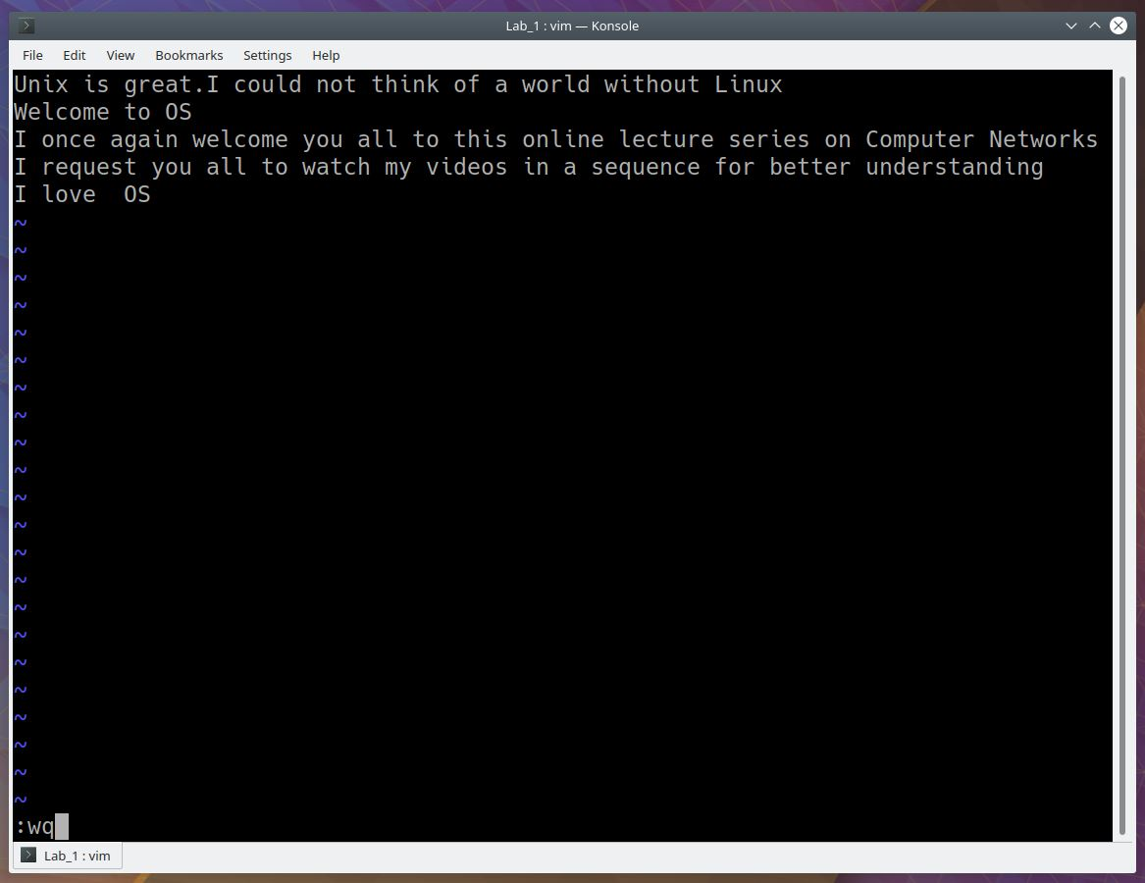

1. Searching in vim

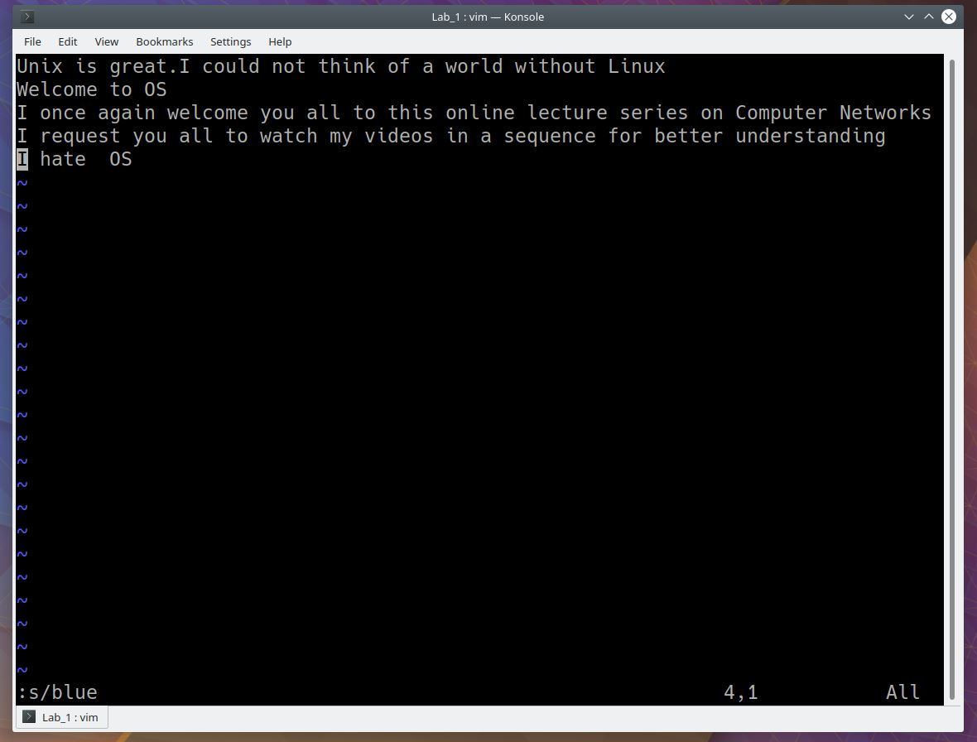

1. Find and replace

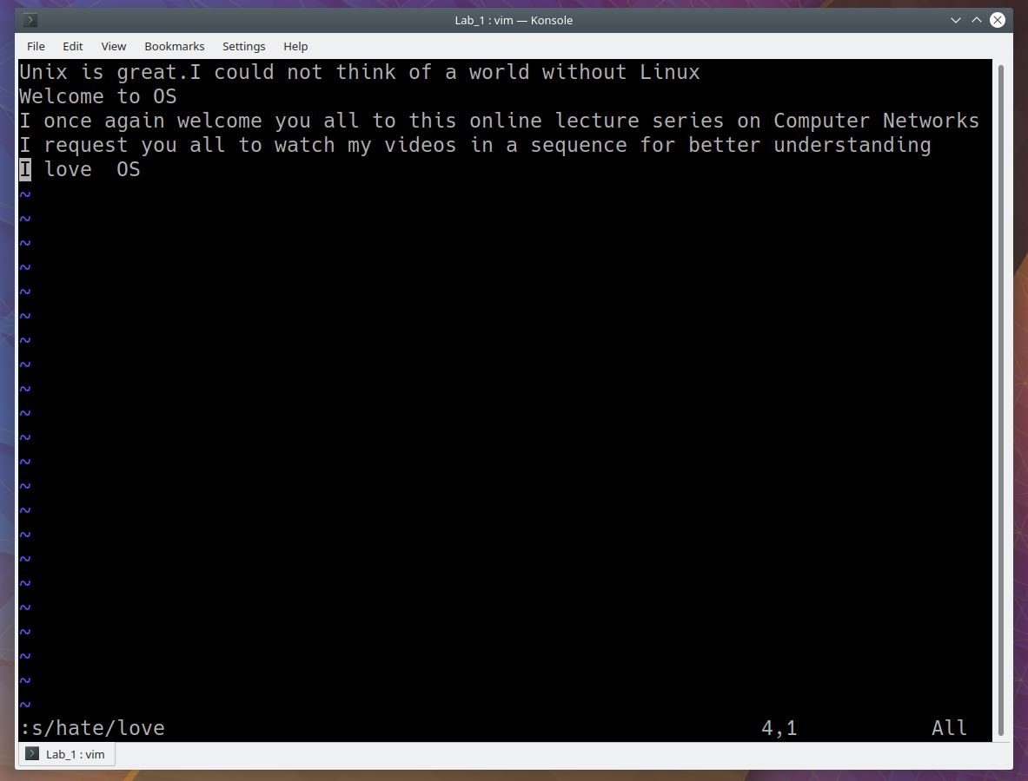

Output after exiting

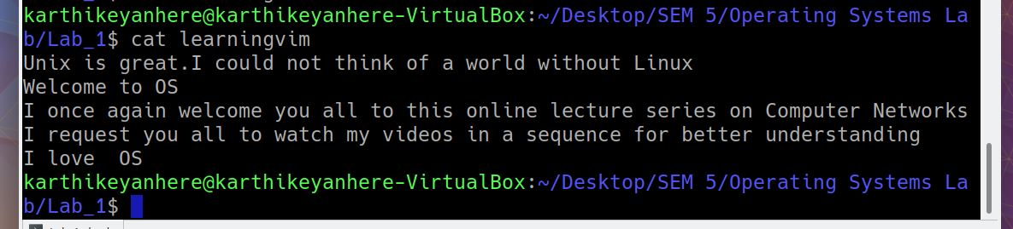

**1.8 DIFF**

diff stands for difference. This command is used to display the differences in the files by comparing the files line by line.

The important thing to remember is that diff uses certain special symbols and instructions that are required to make two files identical. It tells you the instructions on how to change the first file to make it match the second file.

**[refer 18 question for example]**

**1.9 SORT**

SORT command is used to sort a file, arranging the records in a particular order. By default, the sort command sorts file assuming the contents are ASCII.

1. sort [file_name] : sorts the file based on ASCII
2. sort -r [file_name] : reverse sorts the file based on ASCII
3. sort -k 4n [file_name] : sorts the array numerically based on the fourth column

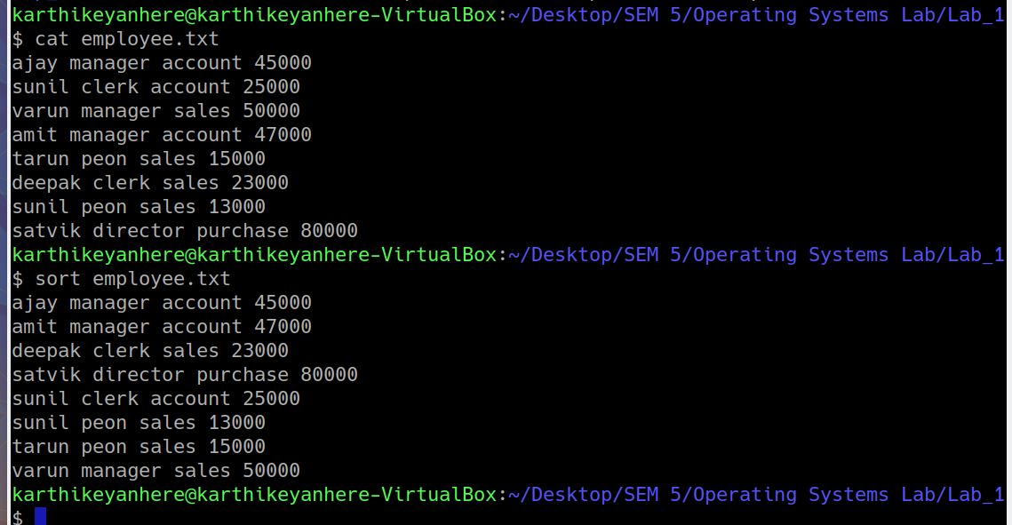

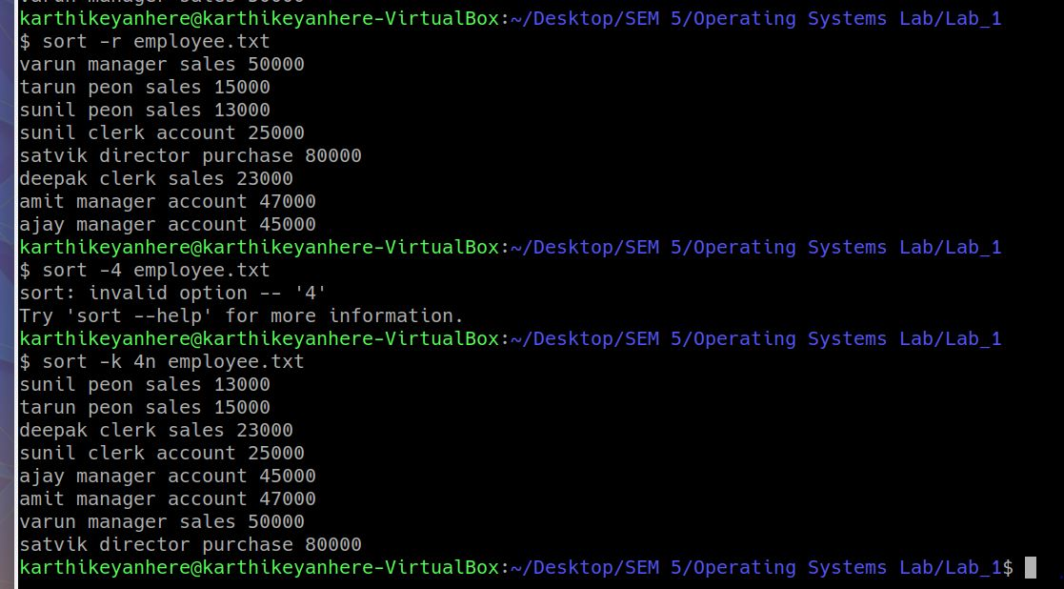

**1.10 EXPORT**

The export command, on the other hand, provides the ability to update the current shell session about the change you made to the exported variable. You don’t have to wait until the new shell session to use the value of the variable you changed.

1. Without any argument : to view all the exported variables

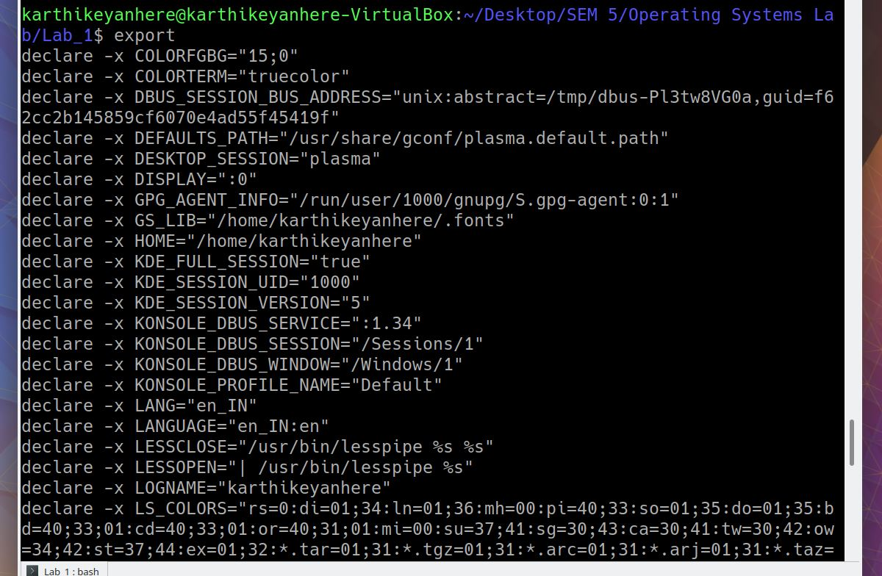

1. -p : to view all the exported variables on current shell

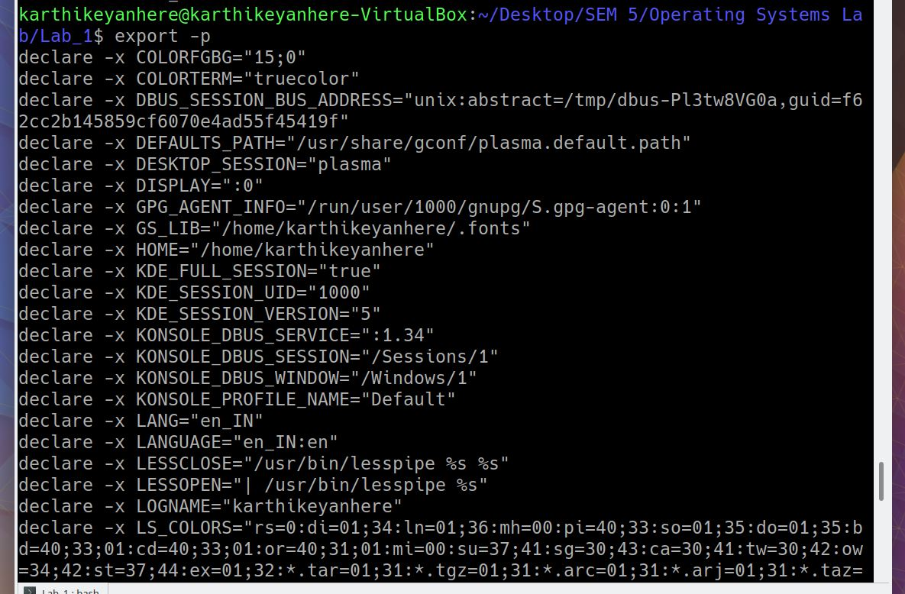

1. -f : refer to function
2. name[=value]

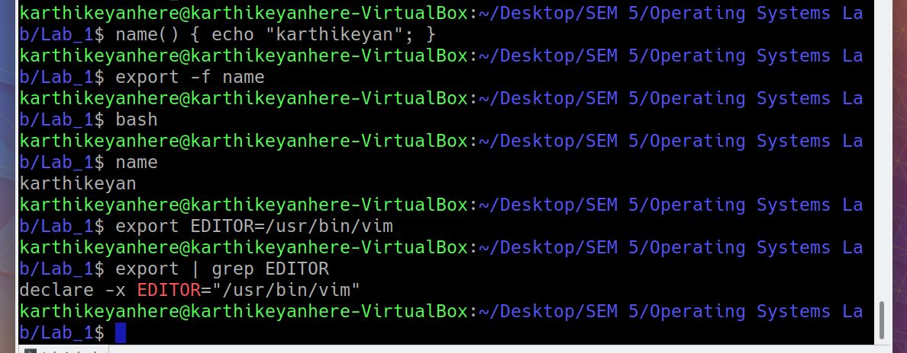

**1.11 XARGS**

The xargs command in Linux is a command line utility for building an execution pipeline from standard input. Whilst tools like grep can accept standard input as parameters, many other tools cannot. Using xargs allows tools like echo and rm and mkdir to accept standard input as arguments.

1. Creating directories
2. Print commands that are executed
3. View the command and view for execution

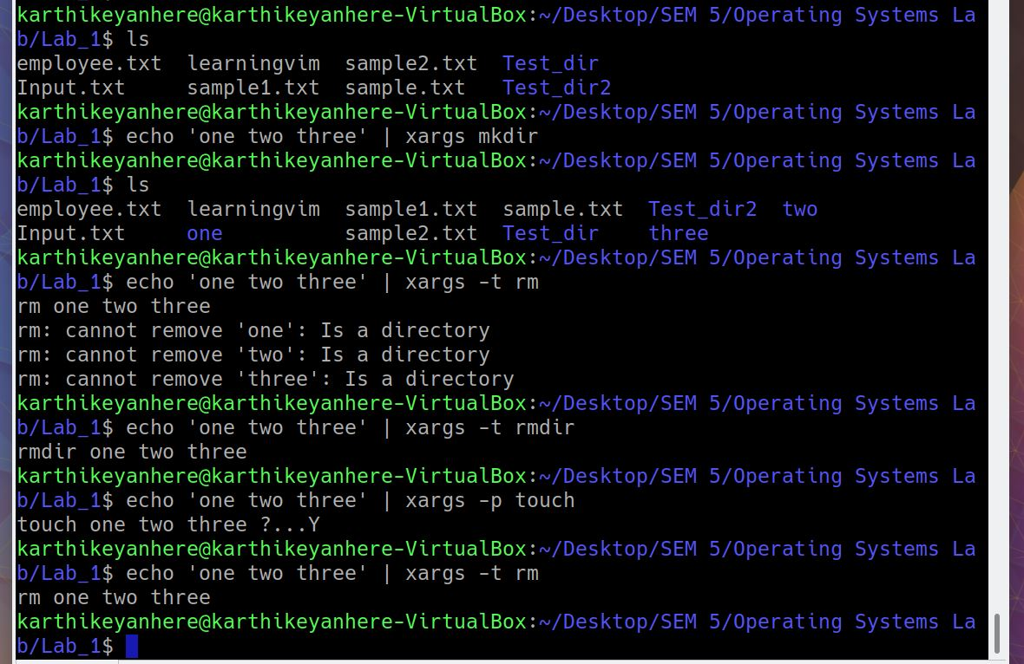

**1.12 LS**

ls is a Linux shell command that lists directory contents of files and directories.

1. open last edited file

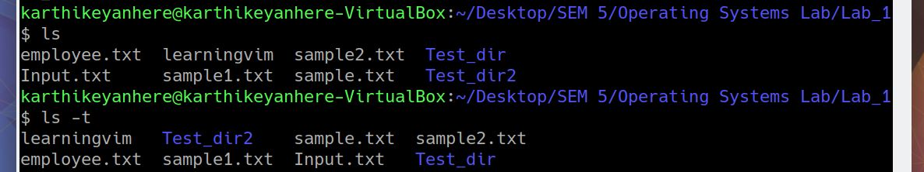

1. display file size in human readable form
2. Order files based on last modified time

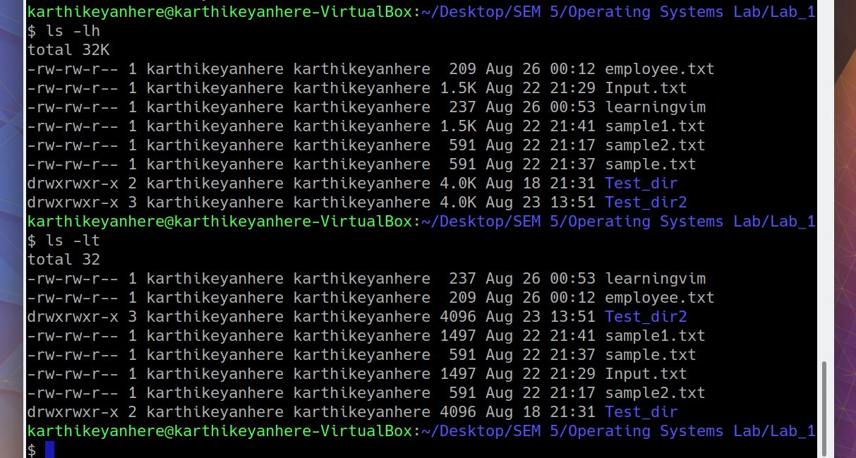

1. Order files based on last modified time in reverse order
2. Display all hidden files
3. Display files recursively

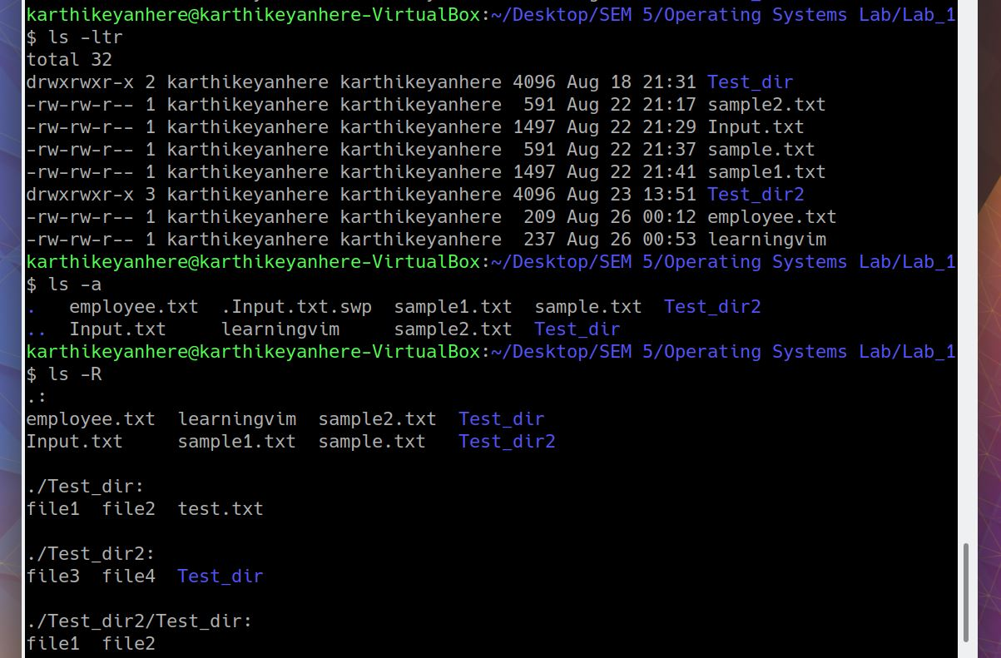

**1.13 PWD**

pwd stands for Print Working Directory. It prints the path of the working directory, starting from the root.

pwd is shell built-in command(pwd) or an actual binary(/bin/pwd).

$PWD is an environment variable which stores the path of the current directory.

1. pwd -L : prints the symbolic path
2. Pwd -P : prints the actual path

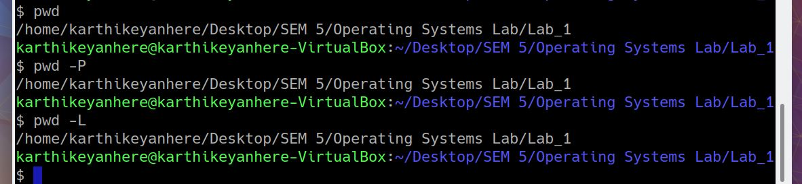

**1.14 CD**

cd command in linux known as change directory command. It is used to change current working directory.

1. Change directory to root directory
2. Change directory to home directory
3. Change to parent directory
4. navigate director with white spaces

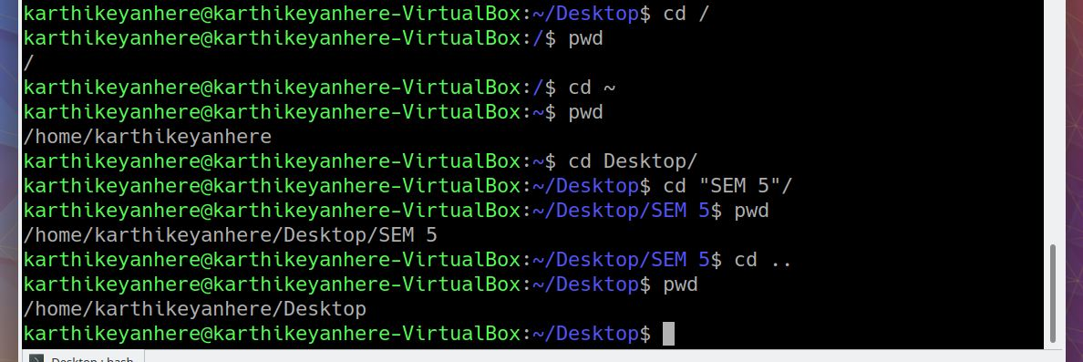

**1.15 GZIP**

gzip command compresses files. Each single file is compressed into a single file. The compressed file consists of a GNU zip header and deflated data.

If given a file as an argument, gzip compresses the file, adds a “.gz” suffix, and deletes the original file. With no arguments, gzip compresses the standard input and writes the compressed file to standard output.

1. -v option : displays name and percentage reduction of each file compressed or decompressed
2. -d option : decompress a file

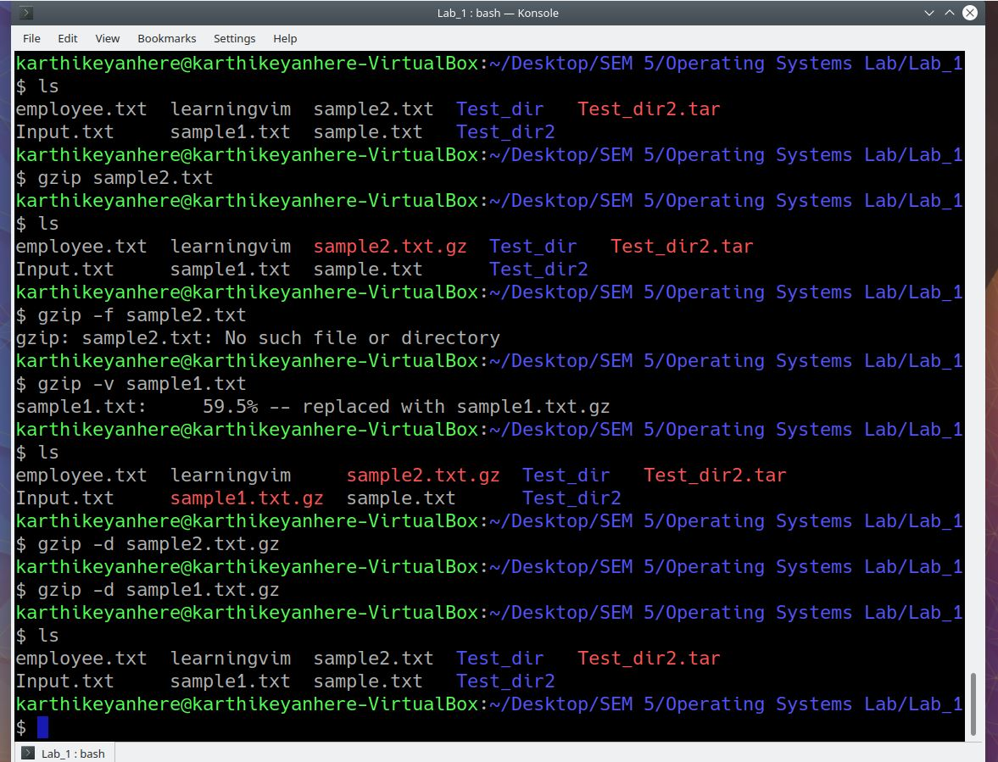

**1.16 BZIP2**

bzip2command is used to compress and decompress the files i.e. it helps in binding the files into a single file which takes less storage space as the original file used to take. It has a slower decompression time and higher memory use.

1. -k option : does compression but does not deletes the original file
2. - v option : show compression ratio of each file processed

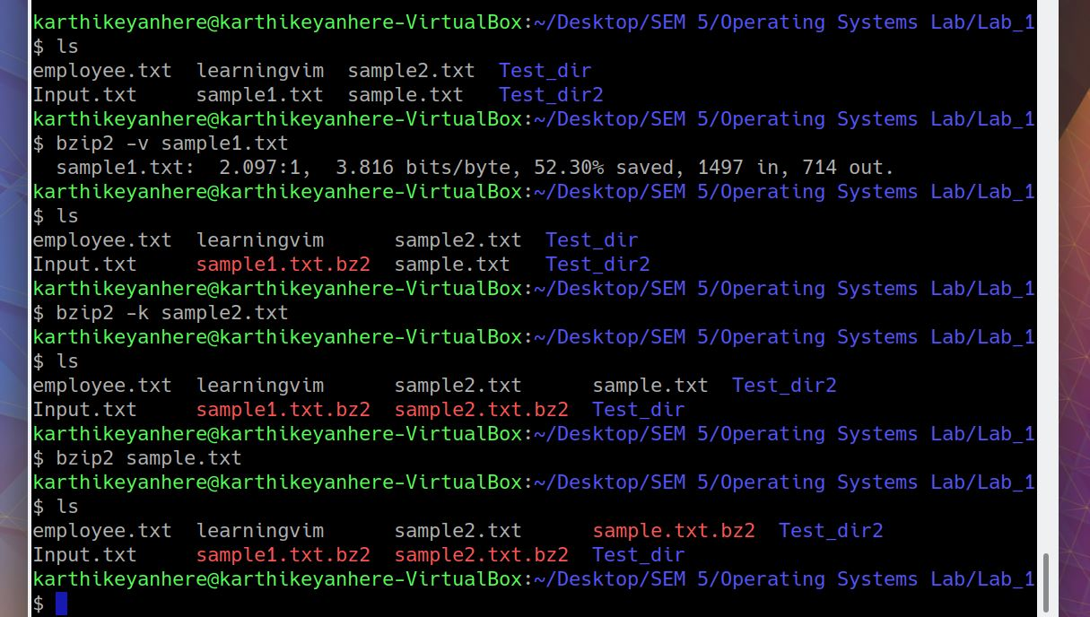

1. -d option : decompression of compressed files

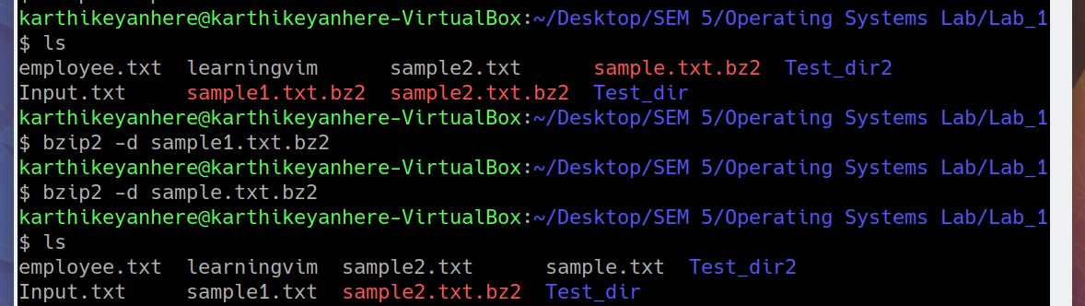

**1.17 ZIP and UNZIP**

ZIP is a compression and file packaging utility for Unix. Each file is stored in single .zip {.zip-filename} file with the extension .zip

1. zip folder.zip [filelist] : Creating a zip folder
2. -u and -d :inserting/deleting files into zip folder
3. -sf : to view the contents of zip folder
4. unzip folder.zip : unzipping a zip folder

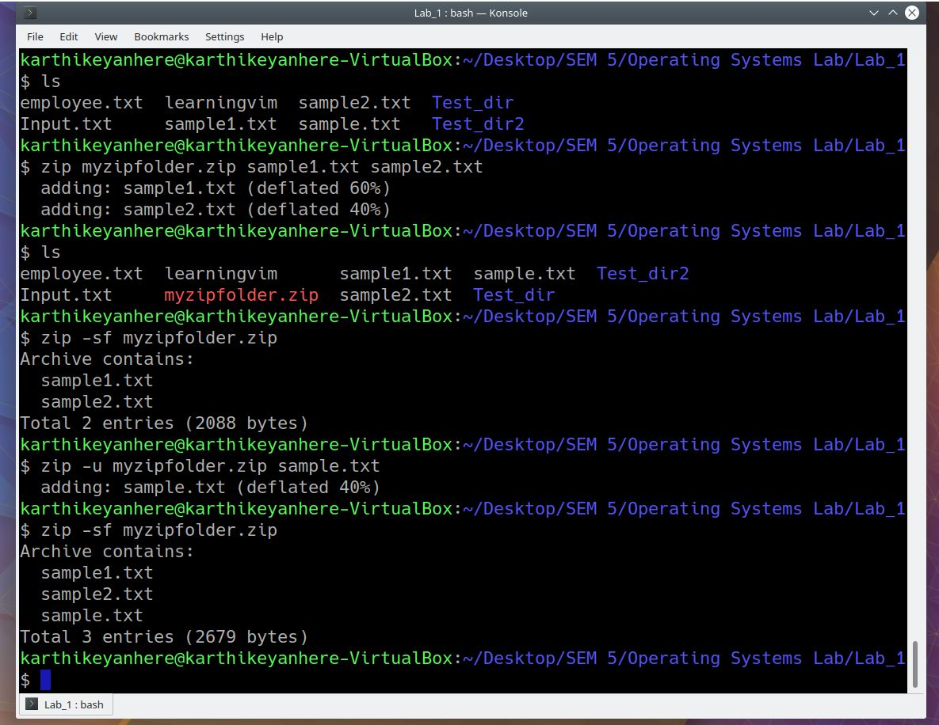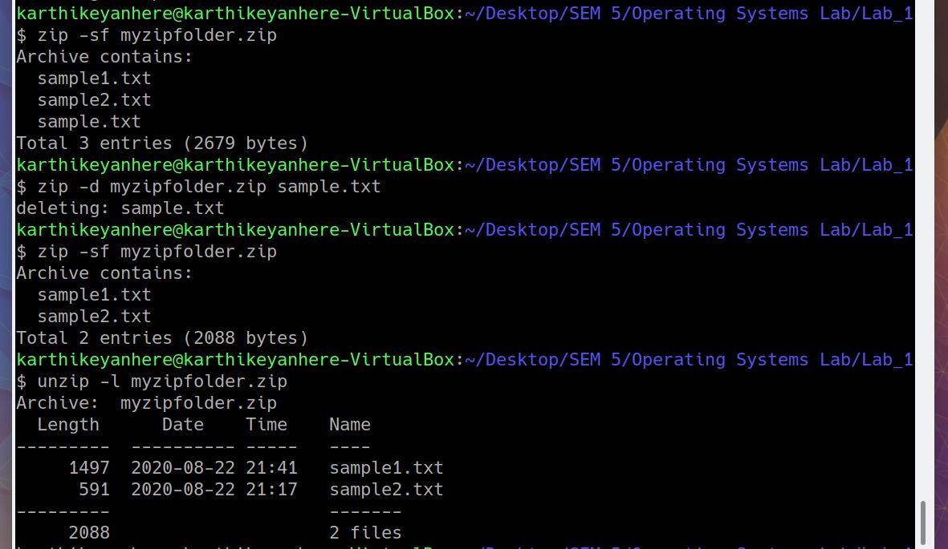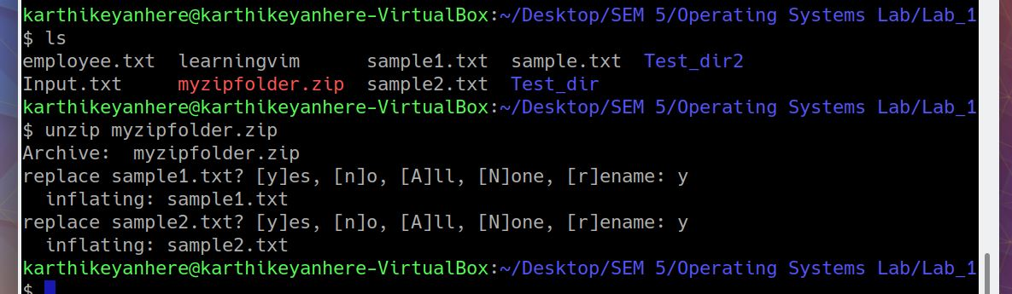

**1.18 SHUTDOWN**

The shutdown command in Linux is used to shutdown the system in a safe way. You can shutdown the machine immediately, or schedule a shutdown using a 24 hour format.It brings the system down in a secure way. When the shutdown is initiated, all logged-in users and processes are notified that the system is going down, and no further logins are allowed.

Only the root user can execute the shutdown command.

*Syntax of shutdown Command*

shutdown [OPTIONS] [TIME] [MESSAGE]

options – Shutdown options such as halt, power-off (the default option) or reboot the system.

time – The time argument specifies when to perform the shutdown process.

message – The message argument specifies a message which will be broadcast to all users.

*How to use shutdown*

sudo shutdown

*Shut down immediately*

sudo shutdown now

*Reboot using shutdown*

shutdown -r

*Canceling a scheduled shutdown*

sudo shutdown -c “cancelling shutdown”

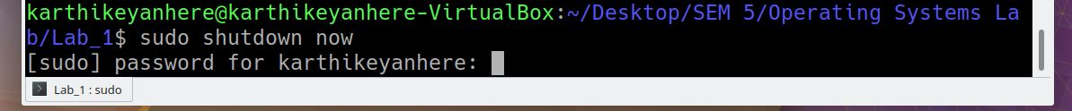

**1.21 SERVICE**

Services are essential background processes that are usually run while booting up and shut down with the OS.

1. Service --status-all : Lists all the active[ + ] and inactive[ - ] services

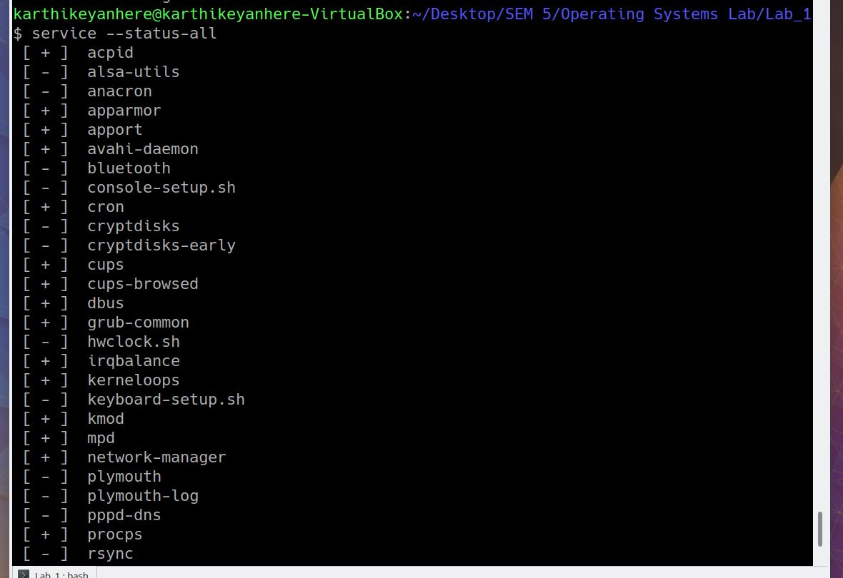

1. service [servicename] start
2. service [servicename] status
3. service [servicename] restart
4. service [servicename] stop

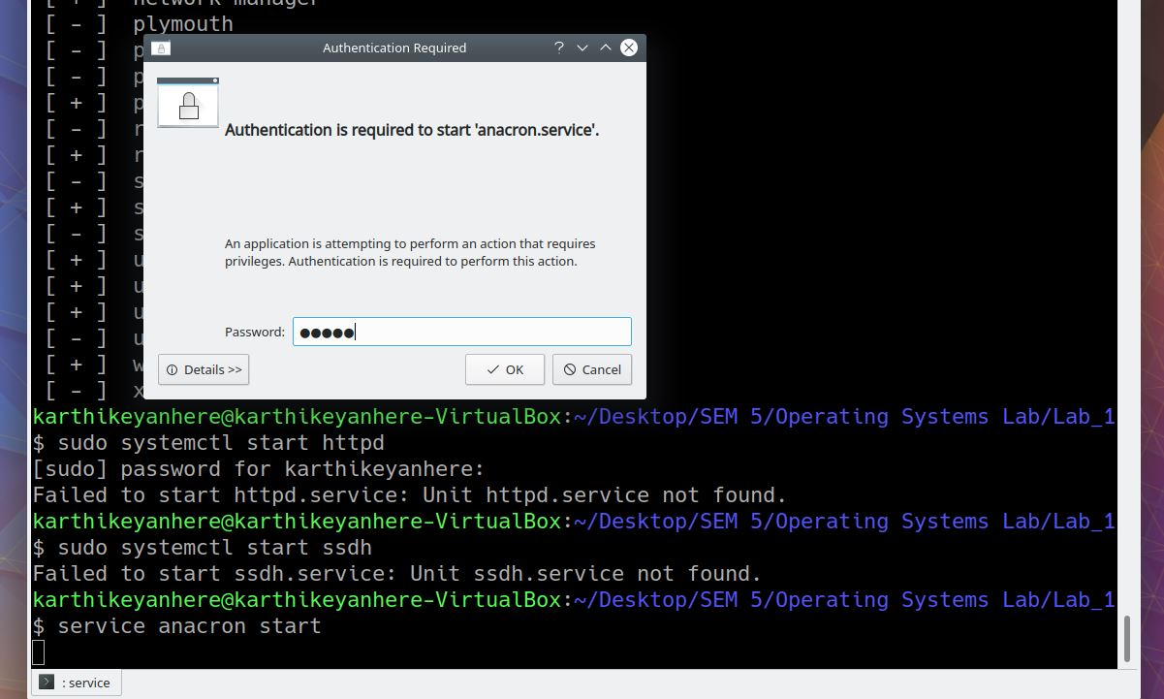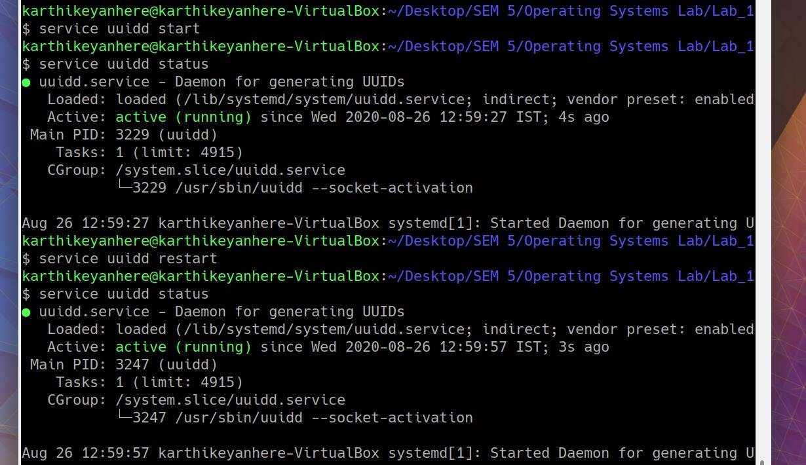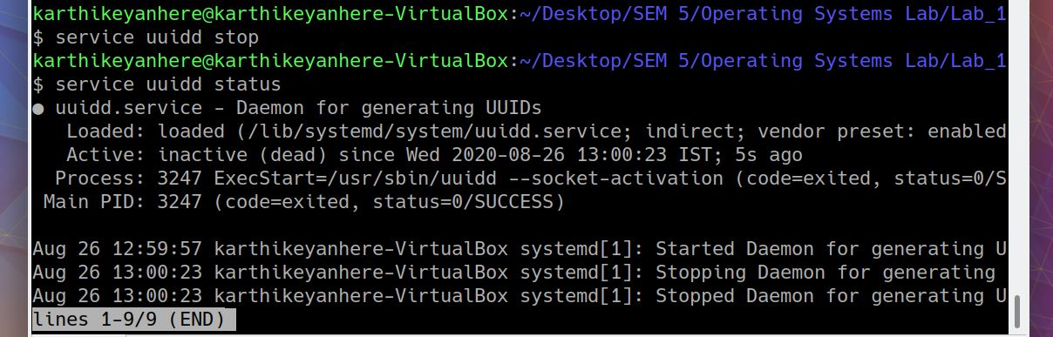

**1.22 PS**

A process is an executing instance of a program and carries out different tasks within the operating system.

Linux provides us a utility called ps for viewing information related to the processes on a system which stands as an abbreviation for “Process Status”. ps command is used to list the currently running processes and their PIDs along with some other information depends on different options.

1. ps -A : lists all the running processes

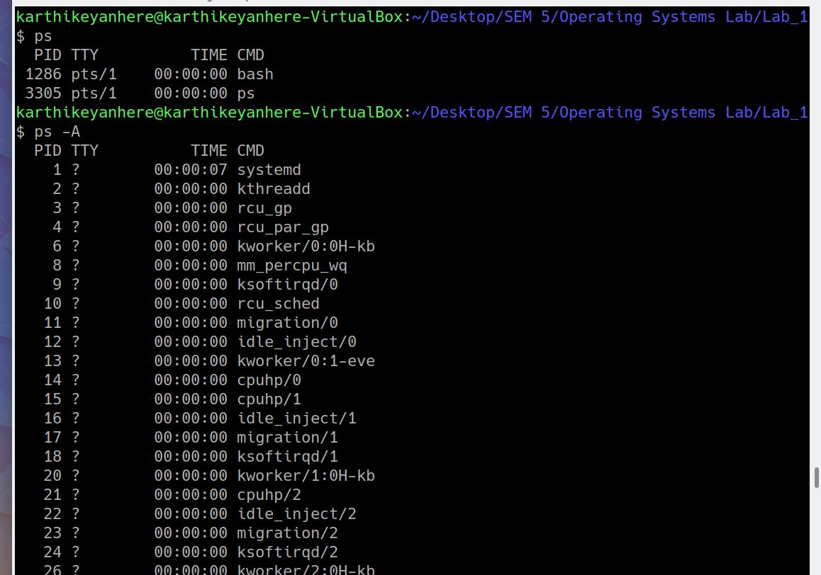

1. ps -T : lists all the processes associated with the terminal
2. ps -x : view all processes owned by you

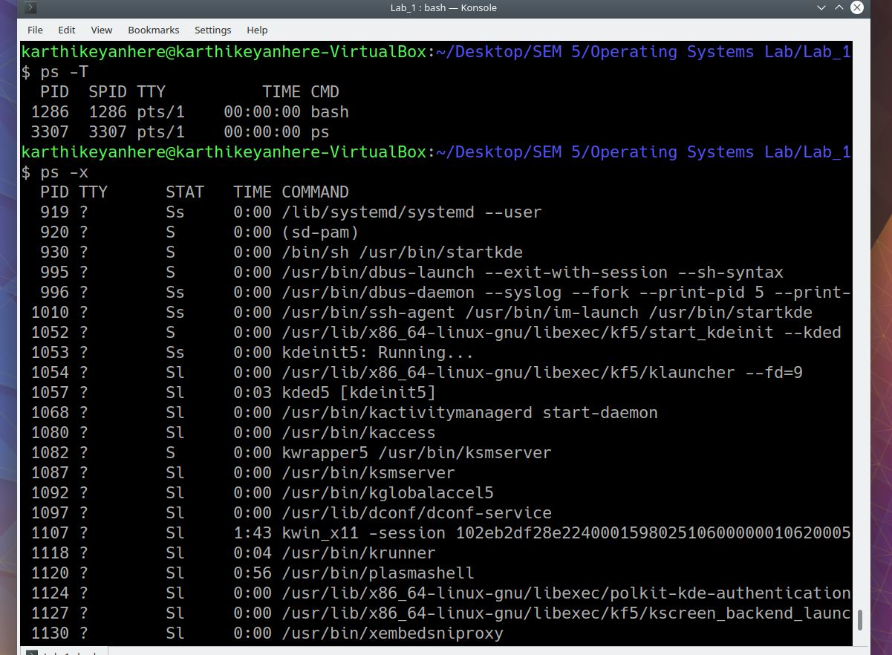

**1.23 FREE**

freecommand displays the total amount of free space available along with the amount of memory used and swap memory in the system, and also the buffers used by the kernel.

1. free -k : displays the result in kilobytes.
2. free -t : displays an additional line containing the total of the total, used and free columns.

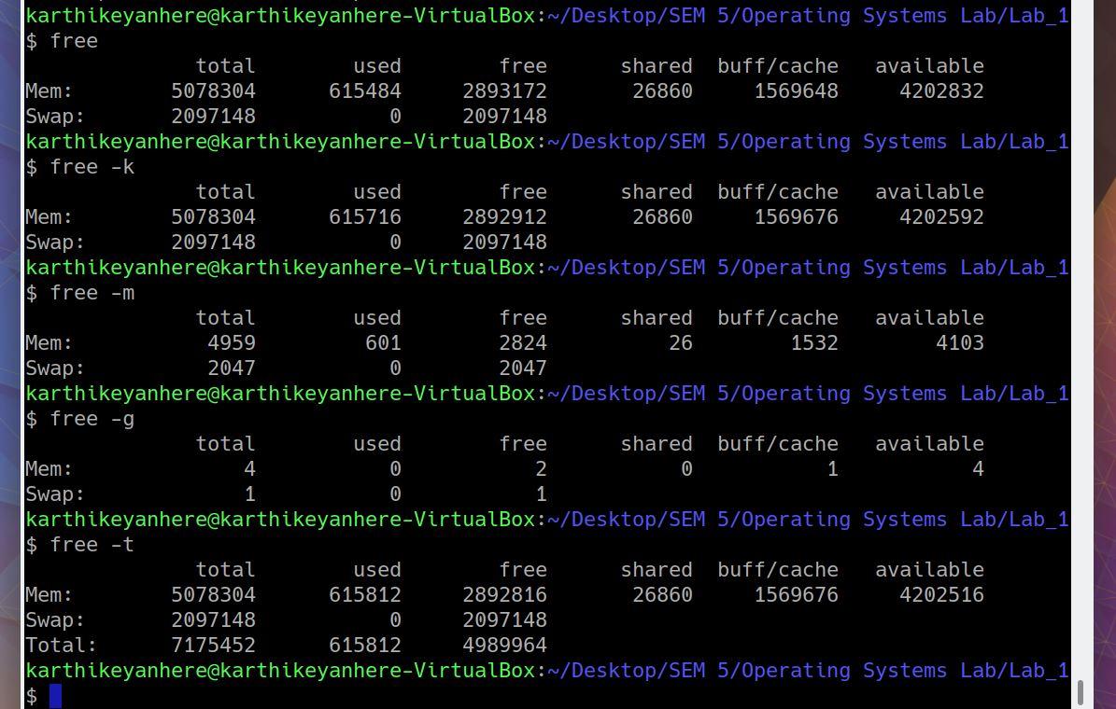

1. free -l : show detailed high and low memory statistics
2. free -s 3 -c 3 : allows you to display the output of free command after a set time gap given by the user, also requires a numeric value to be passed with it that is treated as the number of seconds after which the output will be displayed.

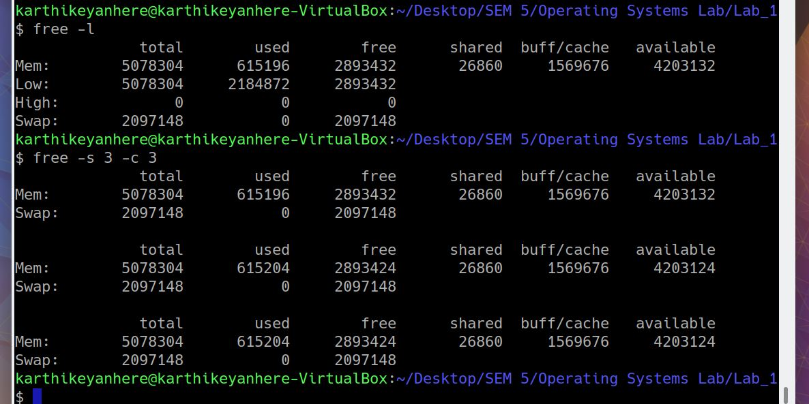

**1.24 TOP**

top command is used to show the Linux processes. It provides a dynamic real-time view of the running system. Usually, this command shows the summary information of the system and the list of processes or threads which are currently managed by the Linux Kernel.

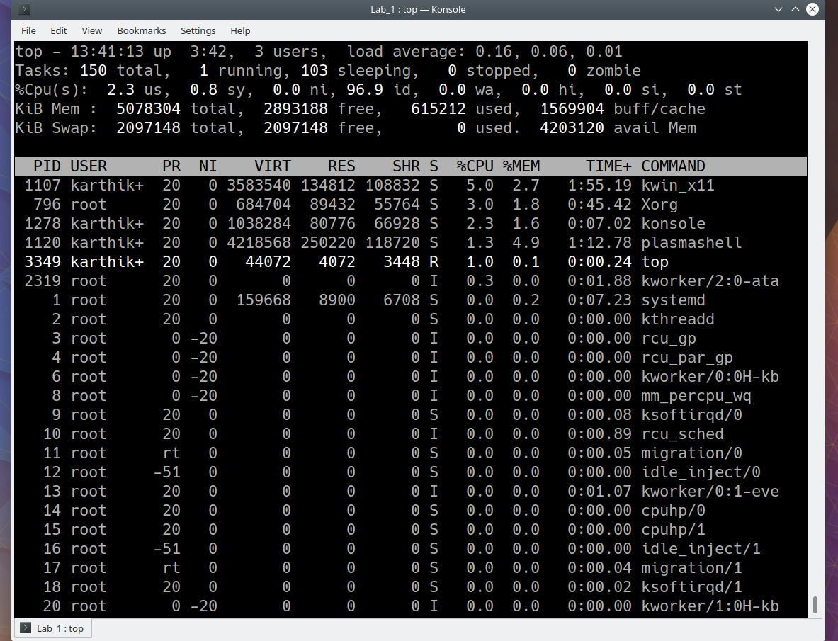

1. top -u [username] : display specific user process

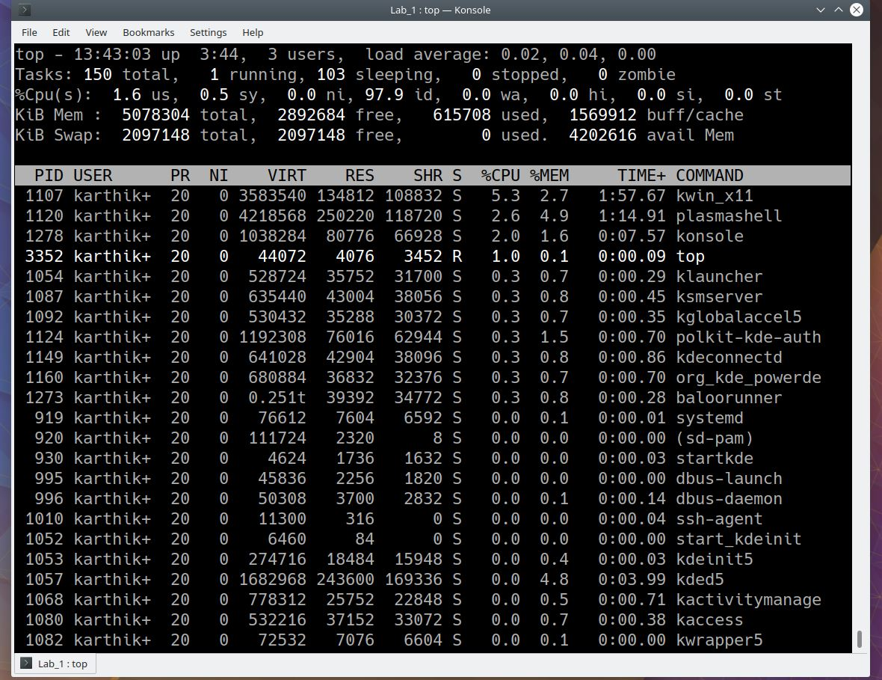

1. top -c : show absolute path of processes

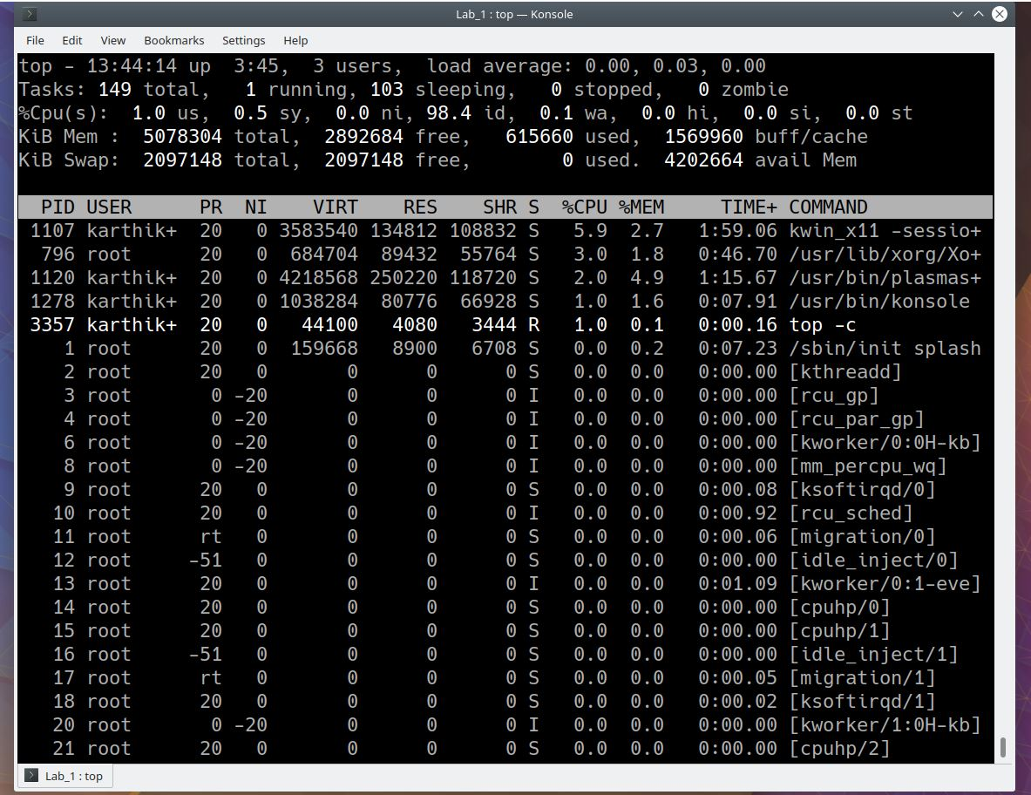

**1.25 DF**

The df command (short for disk free), is used to display information related to file systems about total space and available space.

1. df -a : display all the file system

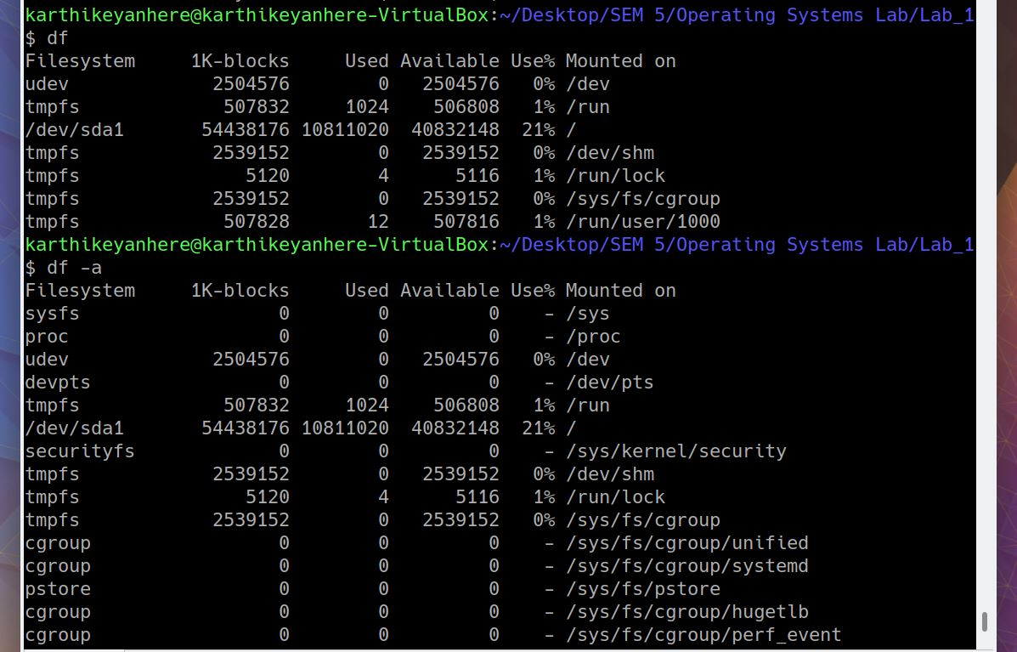

1. df -h /home/user : display size in power of 1024
2. df -H /home/user : display size in power of 1000
3. df --total : to get complete grand total
4. df -T /home/user : to display filetype

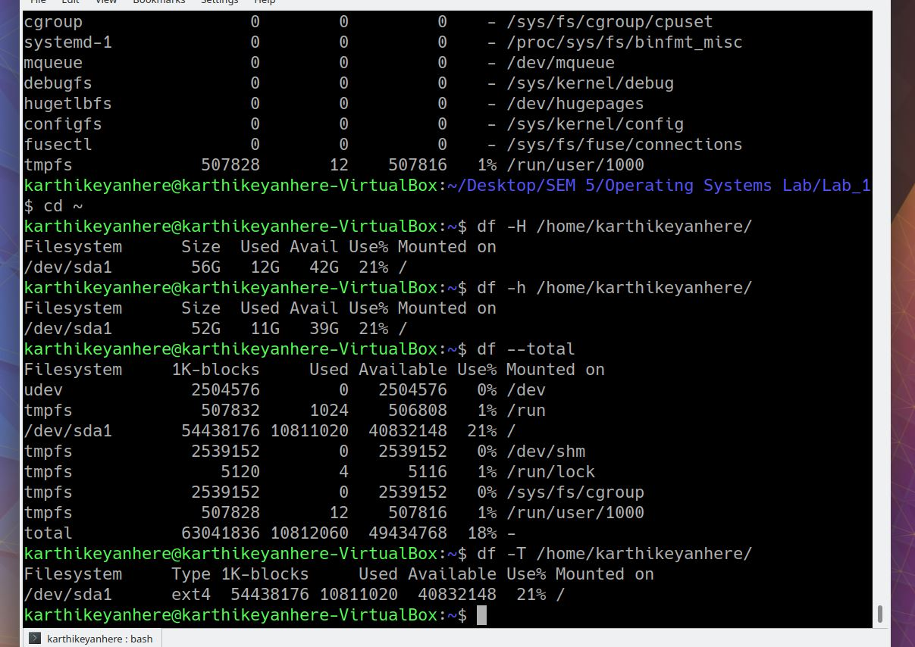

**1.26 KILL**

kill command in Linux (located in /bin/kill), is a built-in command which is used to terminate processes manually. kill command sends a signal to a process which terminates the process.

1. kill -l : to display all the available signals
2. kill [pid] : using pid to kill process

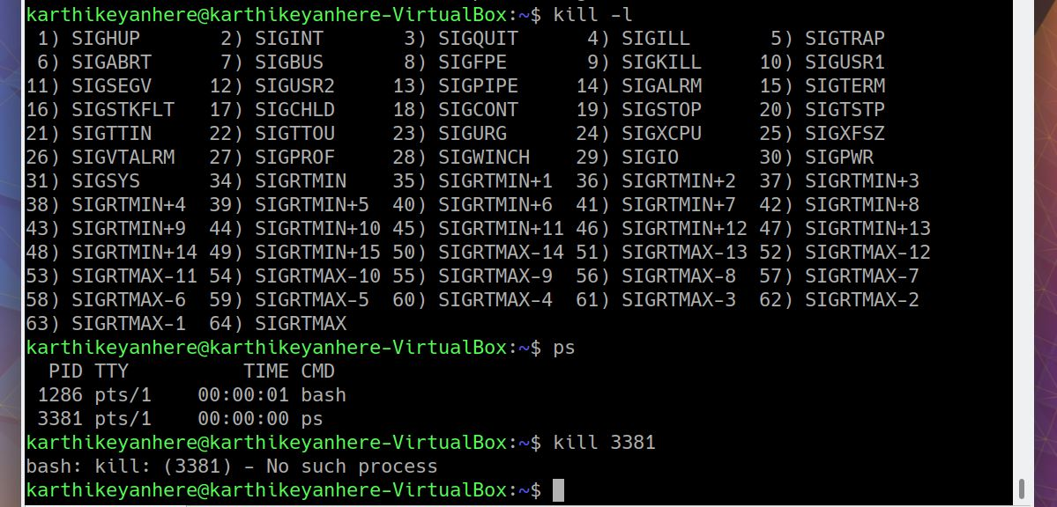

**1.27 RM**

rm stands for remove here. rm command is used to remove objects such as files, directories, symbolic links and so on from the file system like UNIX.

rm [filename]

1. rm -i [filename] : interactive remove
2. rm -r [directory] : recursively removing a directory

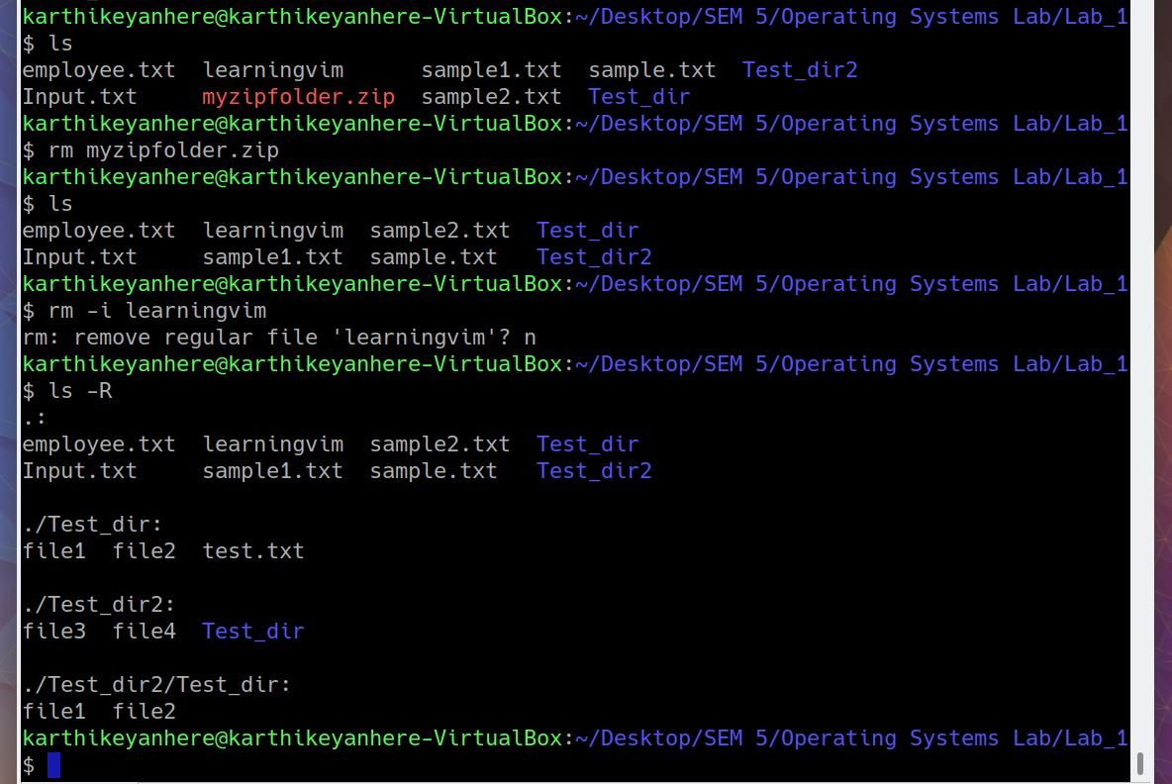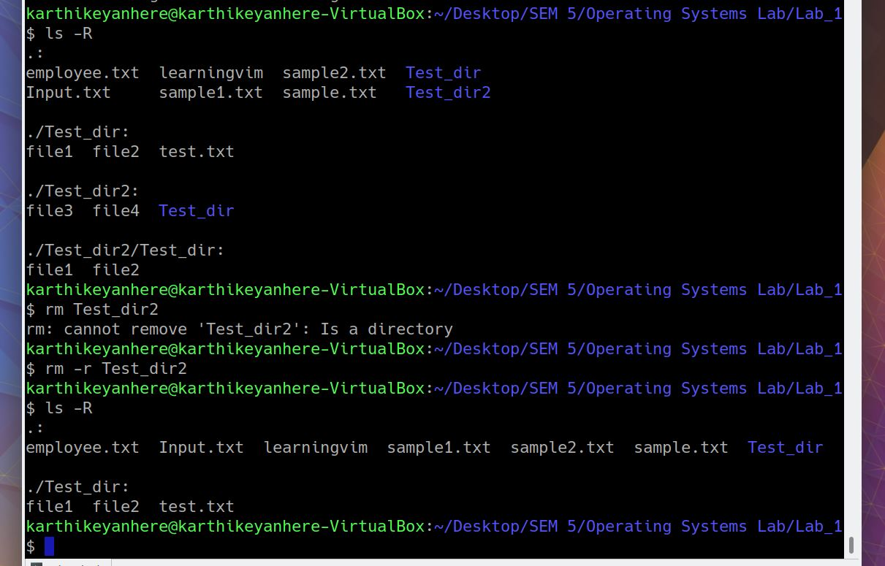

**1.28 CP**

cp stands for copy. This command is used to copy files or groups of files or directory. It creates an exact image of a file on a disk with a different file name. *cp* command requires at least two filenames in its arguments.

1. cp [srcfile] [destfile]

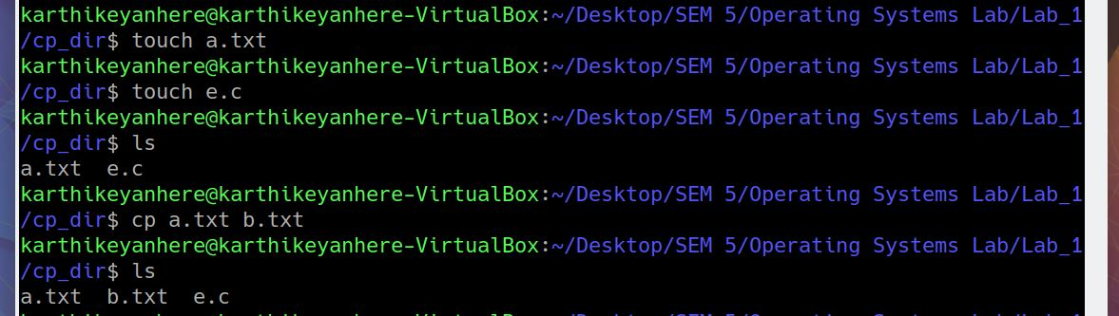

1. cp {filelist} [destfolder]

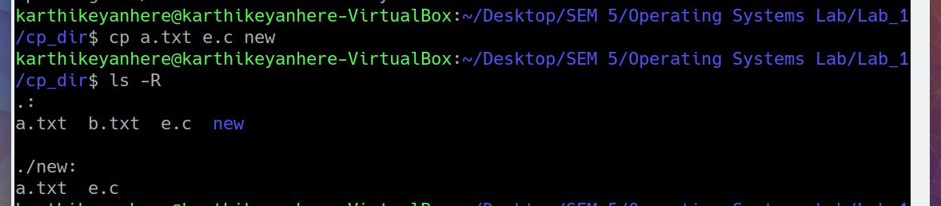

1. cp -r [srcfolder] [destfolder] : recursively copying a directory
2. cp *.txt [destfolder] : creating a directory containing one type of files

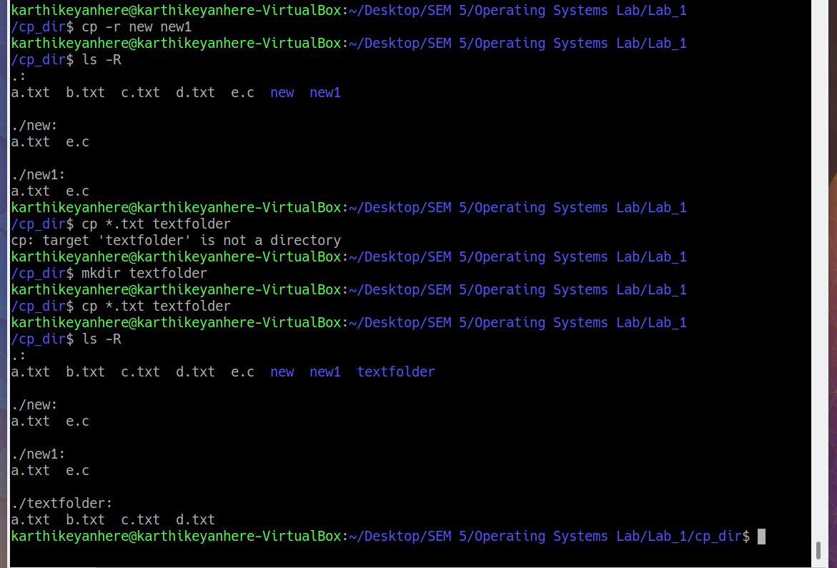

1. cp -p [srcfile] [destfile] : destfile preserves the characteristics of srcfile

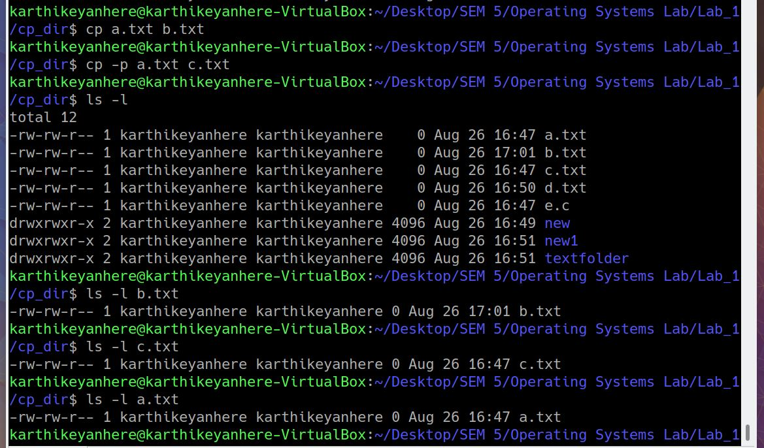

**1.29 MV**

mv stands for move. mv is used to move one or more files or directories from one place to another in a file system like UNIX. It has two distinct functions:

(i) It rename a file or folder.

(ii) It moves a group of files to different directories.

No additional space is consumed on a disk during renaming. This command normally works silently means no prompt for confirmation.

1. mv [srcfile] [destfile]
2. mv -i [srcfile] [destfile] : interactive mv
3. mv -b [srcfile] [destfile] : backup of destfile which will be overwritten
4. mv *.txt [destfolder] : moving files of one type into a directory

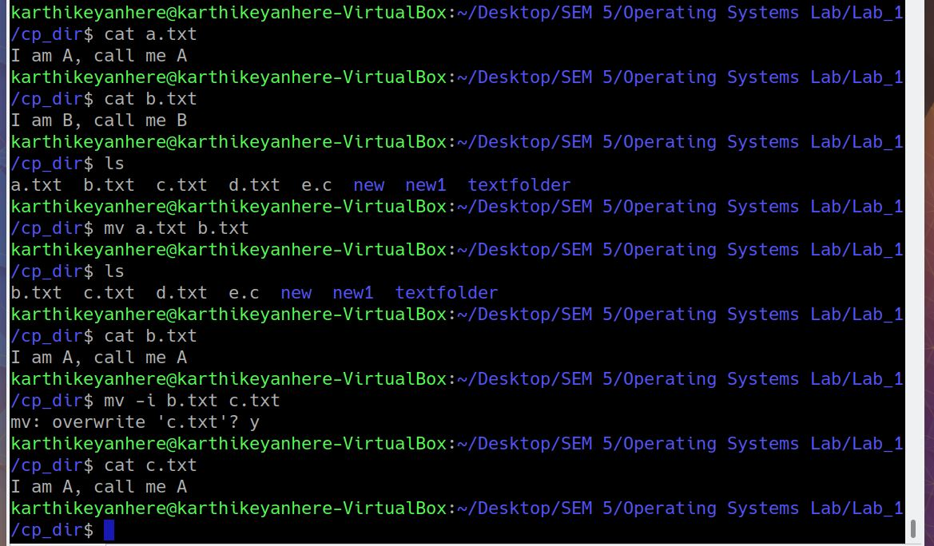

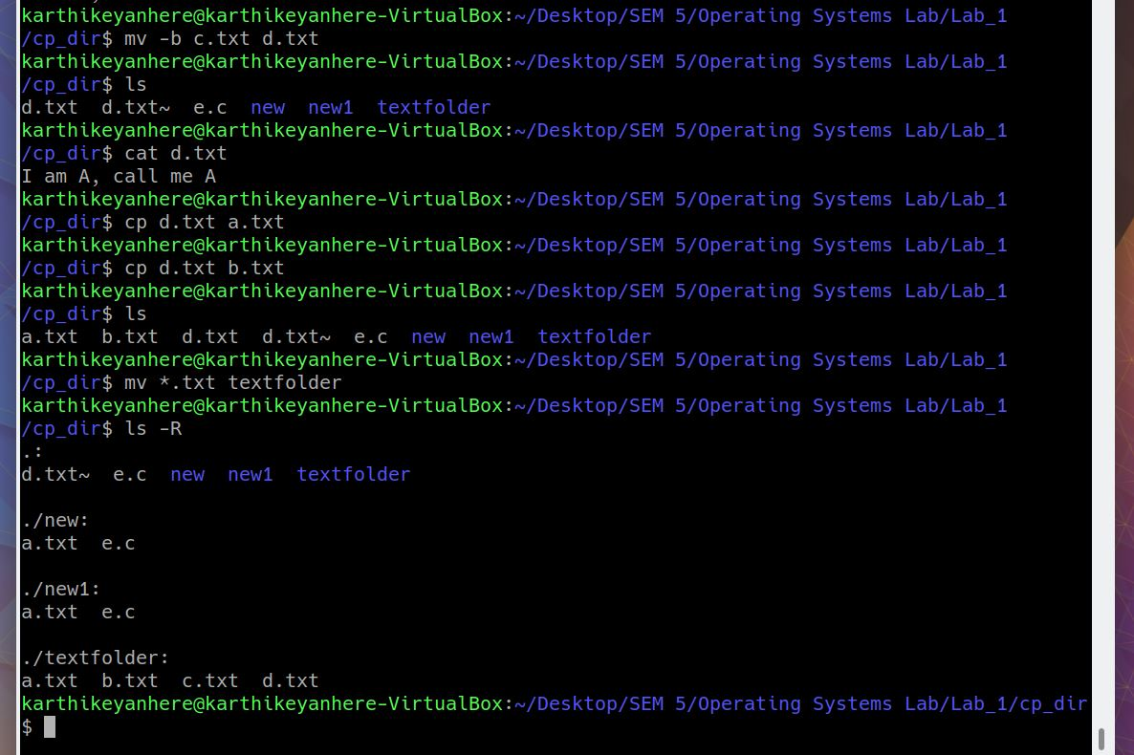

**1.30 CAT**

It reads data from the file and gives their content as output. It helps us to create, view, concatenate files.

1. cat file.txt : displays the file on console
2. cat {filelist} : displays all the files on console
3. cat [srcfile] > [destfile] : replaces the content of destfile with srcfile
4. cat [srcfile] >> [destfile] : appends the content of destfile with srcfile
5. tac file.txt : displays the file in reverse order
6. cat *.txt : displays all the txt files on console
7. cat {filelist} > [destfile] : merges the files into a single file

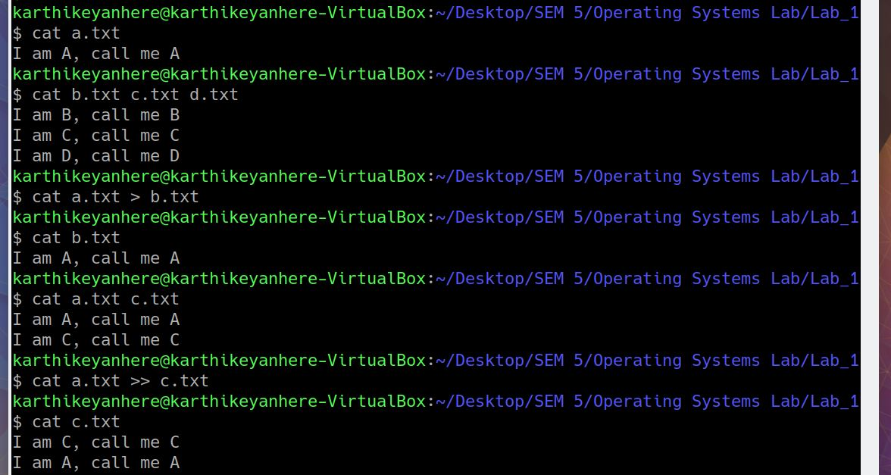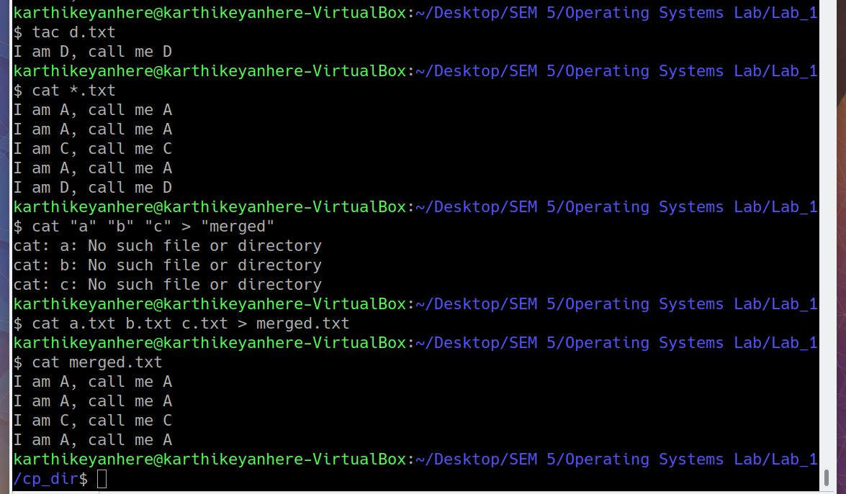

**1.31 MOUNT**

mount command is used to mount the filesystem found on a device to a big tree structure(Linux filesystem) rooted at ‘/‘. Conversely, another command umount can be used to detach these devices from the Tree.

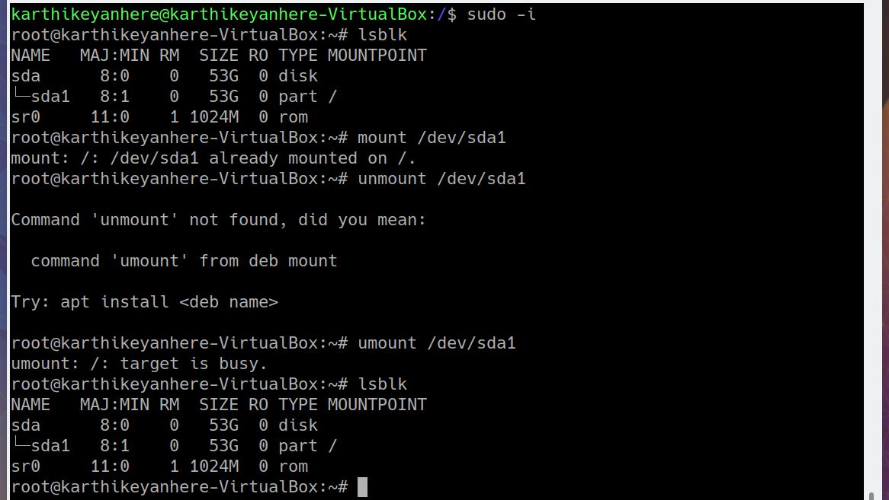

**1.32 CHMOD**

chmod command is used to change the access mode of a file.

r Permission to read the file.

w Permission to write (or delete) the file.

x Permission to execute the file, or, in

the case of a directory, search it.

Reference Class Description

u owner file's owner

g group users who are members of

the file's group

o others users who are neither the

file's owner nor members of

the file's group

a all All three of the above

chmod u=rw [filename] : change the user permission to read write

chmod 467 [filename] : change the user=r, group=rw, other= rwx

**[REFER q6 and q11] for example**

**1.33 CHOWN**

Different users in the operating system have ownership and permission to ensure that the files are secure and put restrictions on who can modify the contents of the files.

chown [owner_name] [file_name]

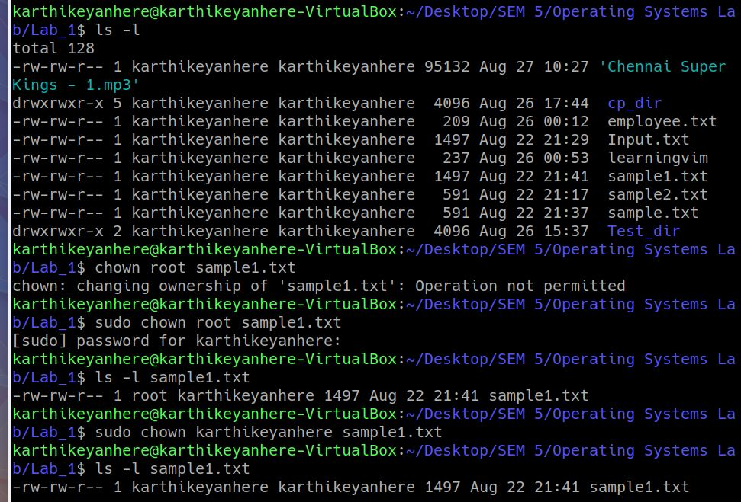

**1.34 PASSWD**

*passwd* command in Linux is used to change the user account passwords. The root user reserves the privilege to change the password for any user on the system, while a normal user can only change the account password for his or her own account.

1. -d : delete the password of the user, making user passwordless
2. -S : status of the user password

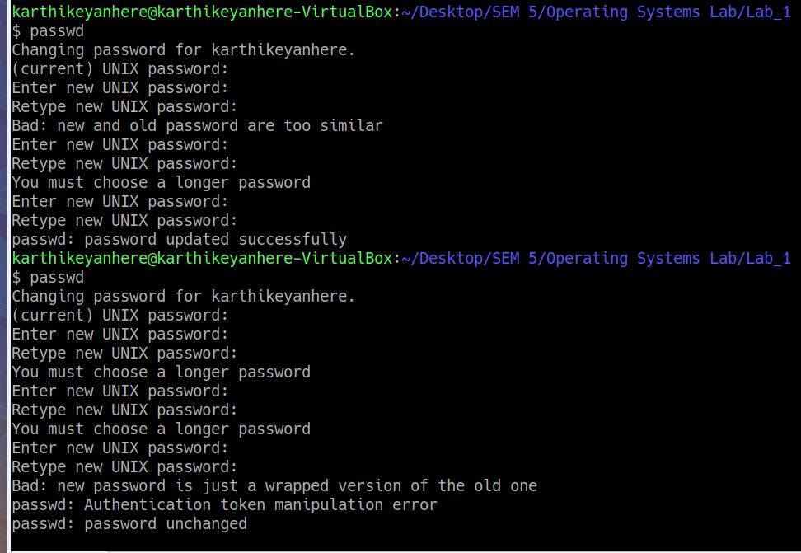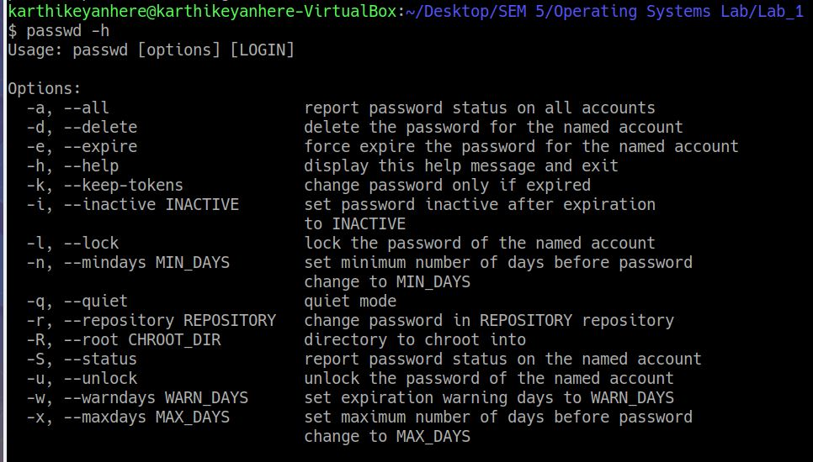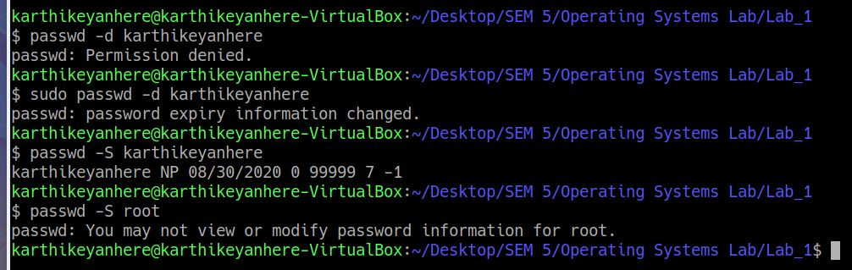

**1.35 MKDIR**

mkdir command in Linux allows the user to create directories (also referred to as folders in some operating systems ). This command can create multiple directories at once as well as set the permissions for the directories. It is important to note that the user executing this command must have enough permissions to create a directory in the parent directory, or he/she may receive a ‘permission denied’ error.

1. mkdir {folder_name(s)} : creates a list of directories.
2. mkdir -m [permissions] dir_name : giving permissions at the time of creation

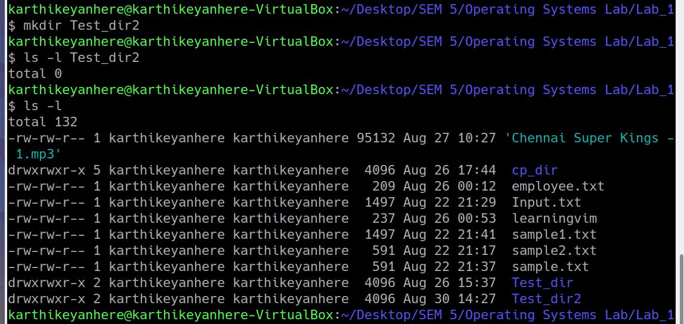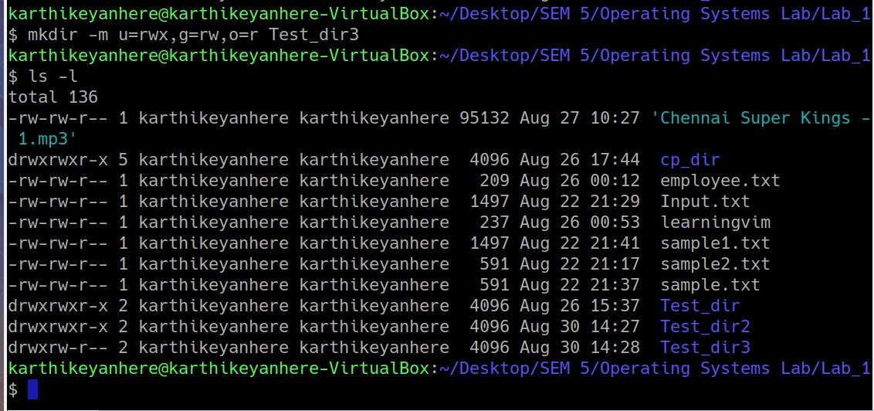

**1.36 IFCONFIG**

ifconfig(interface configuration) command is used to configure the kernel-resident network interfaces. It is used at the boot time to set up the interfaces as necessary.

1. ifconfig -a : displays all the interfaces even if they are down
2. ifconfig -s : hides the details

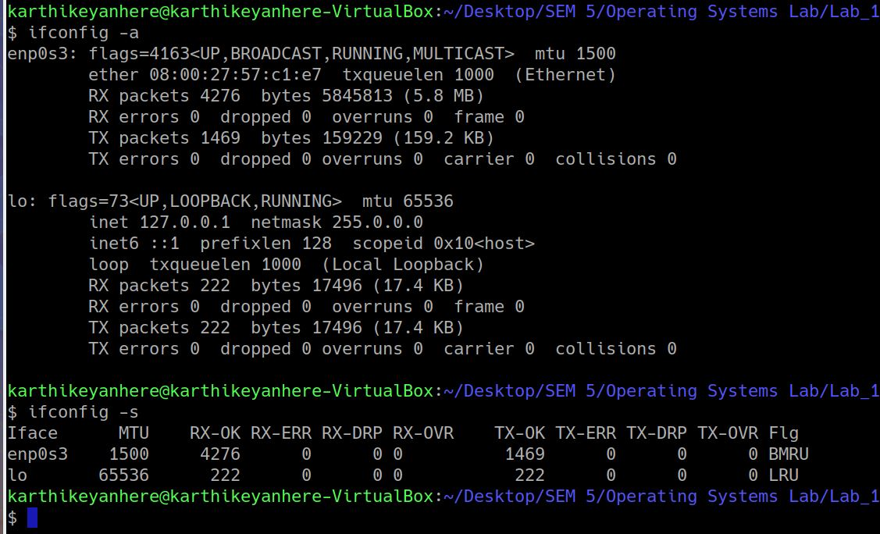

**1.37 UNAME**

The command ‘*uname*‘ displays the information about the system.

1. uname -a : prints all the system information in the following order: *Kernel name*, *network node hostname*, *kernel release date*, *kernel version*, *machine hardware name*, *hardware platform*, *operating system*
2. uname -s : prints kernel name
3. uname -n : hostname of the network node (current computer)
4. uname -p : type of processor
5. uname -o : name of the operating system
6. uname -v : version of the current kernel

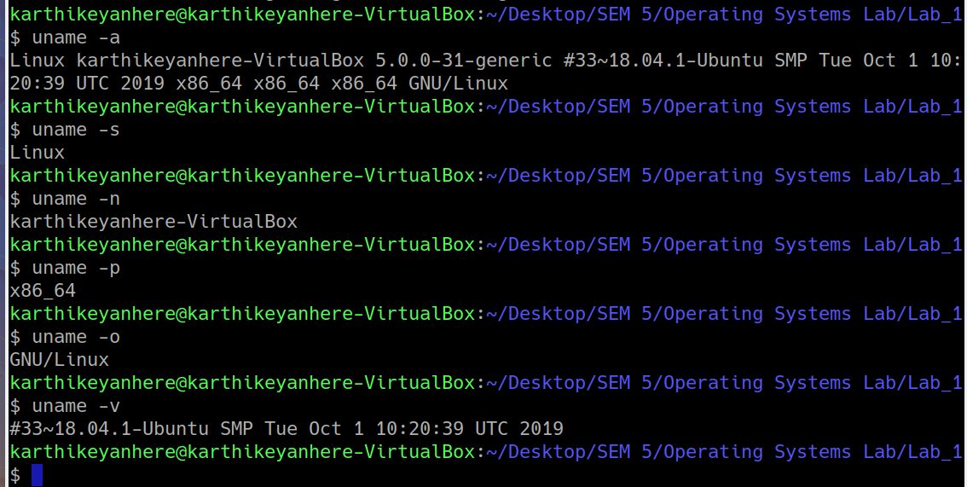

**1.38 WHEREIS**

*whereis* command is used to find the location of source/binary file of a command and manuals sections for a specified file in Linux system.

1. whereis [command_name] : find the location of the command
2. whereis -b [command_name] : search for binaries
3. whereis -m [command_name] : search for manuals

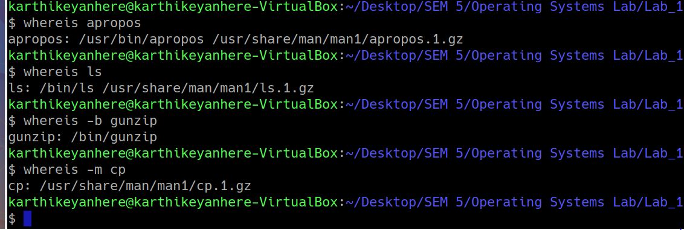

**1.39 WHATIS**

whatis command in Linux is used to get a one-line manual page description. In Linux, each manual page has some sort of description within it. So this command searches for the manual page names and shows the manual page description of the specified filename or argument.

whatis [command_name]

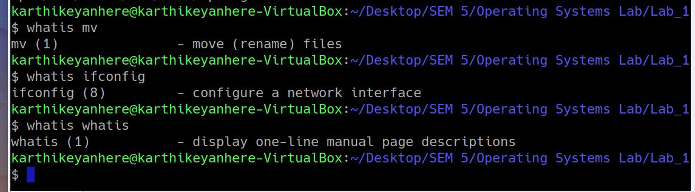

**1.40 LOCATE**

locate command can quickly search for the location of a specific file (or group of files). Locate command uses the database created by updatedb.

1. locate [file_name] : locate all the files having [filename]
2. locate -c [.c]* : : count all the files with [.c]

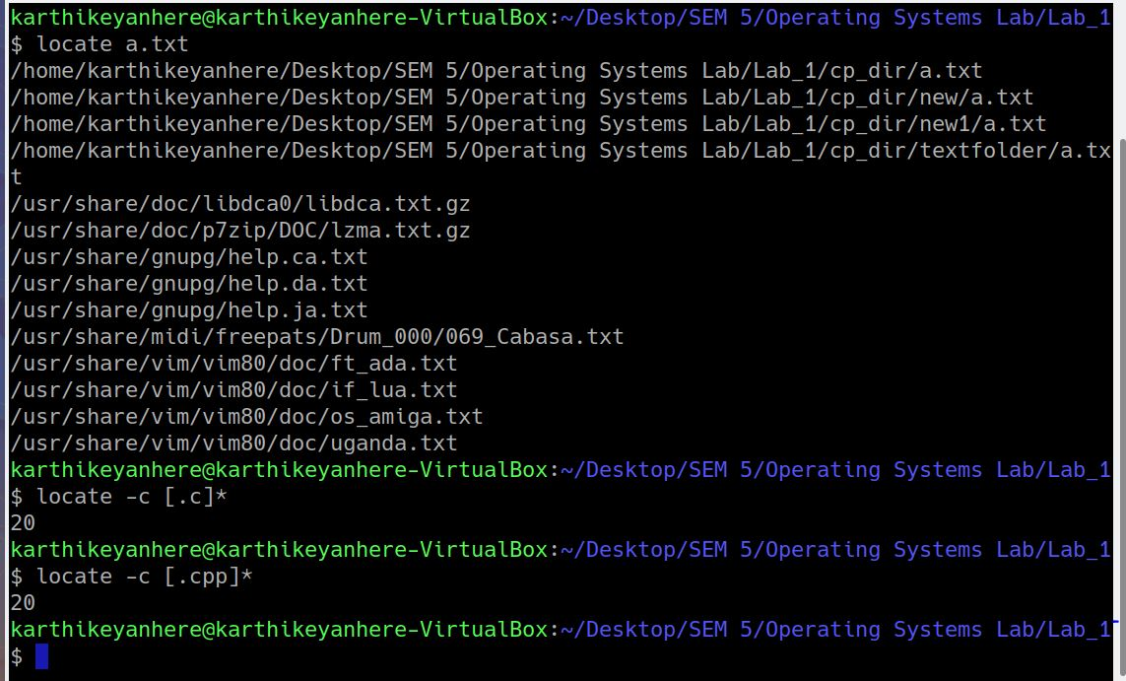

**1.41 MAN**

man <keyword> : It displays the one or several manual pages for <keyword>

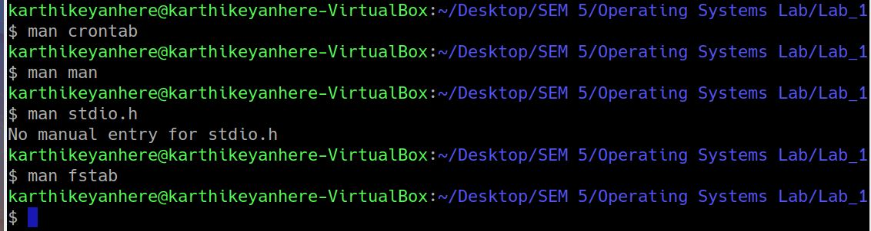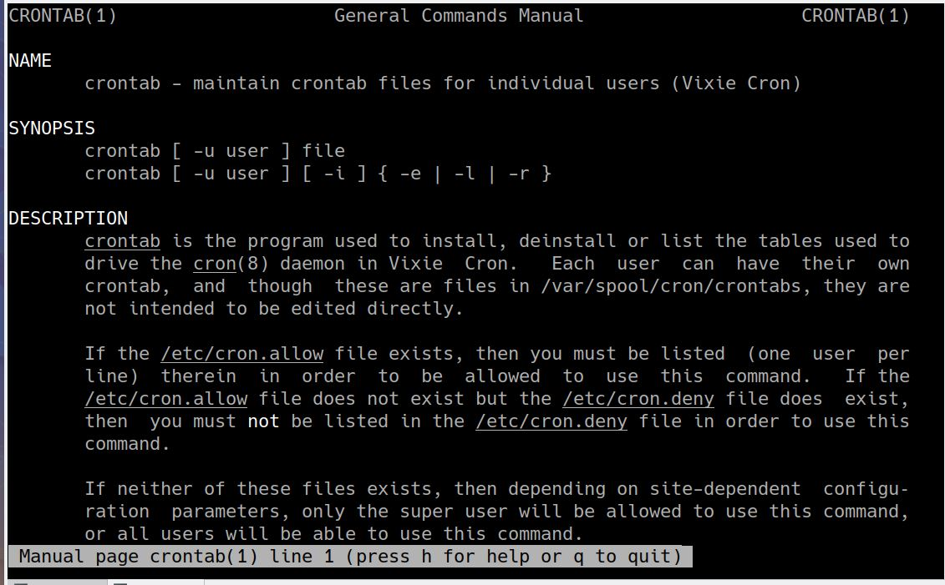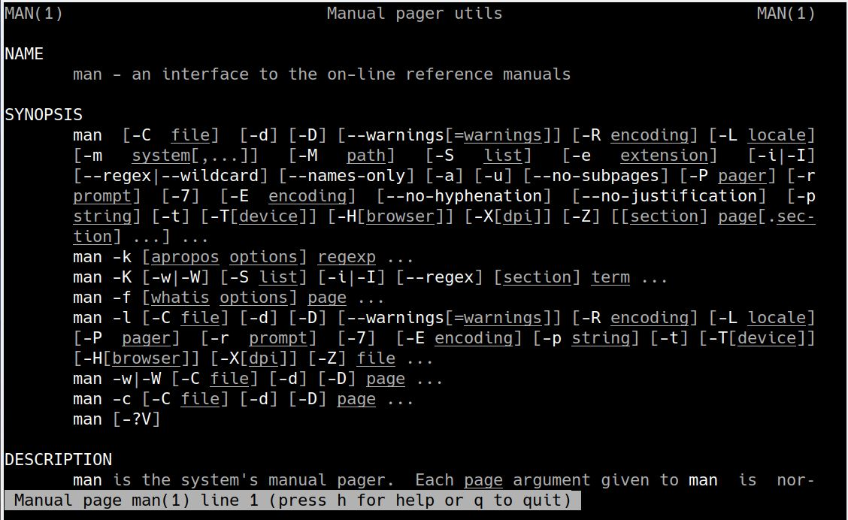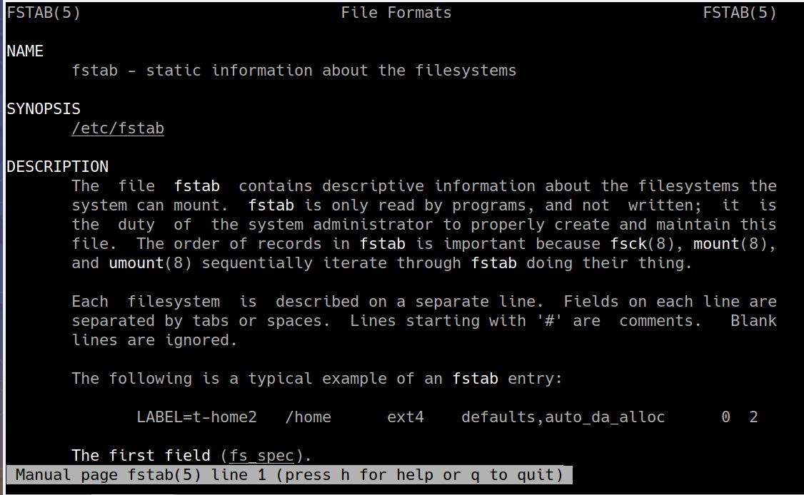

**1.42 TAIL**

It prints the last N number of data of the given input. By default it prints the last 10 lines of the specified files. If more than one file name is provided then data from each file is preceded by its file name.

tail [-N] <file> : lists the last N lines of the file (by default it is 10). beneficial for huge files!!

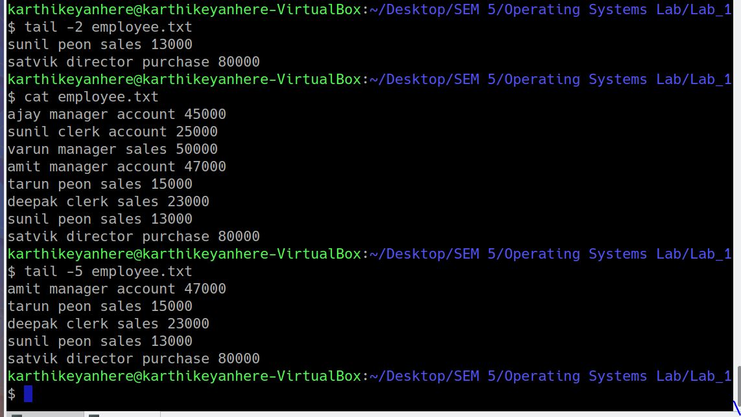

**1.43 LESS**

Less command is linux utility which can be used to read contents of a text file one page(one screen) per time. It has faster access because if the file is large, it doesn't access the complete file, but access it page by page.

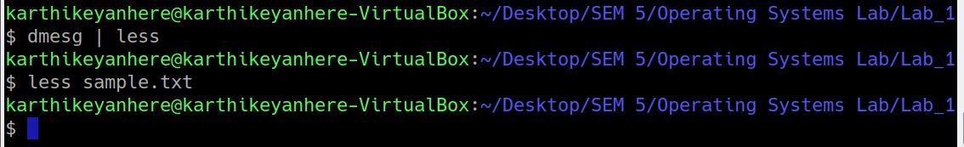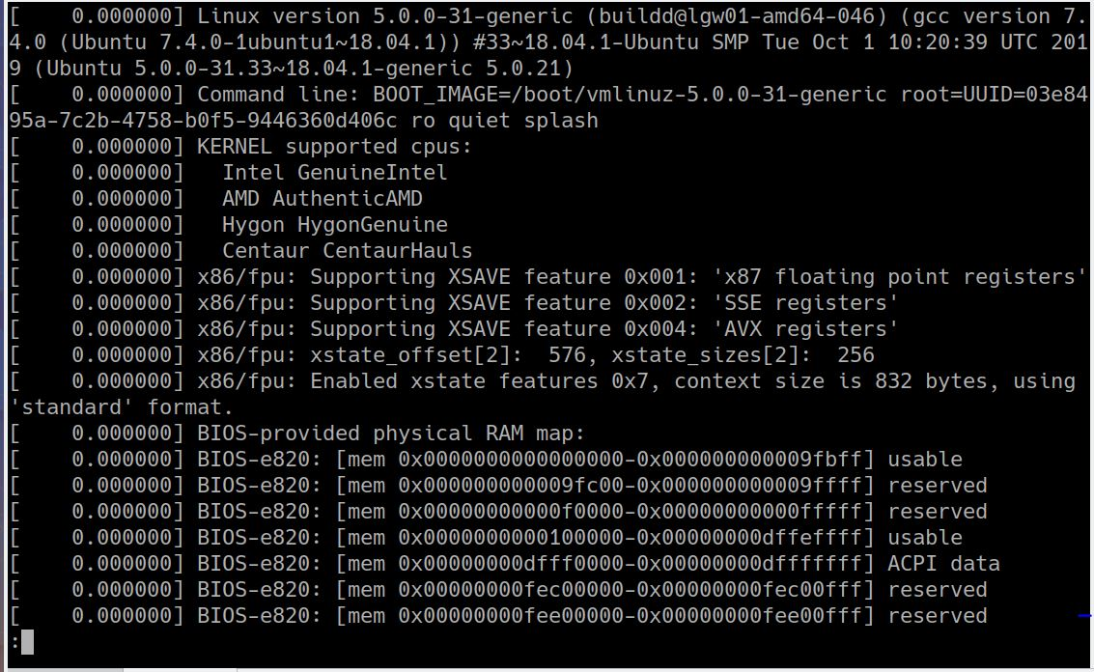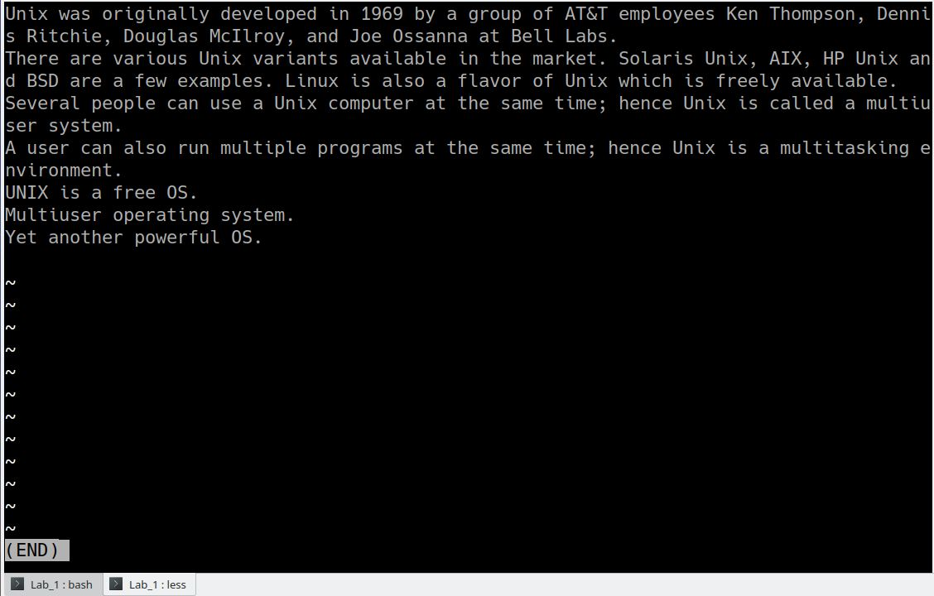

**1.48 PING**

PING (Packet Internet Groper) command is used to check the network connectivity between host and server/host. This command takes as input the IP address or the URL and sends a data packet to the specified address with the message “PING” and gets a response from the server/host this time is recorded which is called latency. Fast ping low latency means faster connection.

1. ping googl.com : will send packets continuously (ctrl C needed to terminate)
2. ping -c 3 iiitdm.ac.in : sending 3 packets
3. ping - s 50 -c 4 iiitdm.ac.in : sending 4 packets of size 50 bytes

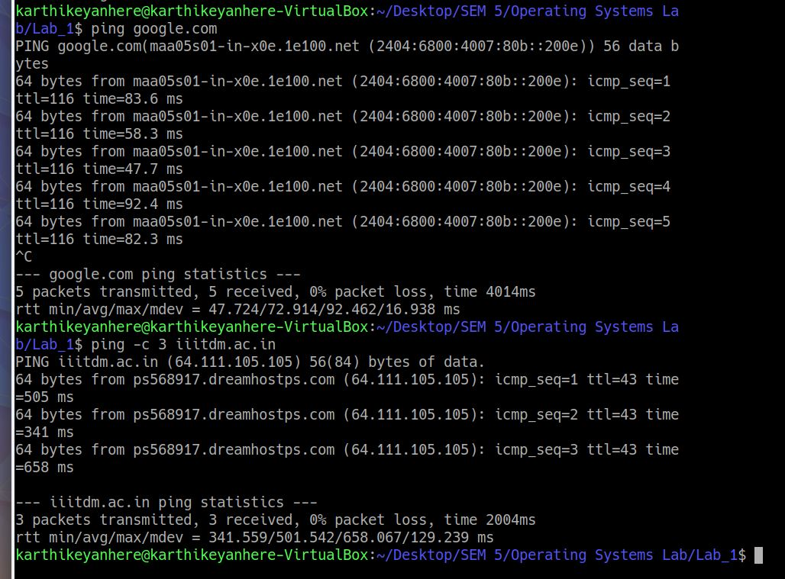

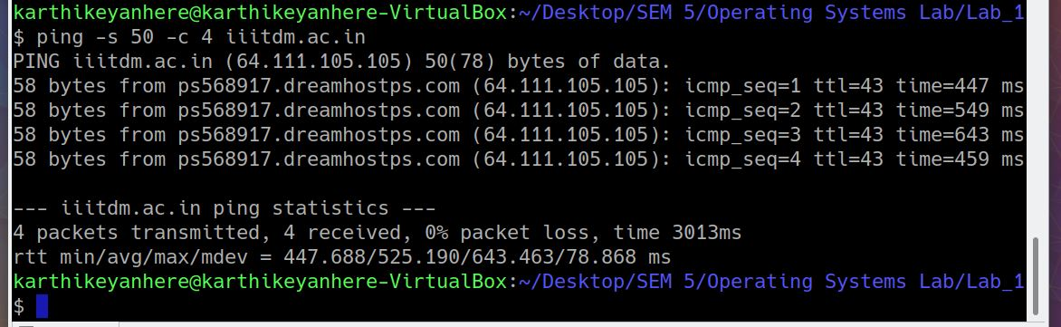

**1.49 DATE**

date command is used to display the system date and time. date command is also used to set the date and time of the system. By default the date command displays the date in the time zone on which the unix/linux operating system is configured.You must be the super-user (root) to change the date and time.

1. date : displays the date
2. date --date=”2 year ago” : displays the 2 year back date
3. date --date=”next fri” : displays the next friday date
4. date -r sample1.txt : displays the last modified date of sample1.txt
5. date “+%Y-%m-%d” : formatting the date

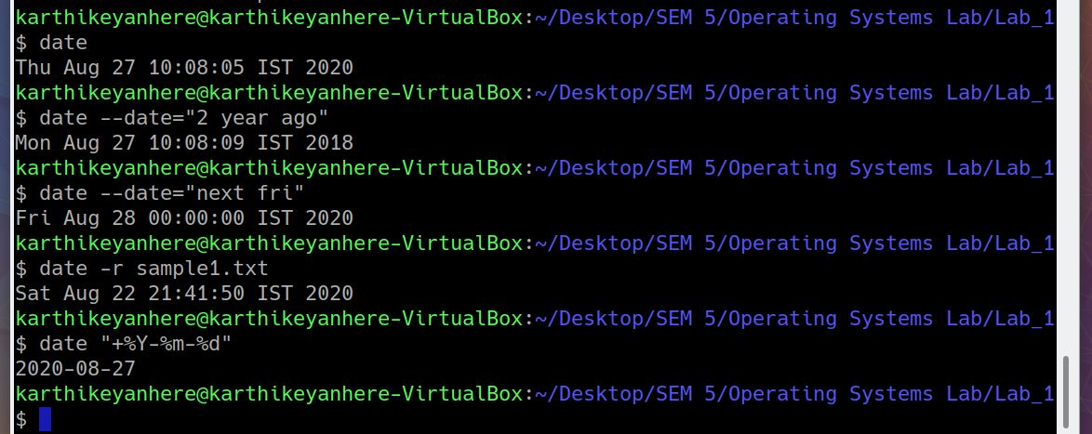

**1.50 WGET**

Wget is the non-interactive network downloader which is used to download files from the server even when the user has not logged on to the system and it can work in the background without hindering the current process.

1. wget -b [URL] - download in background
2. wget -c [URL] - resume a partially downloaded file
3. wget -t 3 [URL] : to try 3 number of times

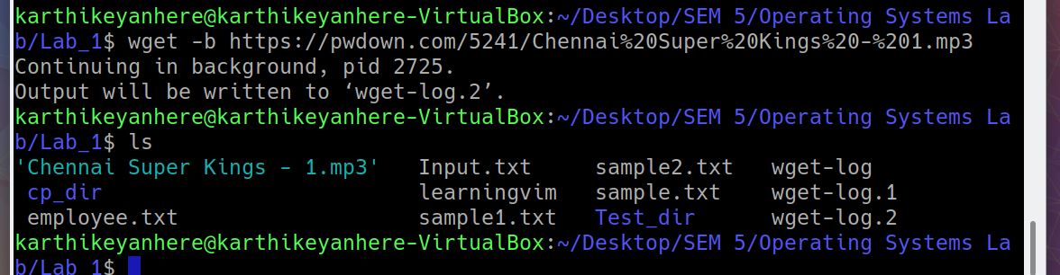

**1.51 LN**

To create a link to another file/directory

Ex To create a shortcut

1. ln -s ./ OS_shortcut : (soft link) creating a shortcut of pwd
2. rm OS_shortcut : removing a shortcut (doesn’t remove the actual file)

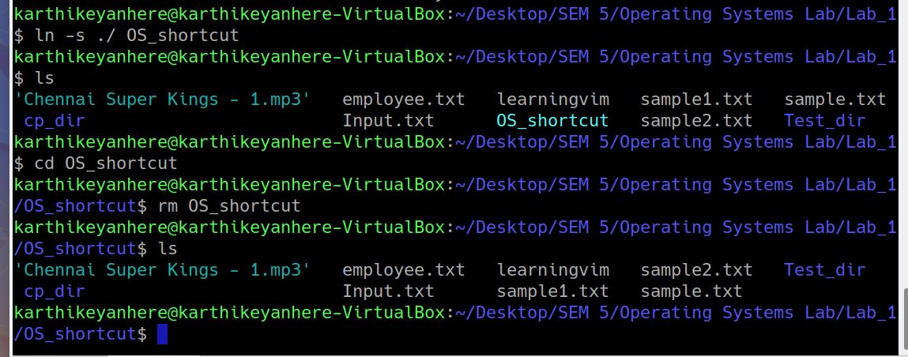

**2. Create a directory and create a file inside that directory.**

**mkdir [dir_name] : create a directory in the present working directory**

**touch [file_name] : create a file in the present working directory**

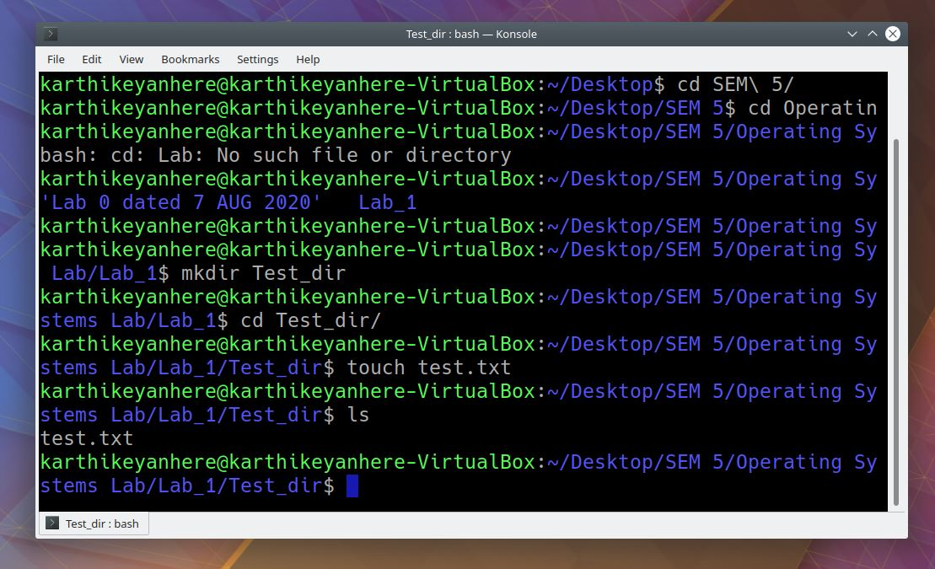

**3. List the files and directories that are empty in a working directory.**

**find -type f -empty : list the files that are empty in a working directory.**

**find -type d -empty : list the directories that are empty in a working directory.**

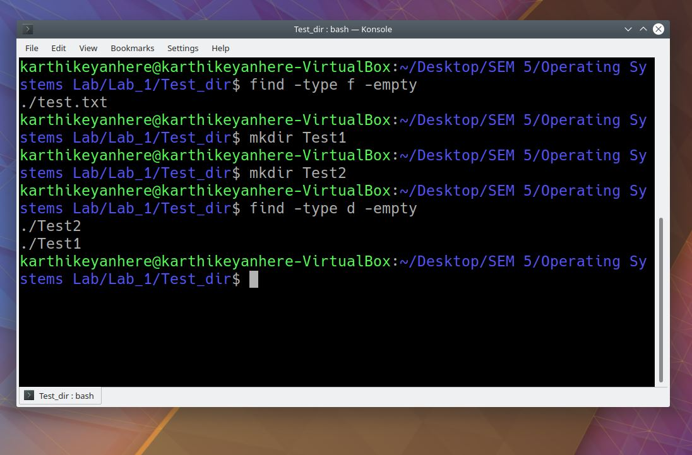

**4. Show commands to delete empty and non-empty directory.**

**rm -r [dir_name] : deletes empty as well as non-empty directory**

**rmdir [dir_name] : deletes only when the directory is empty**

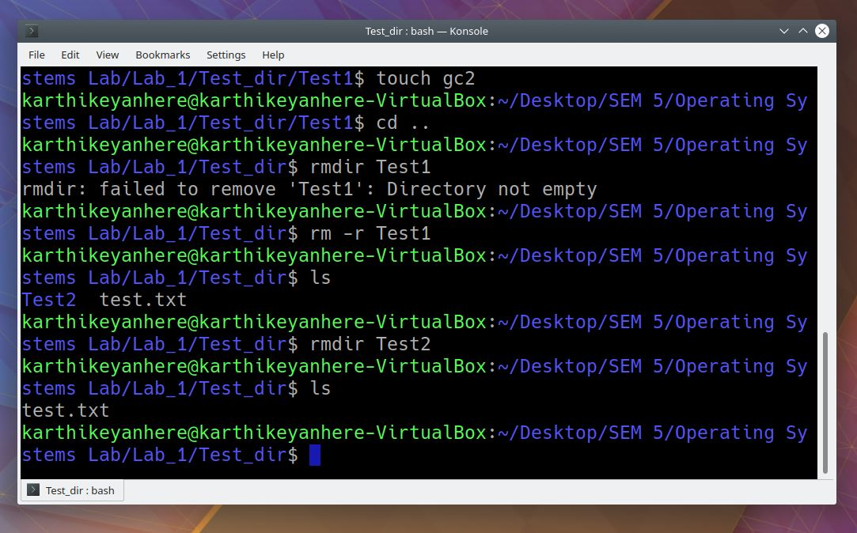

**5. Find the location of the input files using locate and find command.**

**find / -name test.txt**

**locate test.txt**

**find searches in the real system. Is slower but always up-to-date and has more options (size, modification time,...)**

**locate uses a previously built database (command updatedb). Is much faster, but uses an 'older' database and searches only names or parts of them.**

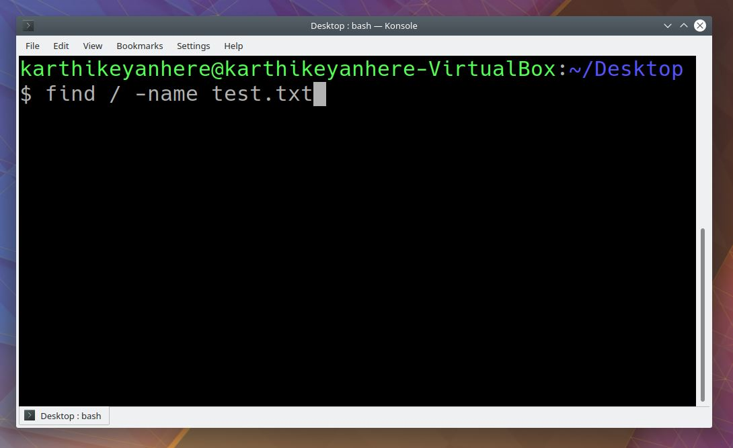

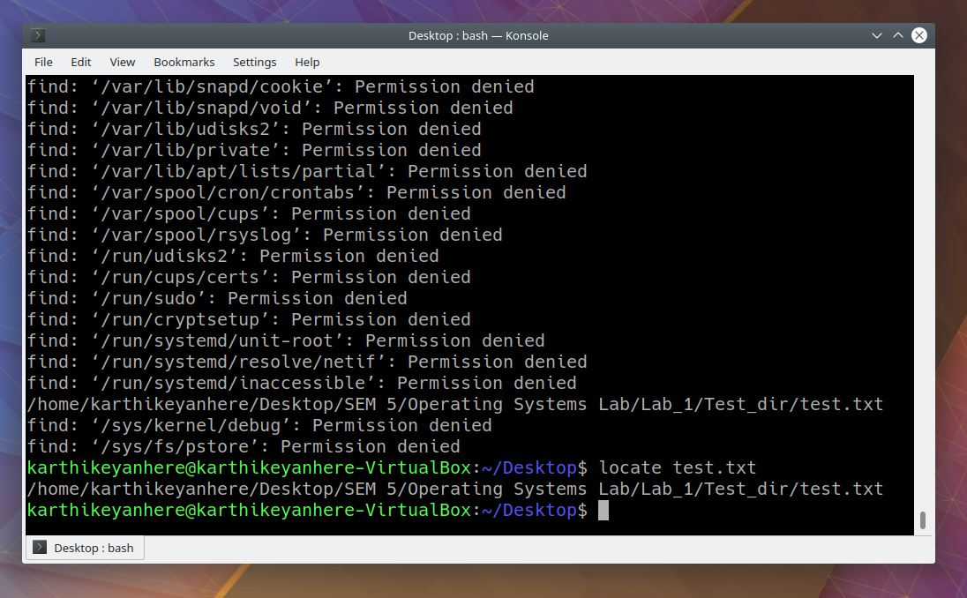

**6. View the user permissions and ownership of the files in the current directory and change the ownership of some selected files to another user.**

**ls -l : list all the files in the directory with user permissions and modification details**

**chmod 666 text.txt : changes the user permissions to read-write**

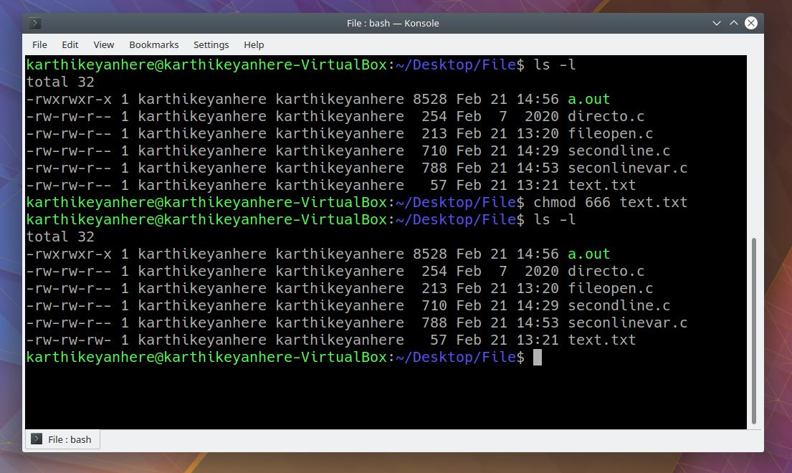

**7. List all the files in the current directory and subdirectories.**

**ls -LR : list all the files in the current directory and subdirectories**

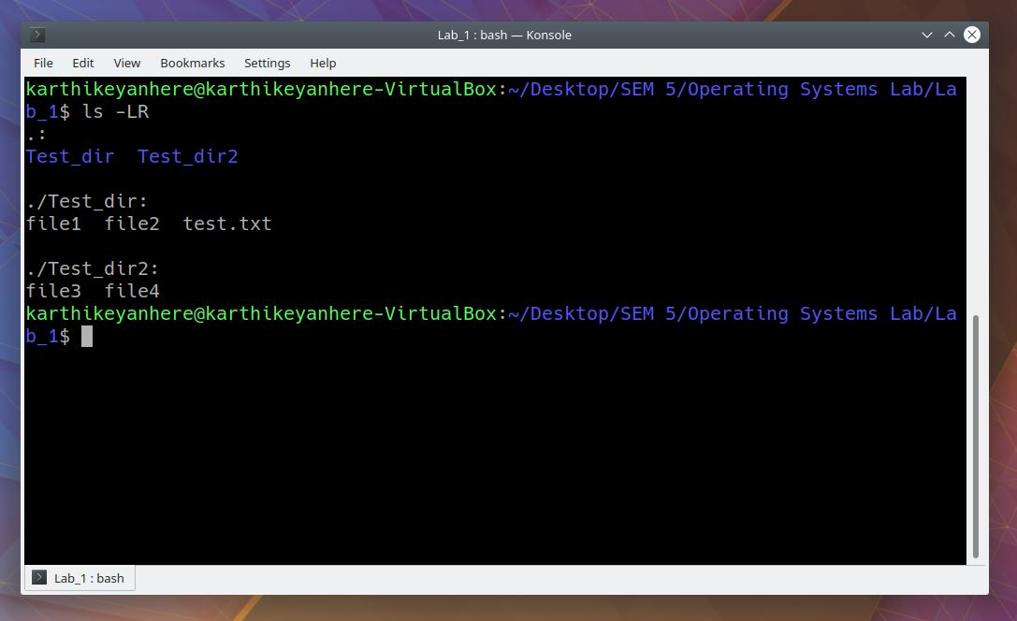

**8. Concatenate the two input files: “sample1.txt” and “sample2.txt” and save it to a new file named “Input”.**

**cat sample1.txt sample2.txt > Input.txt**

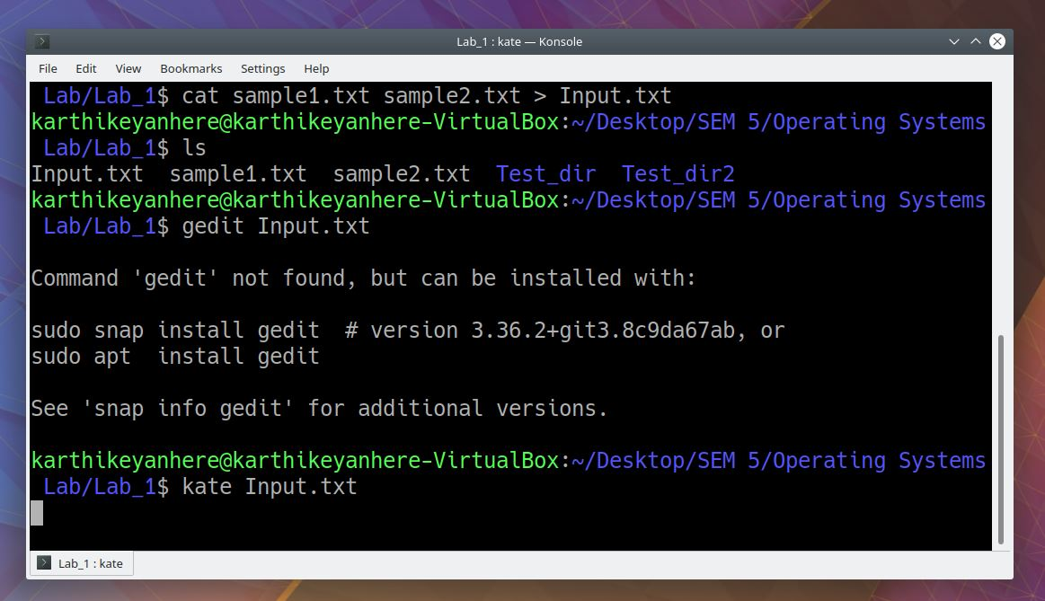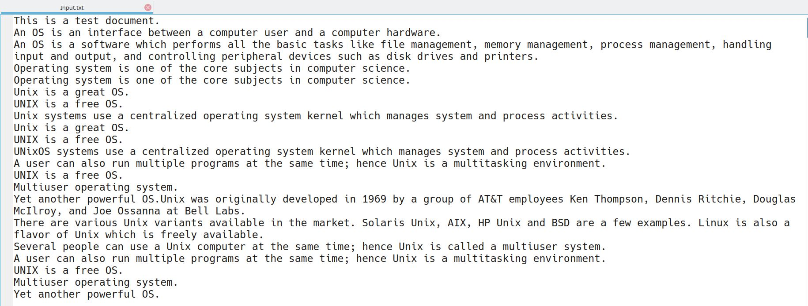

**9. Copy the contents of file ‘sample2.txt’ to ‘sample.txt’**

**cp sample2.txt sample.txt**

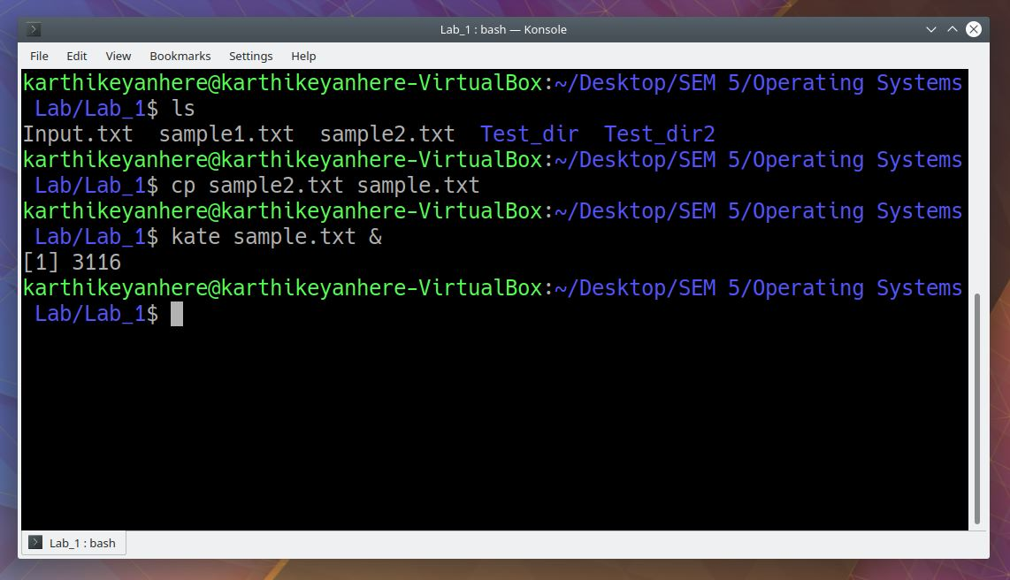

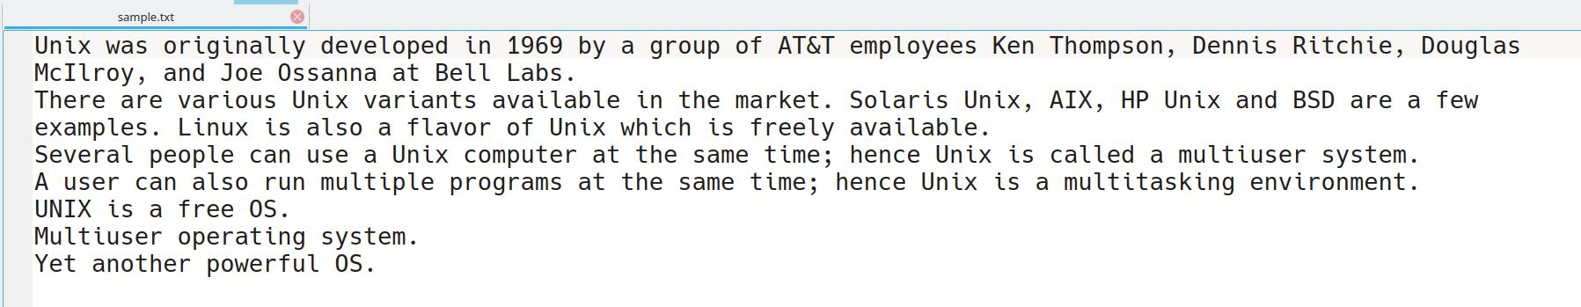

**10. Append the file contents of input file ‘sample2.txt’ to the end of the first input file ‘sample1.txt’.**

**cat sample2.txt >> sample1.txt**

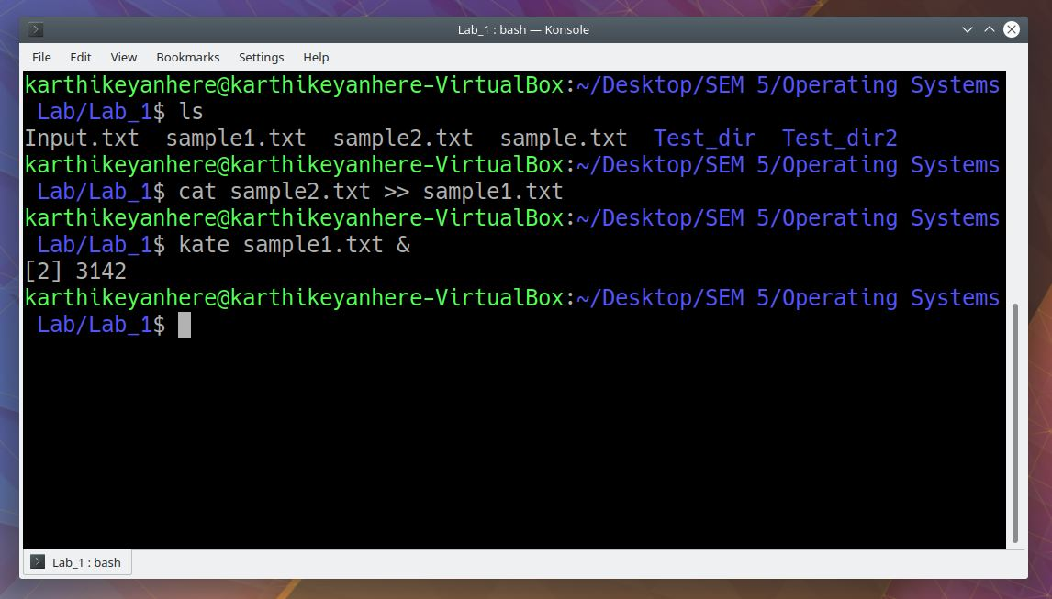

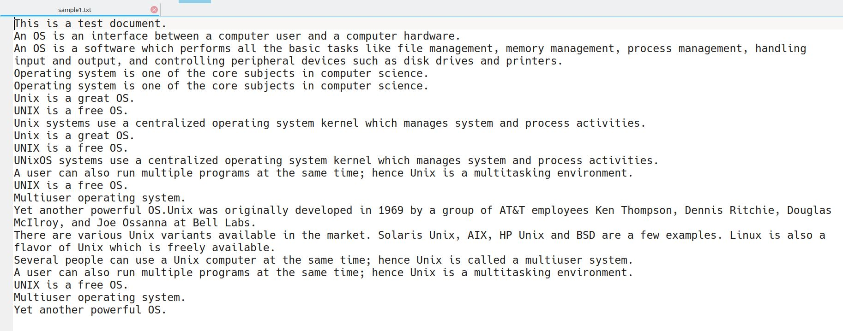

**11. Remove the permission for the users to read, write and execute the file ‘sample.txt’.**

**chmod u-rwx sample.txt**

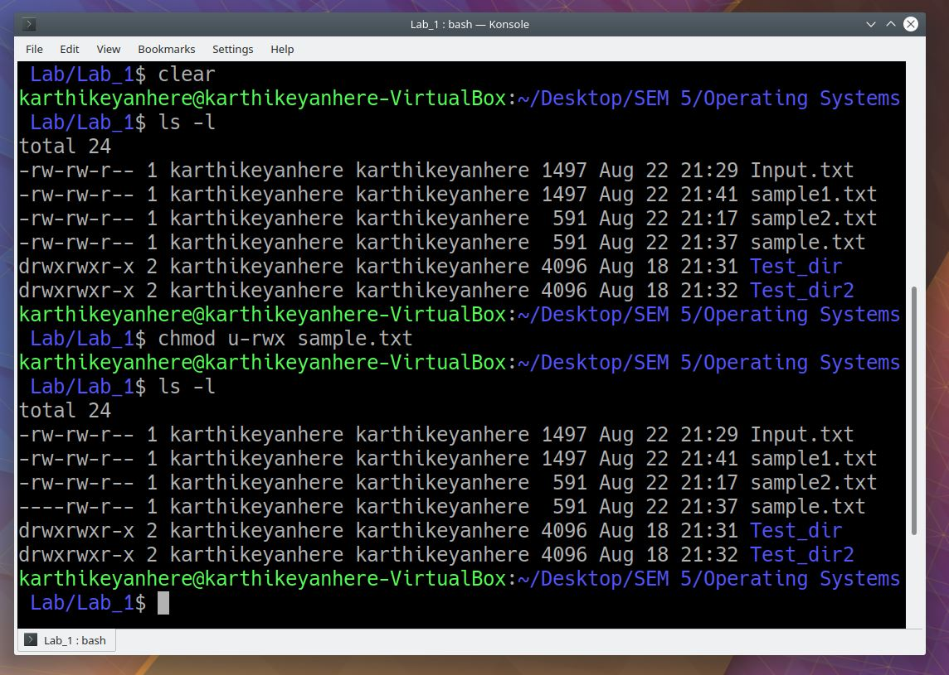

**12. Display the current date with the day of week, month, time and the year.**

**date : your country time**

**date -u : universal time**

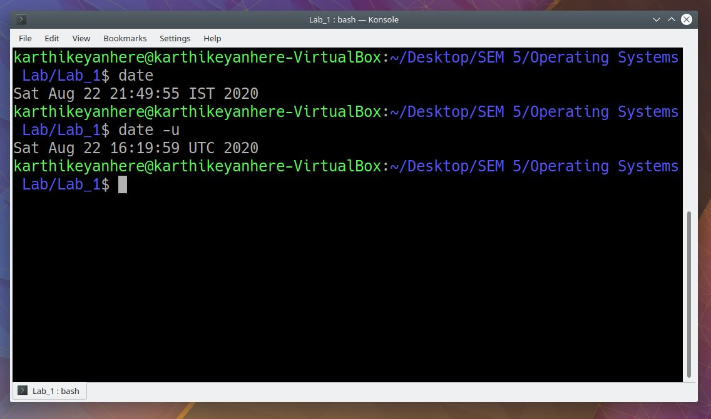

**13. Show the calendar of previous, current and next month.**

**cal : shows the calendar of present month**

**cal -3 : shows the calendar of previous month and next month along with the present month**

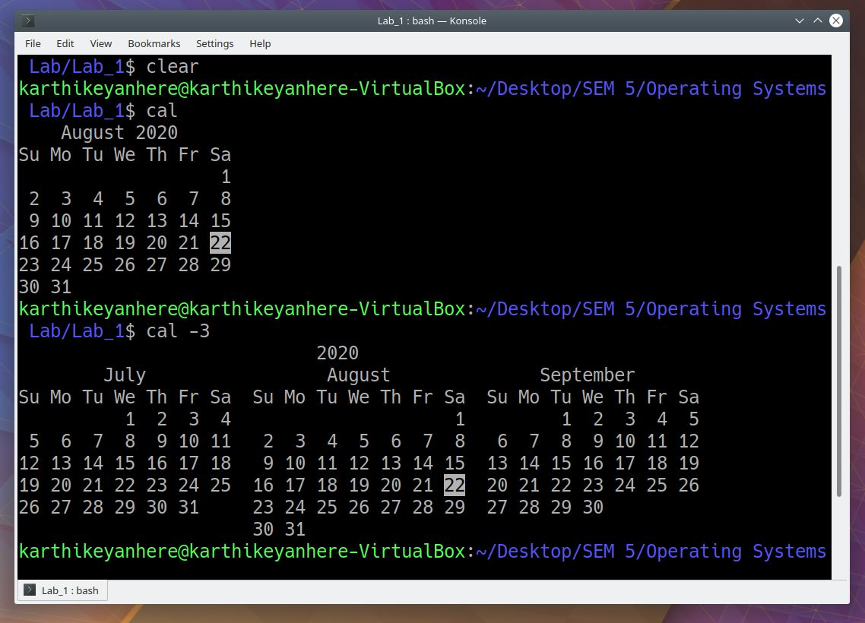

**14. Sort the contents of the file ‘sample1.txt’ in alphabetical order.**

**sort sample1.txt**

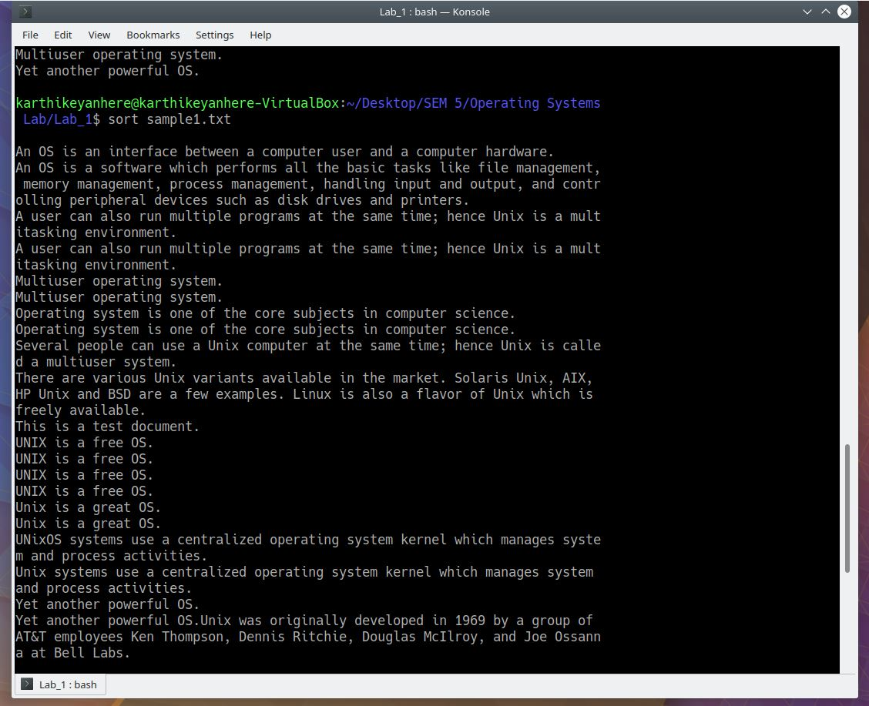

**15. Erase duplicate records in the file ‘sample1.txt’ and display only the unique records**

**sort sample1.txt | uniq**

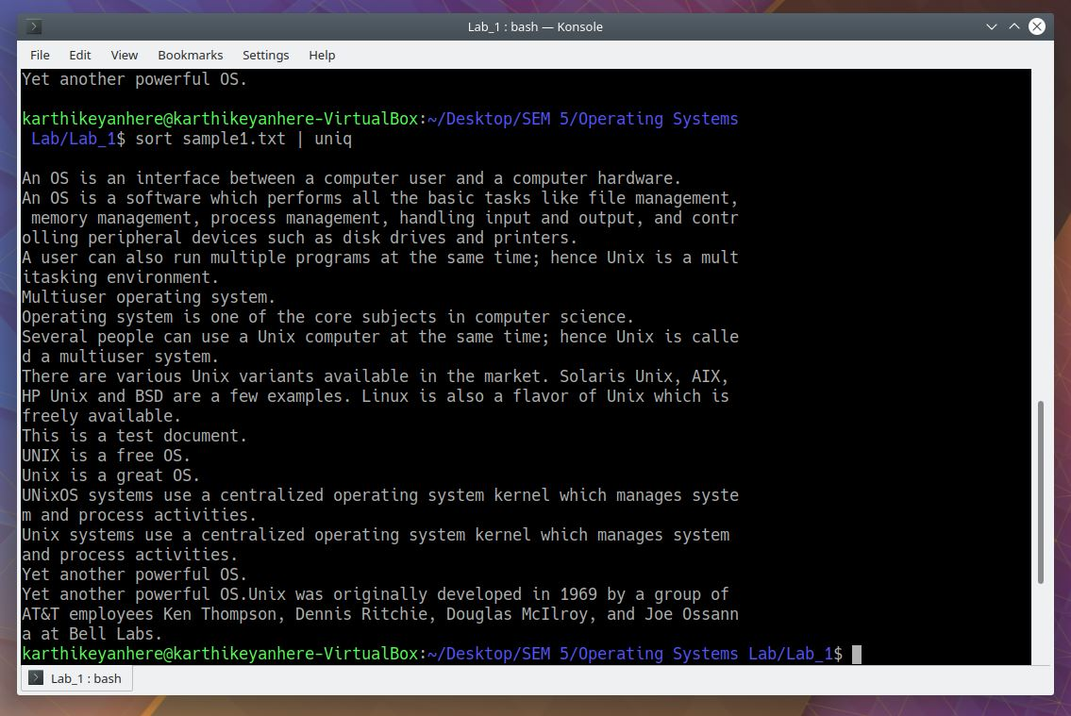

**16. Add line numbers to the file ‘sample2.txt’**

**nl sample2.txt**

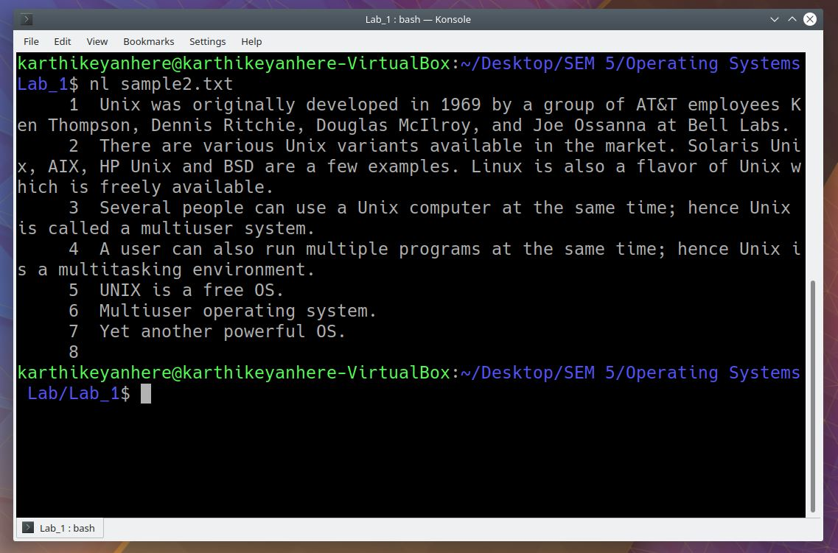

**17. Find out whether the two pairs of input files are identical or not.**

**Compare sample1.txt and sample2.txt**

**Compare sample2.txt and sample.txt**

**cmp sample1.txt sample2.txt**

**cmp sample2.txt sample.txt**

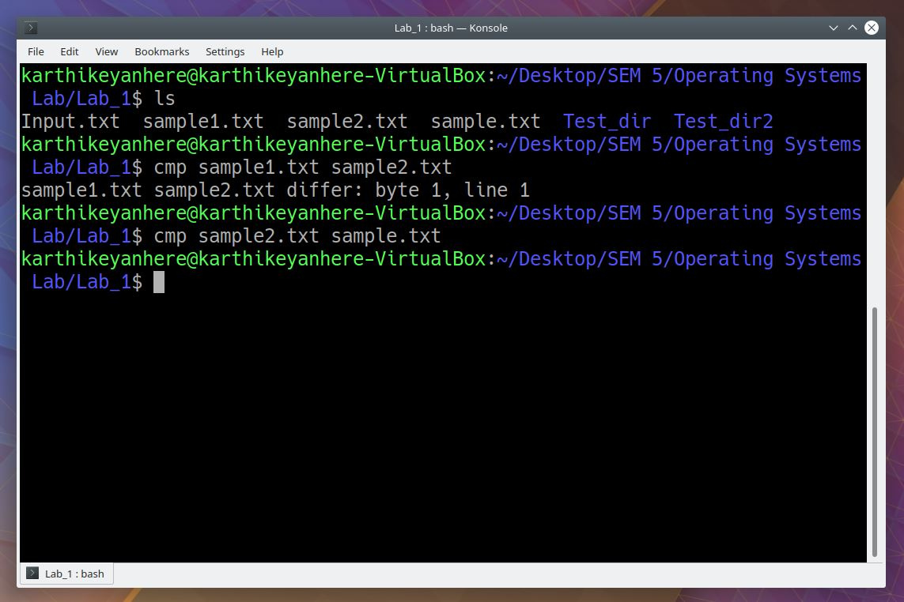

**18. Show how the input file “sample1.txt” differs line by line from “sample2.txt” in context and unified mode.**

**diff -c sample1.txt sample2.txt : context mode**

**diff -u sample1.txt sample2.txt : unified mode**

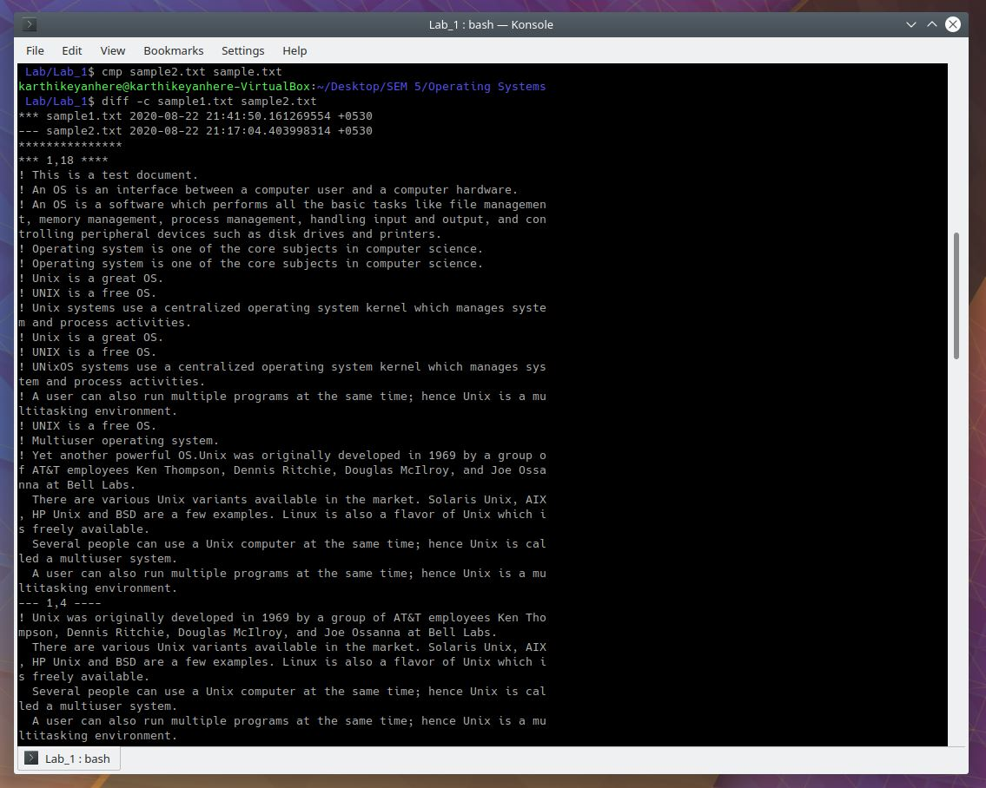

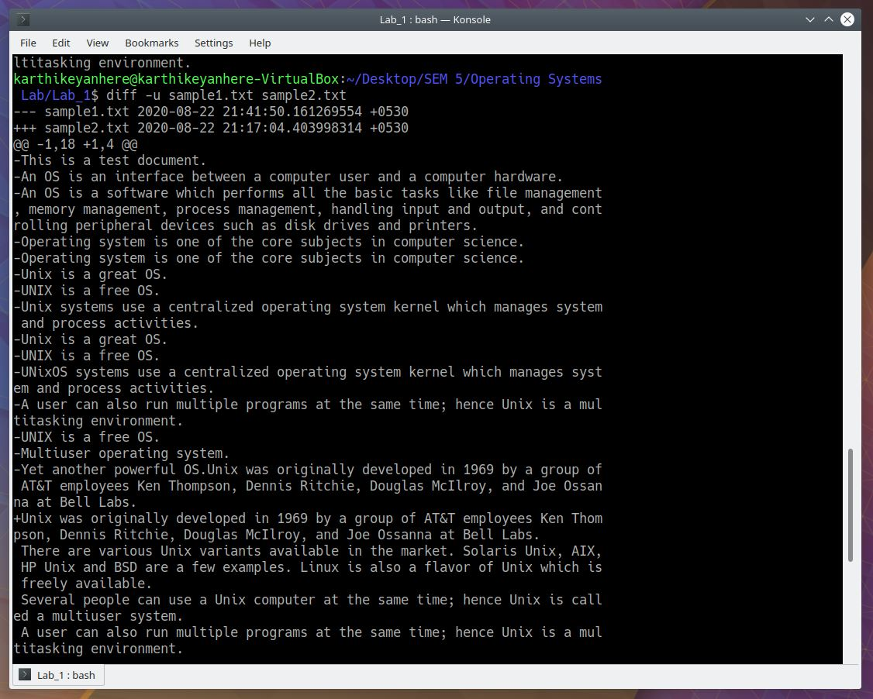

**19. Solve the arithmetic expression: ((8+12)*(5-3))/2 using linux commands,**

**let a=”8+12”**

**let b=”5-3”**

**let c=”$a*$b”**

**let d=”$c/2”**

**printf ‘%s\n’ “$d”**

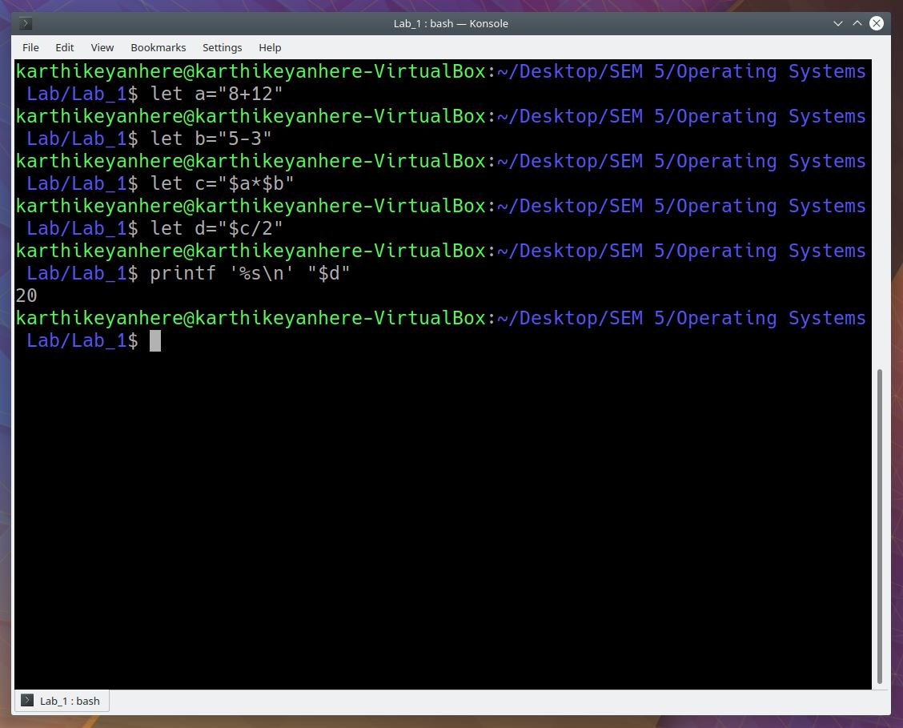

**20. Cut and display the first 10 characters of every line of the file “Input.txt”.**

**cut -c 1-10 < Input.txt**

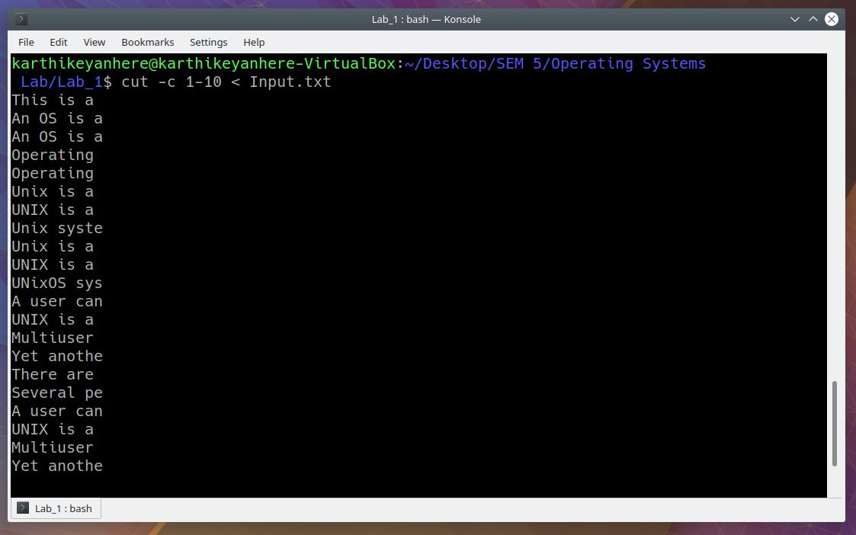

**21. Print the name of the current working directory.**

**pwd**

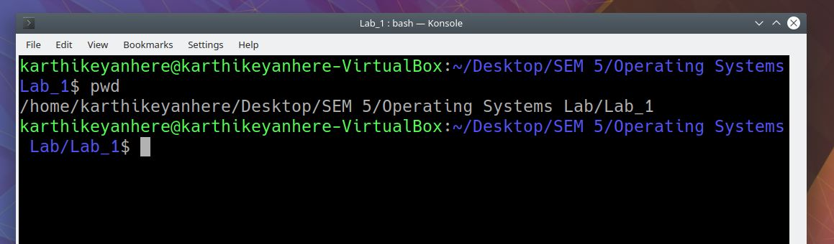

**22. Process Status**

**a. List all the running processes with their corresponding PIDs.**

**b. List the processes that are not associated with the terminal.**

**c. List the processes that are associated with the terminal.**

1. **ps -aux**
2. **ps -T**
3. **ps -a -N**

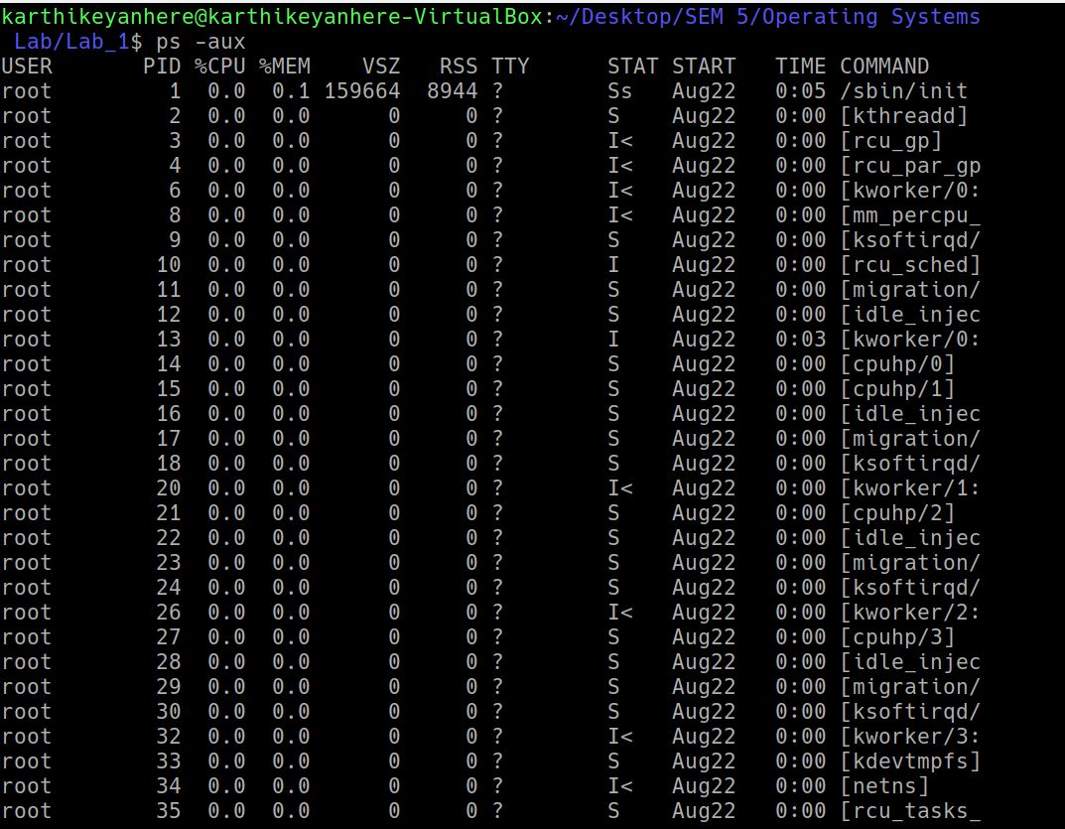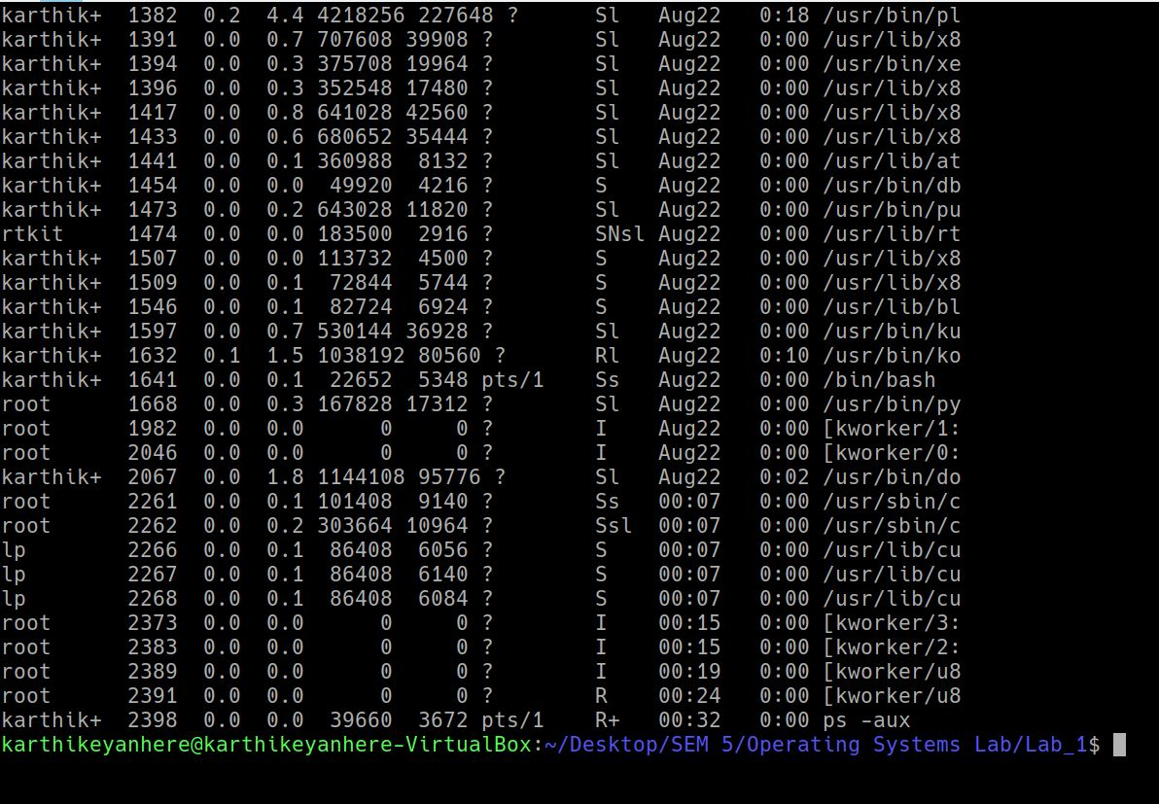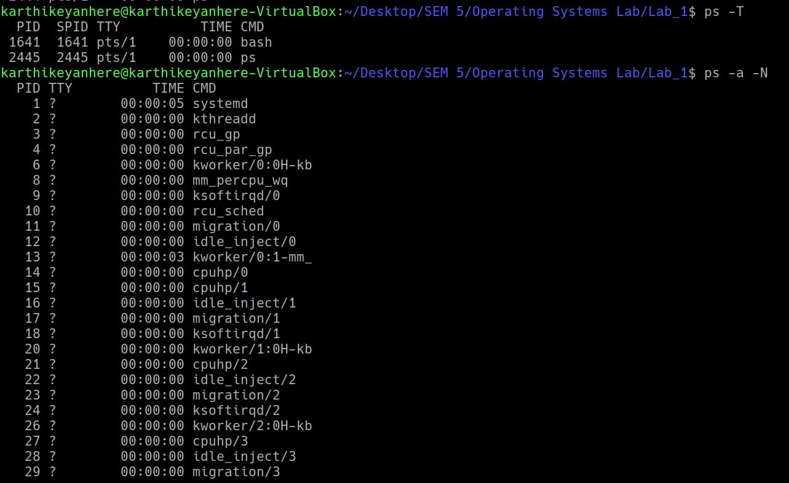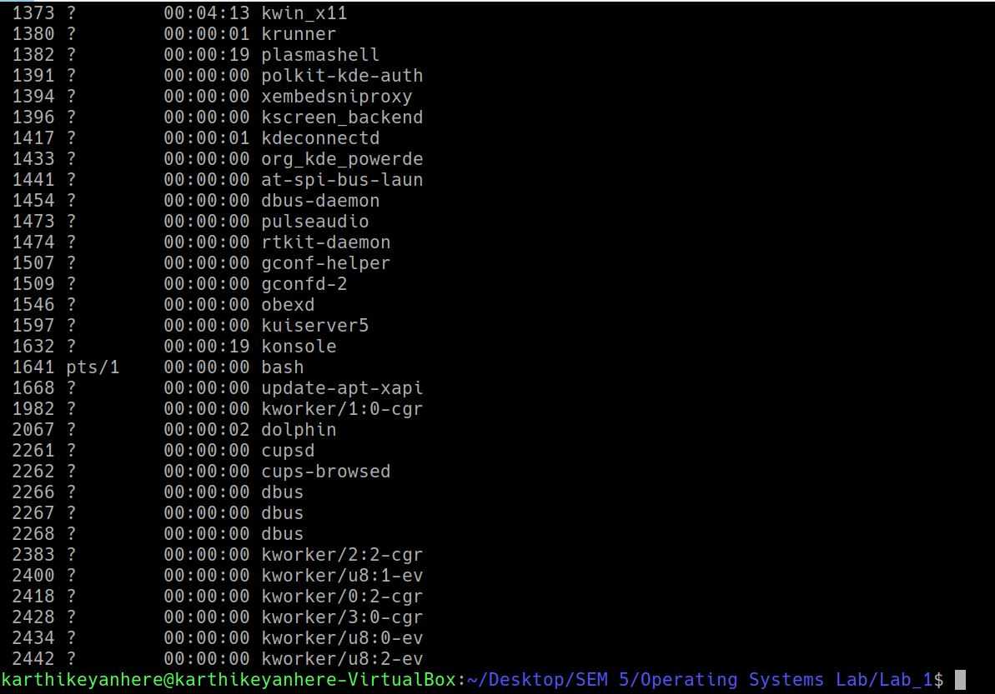

**23. Print the number of characters, number of lines and number of words all the given input files.**

**wc sample1.txt sample2.txt sample.txt Input.txt**

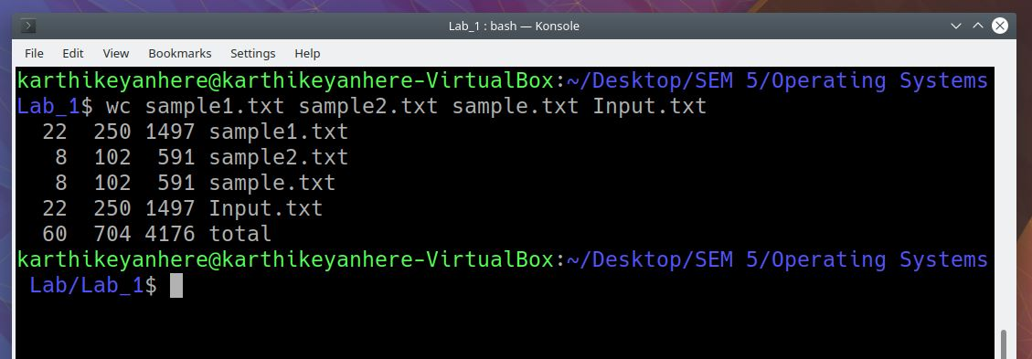

**24. Print the length of the longest line from all the input files.**

**wc -L sample1.txt sample2.txt sample.txt Input.txt**

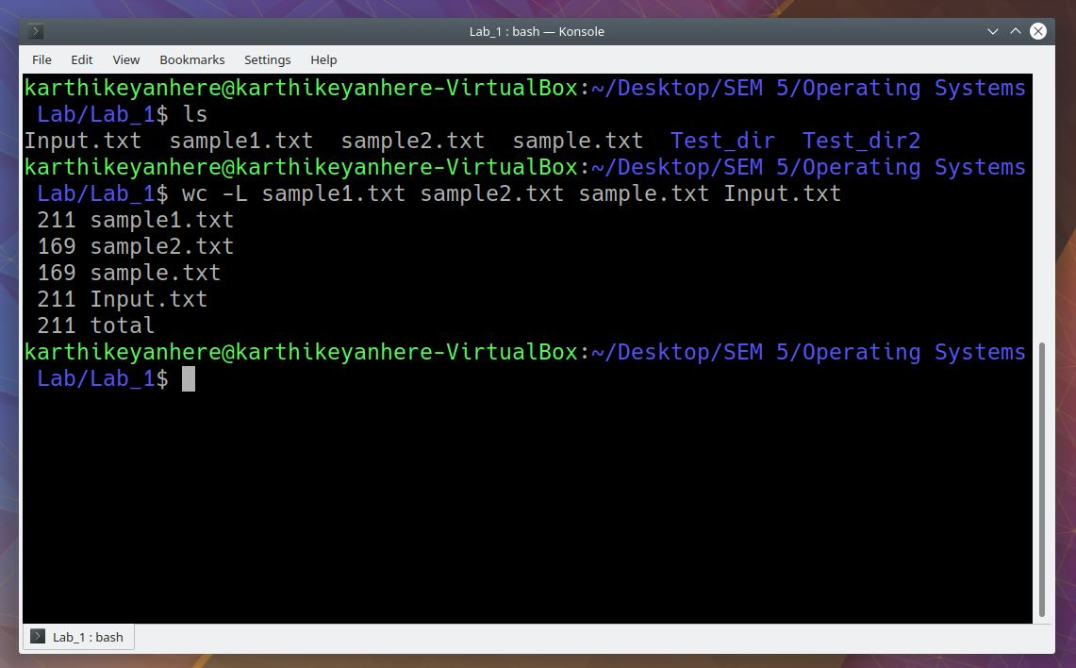

**25. Move the contents of the input file sample.txt to a new file.**

**mv sample.txt newfile.txt**

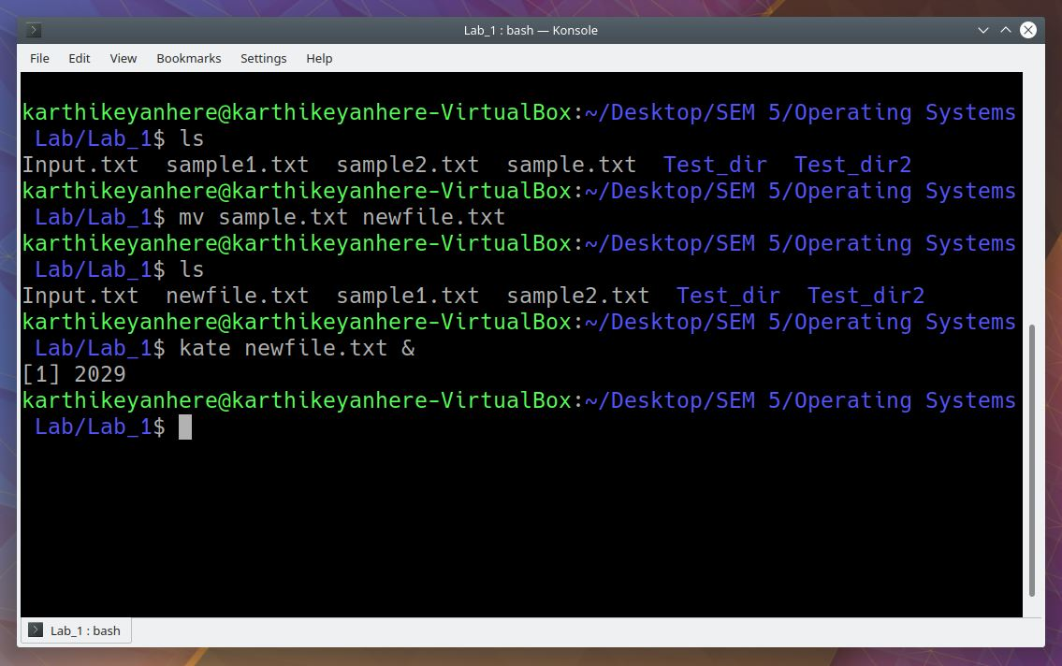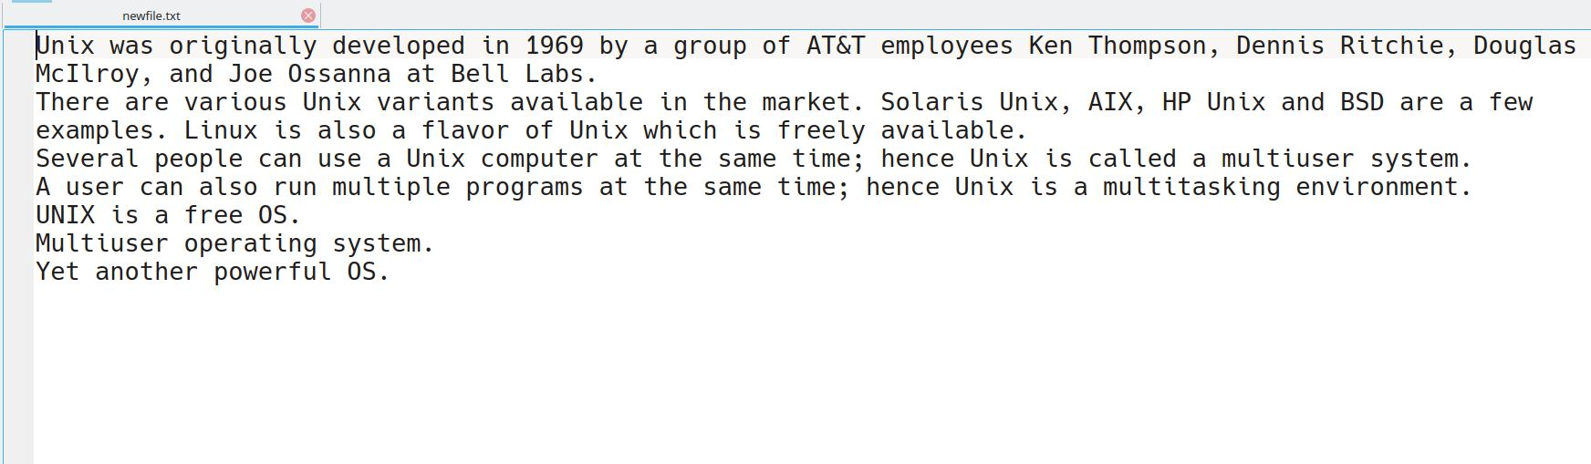

**26. Copy the contents of one directory to another directory.**

**cp -r ./Test_dir/ ./Test_dir2/**

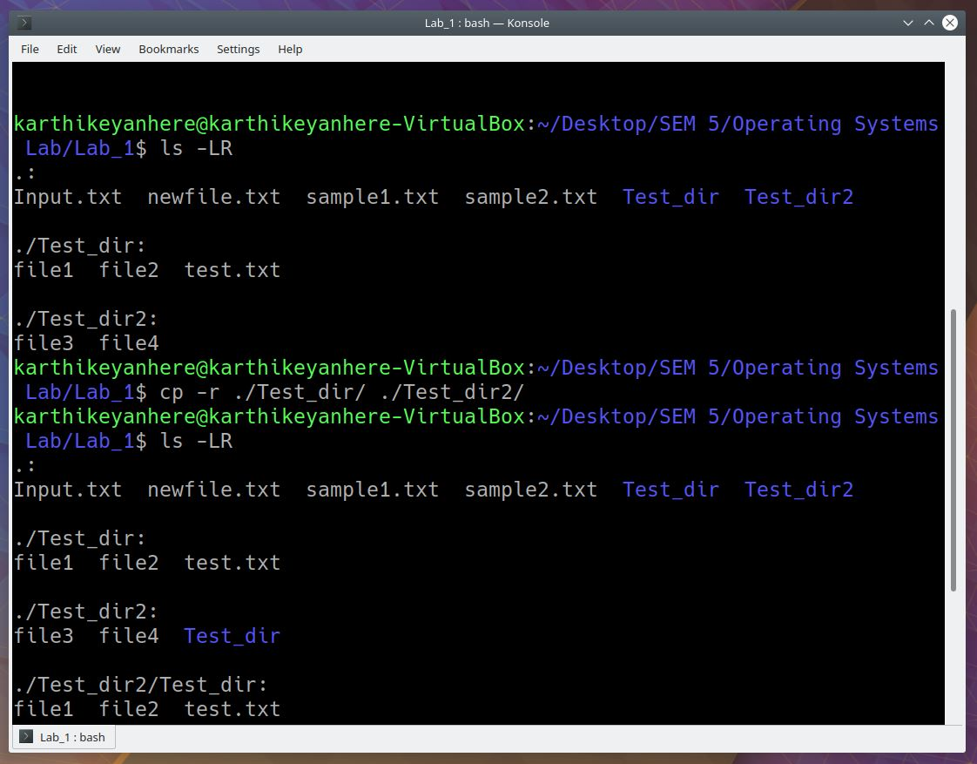

**27. Reverse the lines of the two input files and concatenate the file contents using a single command.**

**tac sample1.txt sample2.txt**

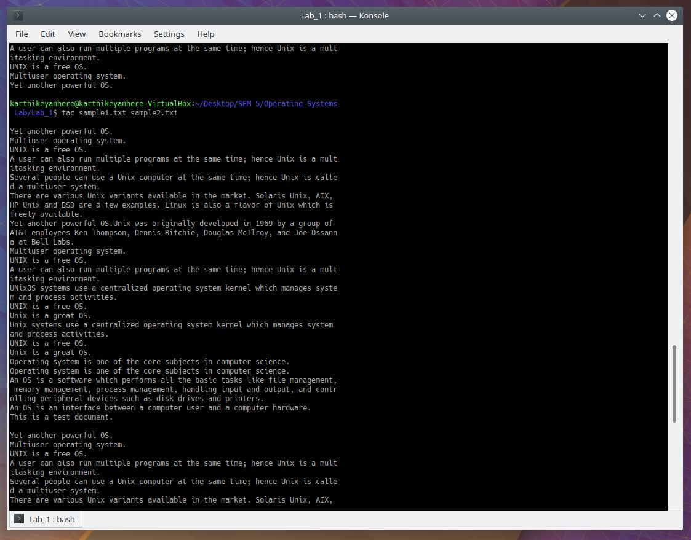

**28. Delete all the files with *.txt extension from the working directory using yes command.**

Instead of writing **rm -i *.txt** and then typing y at the end for every file, what we can do is we can use **yes | rm -i *.txt**.

**yes | rm *.txt**

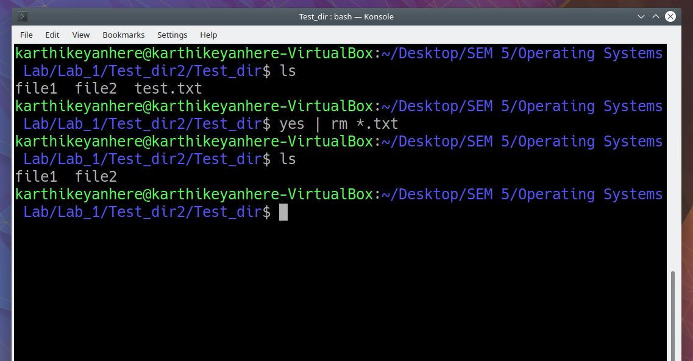

**29. Given the input file “sample1.txt”, print the number of the lines that match the pattern “system”.**

**grep -n “system” sample1.txt**

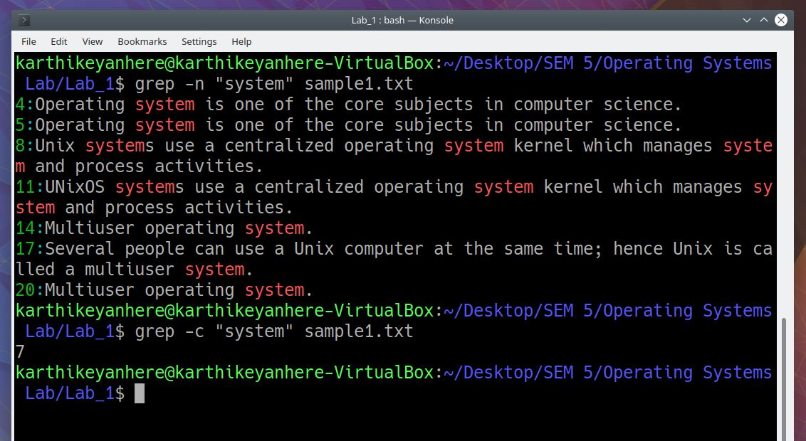

**30. Having sample1 file as input, print the matched lines that contain the pattern “Unix” as whole words.**

**grep -w “Unix” sample1.txt**

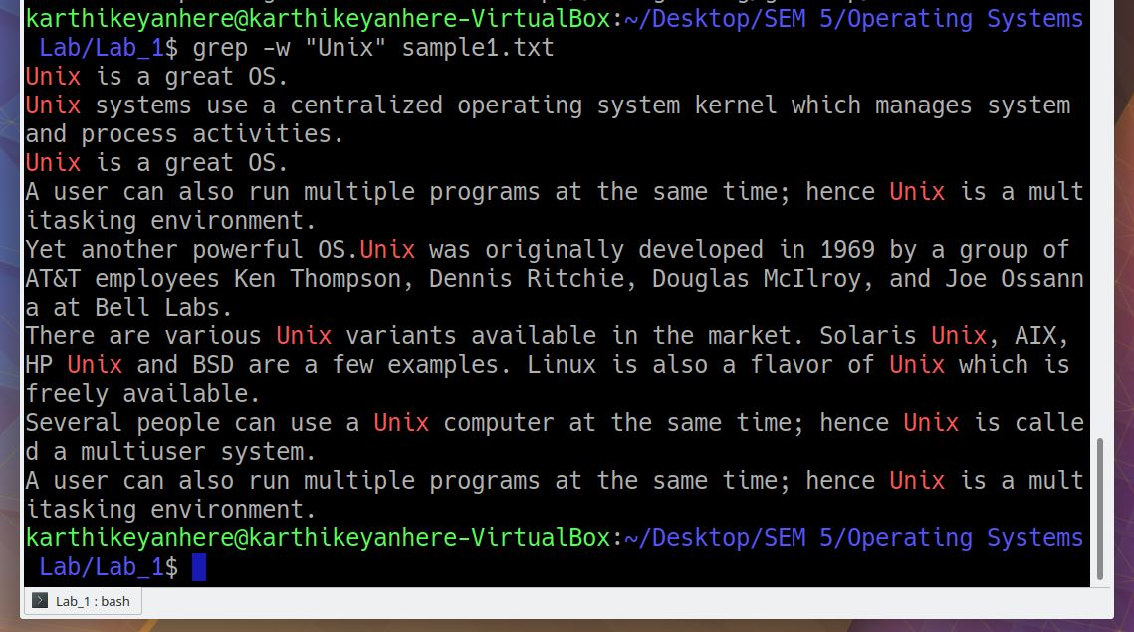

**31. Print the lines from “sample1.txt” that do not match the pattern “OS”.**

**grep -v “OS” sample1.txt**

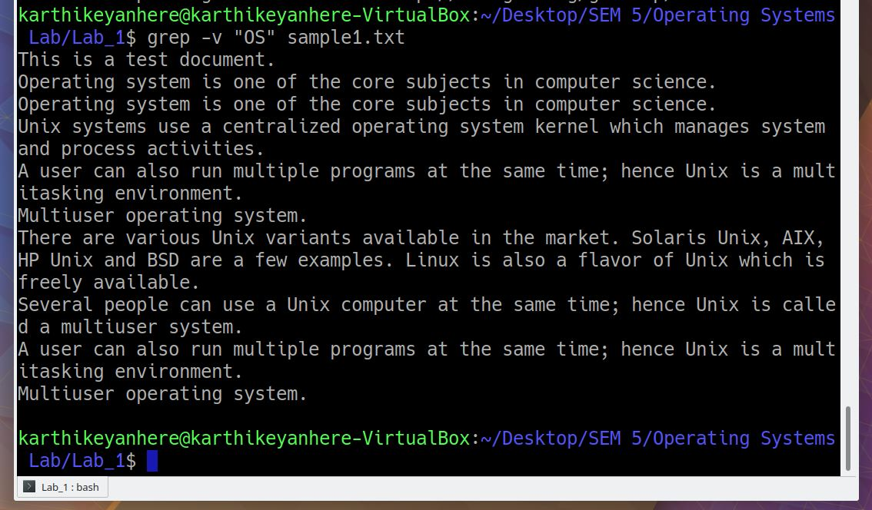

**32. Fetch the files that contain the word “OS”, “Operating System”, “Operating Systems” with its respective line number. (Ignore the case).**

**grep -n -i “Operating Systems\| Operating System\|OS” \***

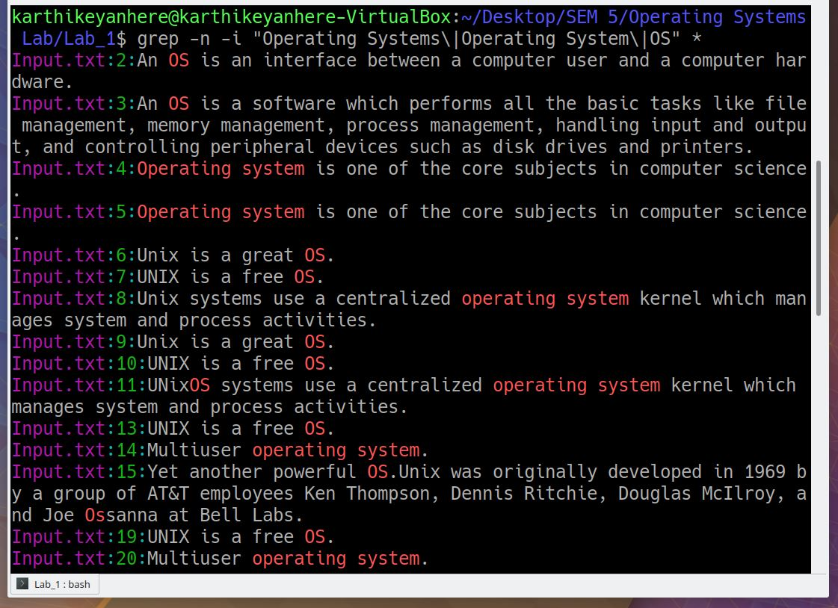

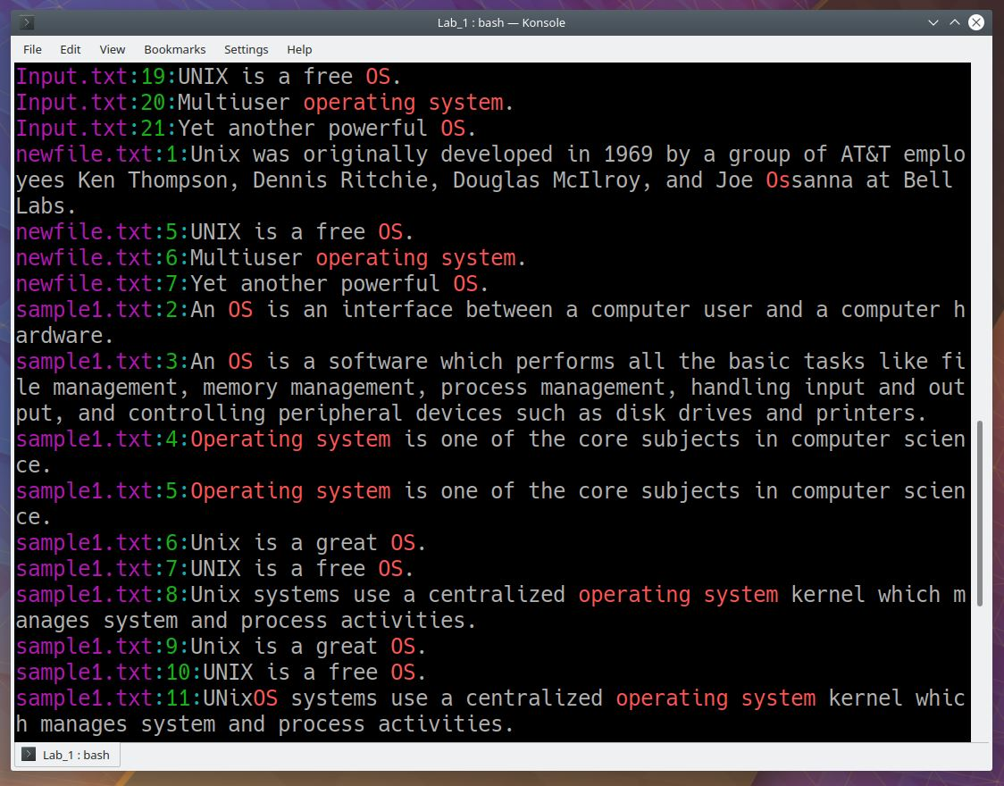

**33. Having “sample1.txt” and “core” as the input and pattern respectively, along with the matched line print three lines before and after the pattern match.**

**grep -C3 “core” sample1.txt**

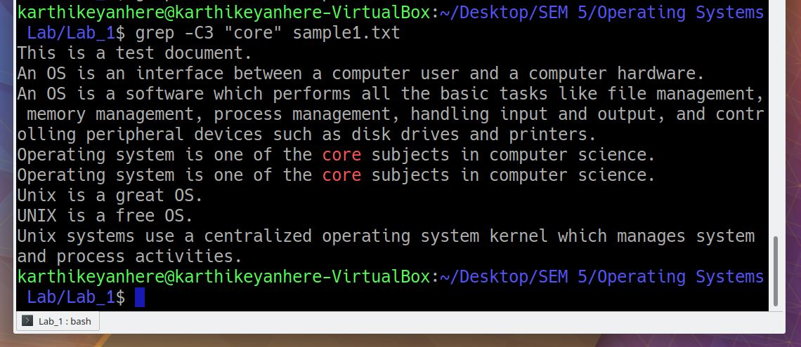

**34. Find and replace the string “OS” with “Operating System”.**

**sed ‘s/OS/Operating System/g’ sample.txt**

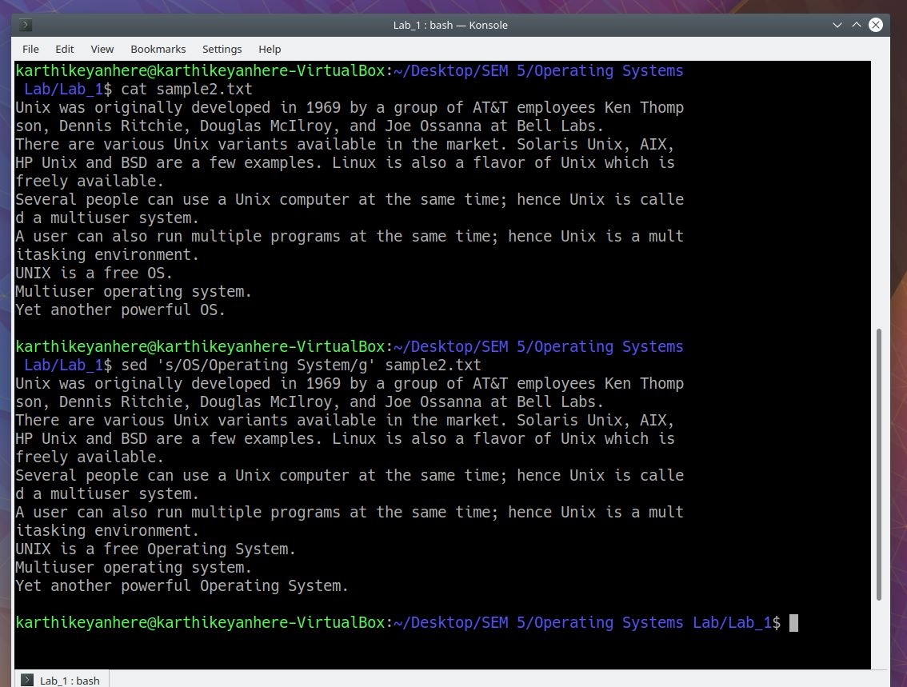

**35. List only the text files in the current working directory with its corresponding disk space occupied.**

**ls -lt *.txt**

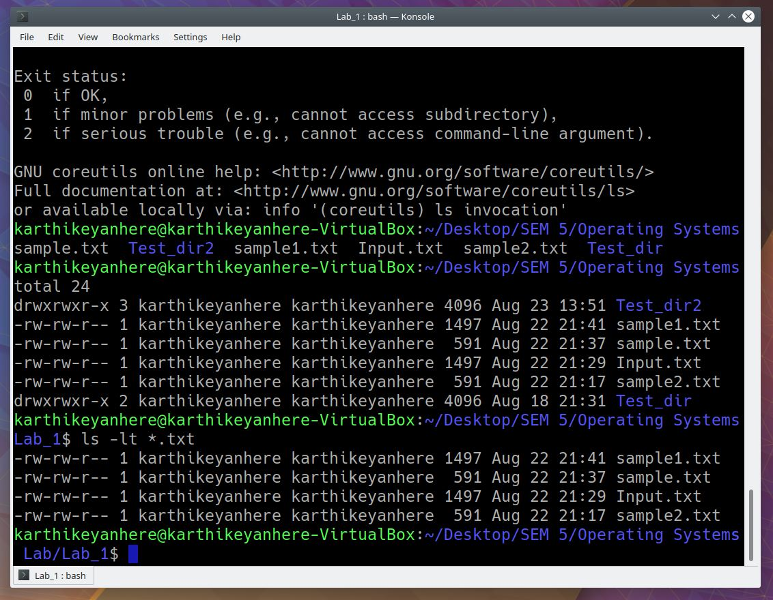

**36. Show the last modification time of all the input text files.**

**ls -lt *.txt**

OR

**stat *.txt**

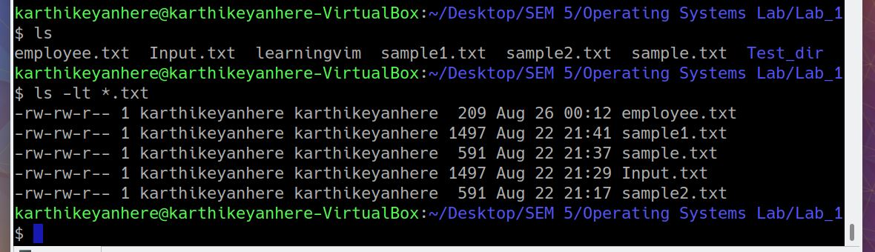

OR

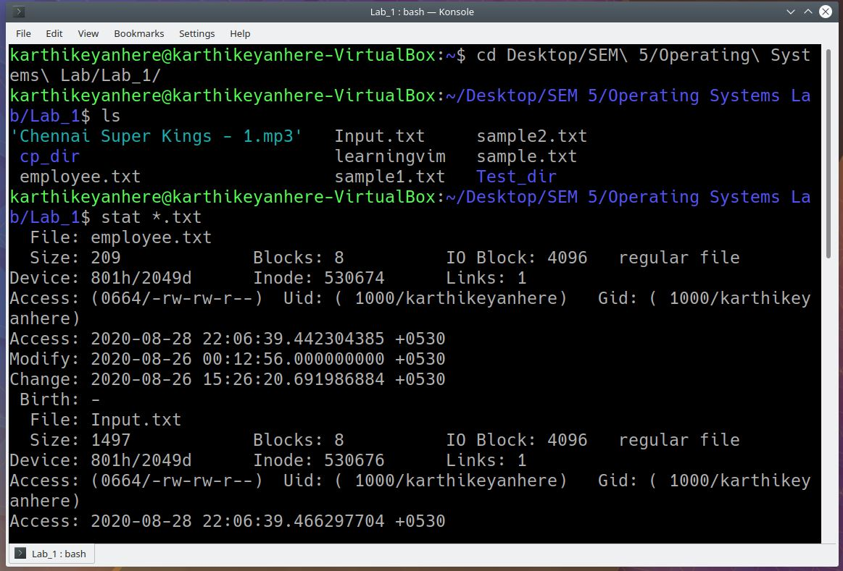

**37. Delete the line that has the word “Powerful” from the text file “sample2.txt”.**

**grep -v -i “Powerful” sample2.txt**

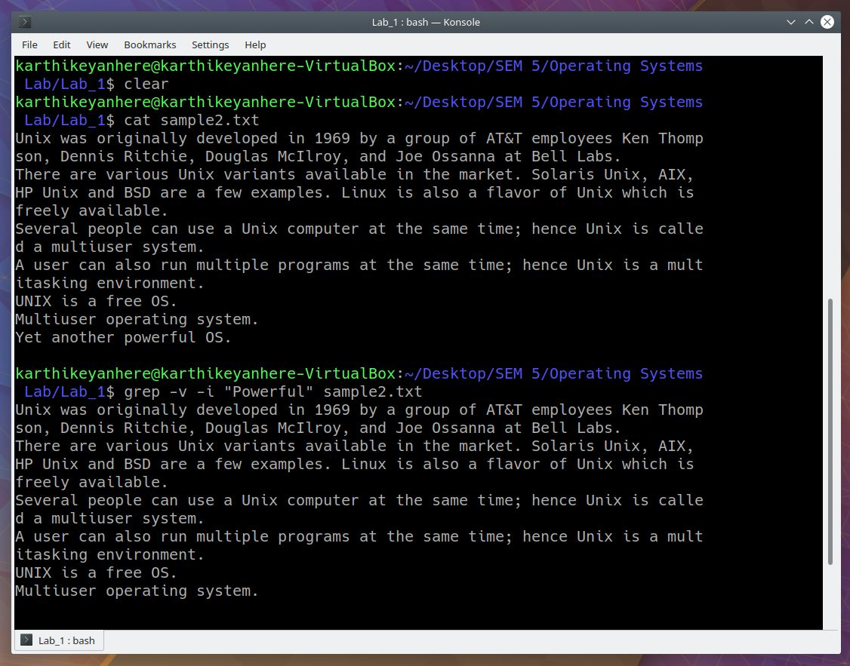

**38. Print the roll numbers that end with even numbers in the format (COE18B002) up to COE18B050.**

**seq -f “COE18B0%02g” 2 2 50**

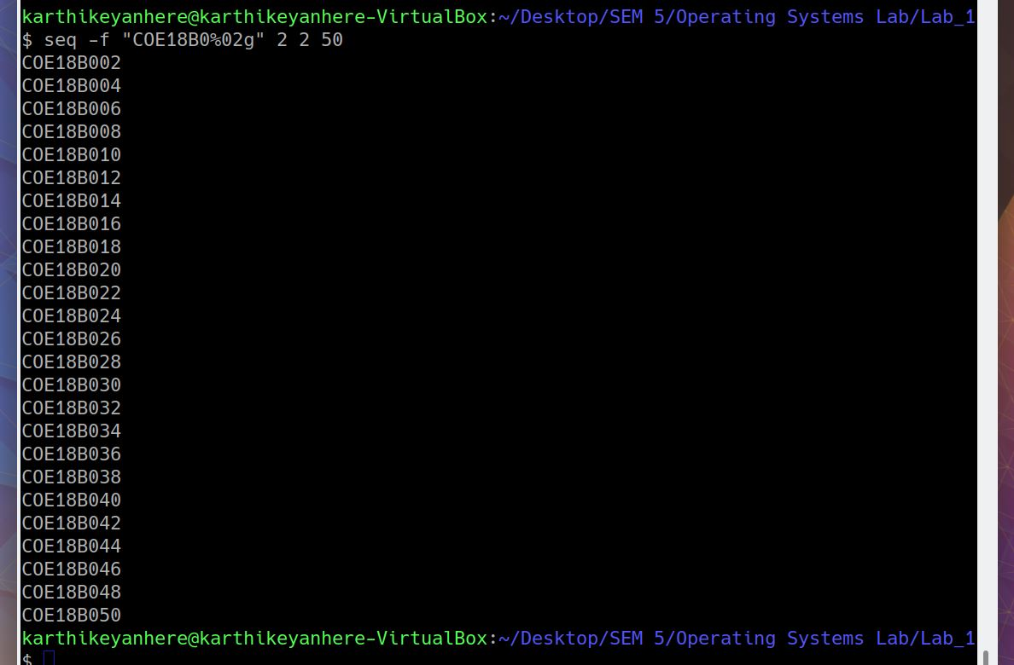

**39. Use filter commands like head, tail, more to view the file contents page by page.**

**head -3 sample.txt : shows the first four lines of sample.txt**

**tail -4 sample.txt : shows the last four lines of sample.txt**

**sort sample.txt : shows the file with sorted order**

**cat sampl.txt | grep Unix : shows the lines which contain Unix**

**wc sample.txt : displays number of words, lines, characters**

**nl sample.txt : displays the line number**

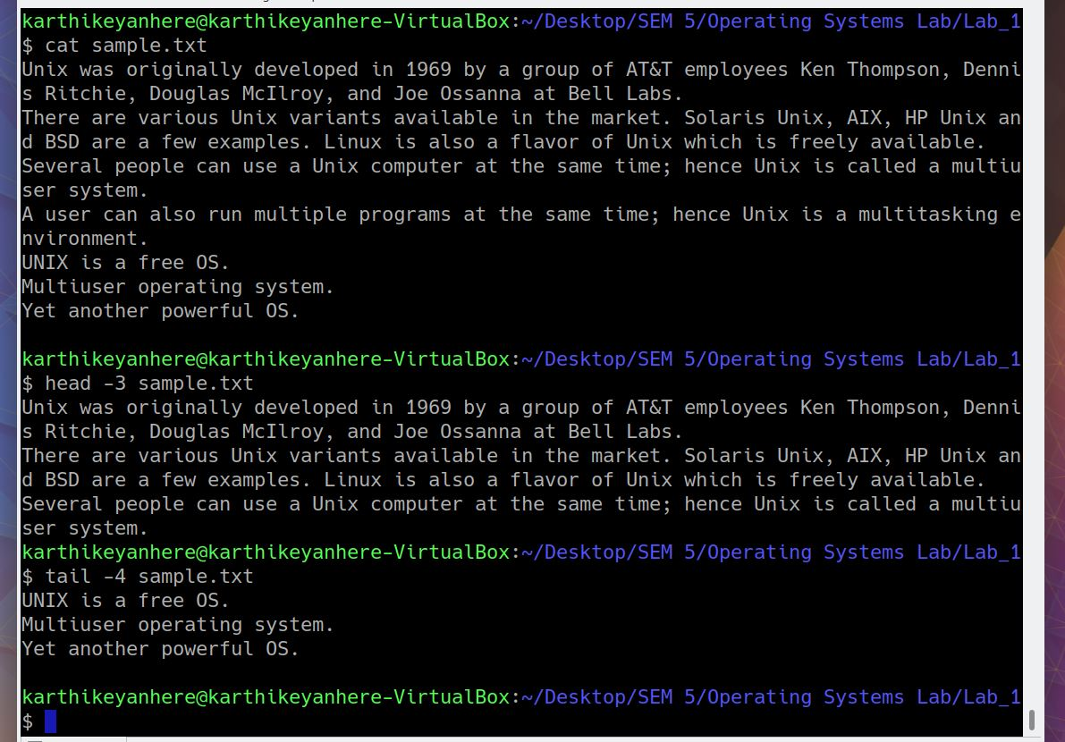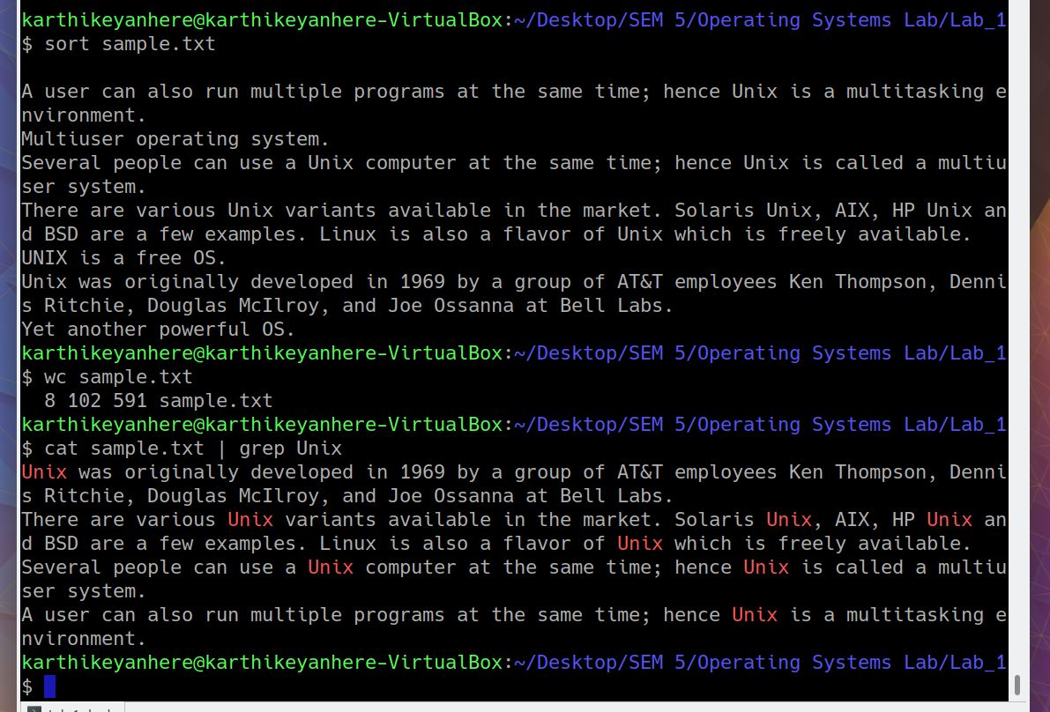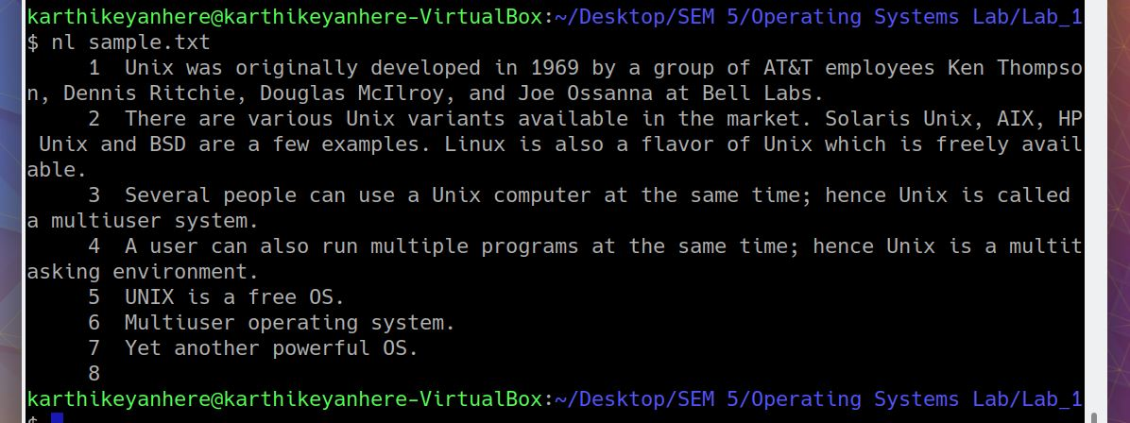

**40. Compress the current working directory contents to a tar file and extract those files from the compressed tar file.**

Compressing the current working directory contents

**name=${PWD##*/}**

**tar -czf $name.tar.gz $name**

Removing the original directory

**rm -r Lab_1**

Showing the contents inside tar file

**tar tvf Lab_1.tar.gz**

Uncompressing the tar file

**tar xvf Lab_1.tar.gz**

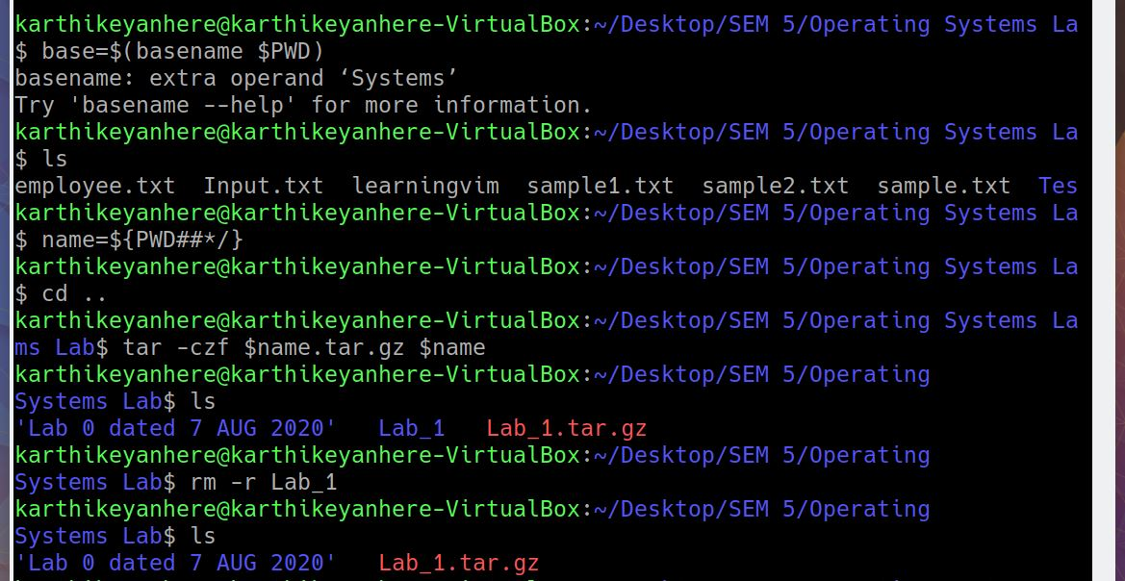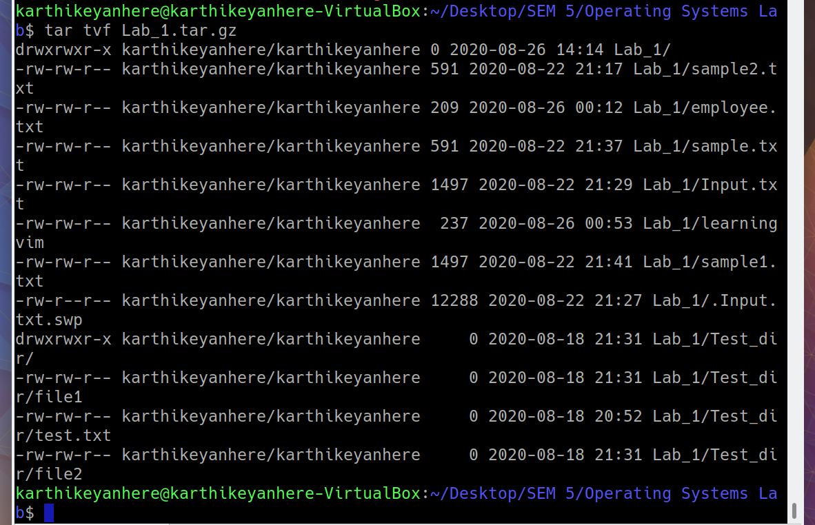

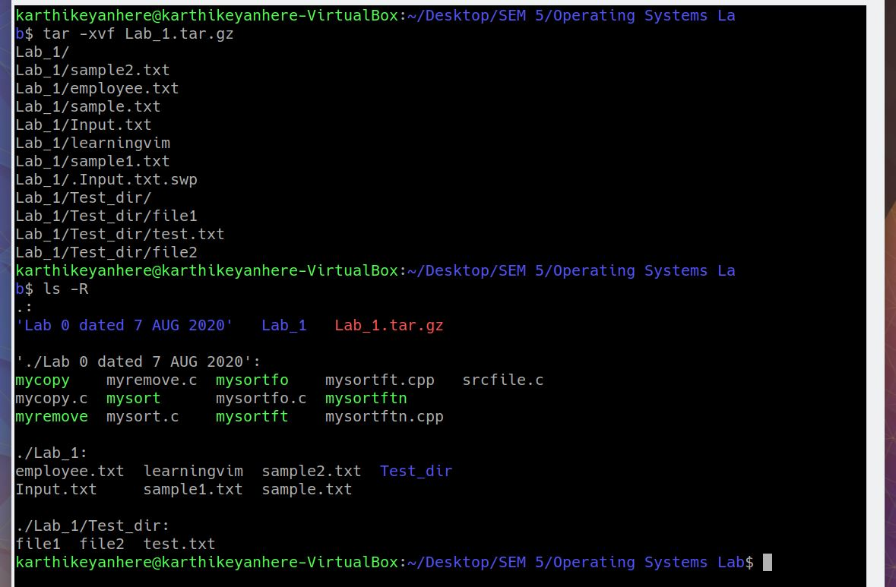

**41. Compress the files using zip command.**

**a. Zip the input file “sample1.txt” as samplezip.zip and remove the file from the current directory after zipping.**

**b. Add “sample2.txt” and update the zip archive.**

**c. Zip a directory with all its contents.**

**d. Remove a file from the zip archive**

**e. Unzip the contents from samplezip.zip**

1. **zip samplezip.zip sample1.txt**
2. **zip -u samplezip.zip sample2.txt**

To show the contents of zip file

**zip -sf samplezip.zip**

1. **zip -r samplezipfolder.zip Test_dir/**
2. **zip -d samplezip.zip sample1.txt**
3. **unzip samplezip.zip**

